**CPRS Analysis Report**

**Deliverables 6.2, 6.4, 6.5, 7.2, 7.4, 7.5**

**Tasks 6, 7**

**Emerging Health Technology**

**Investigations Support Project**

*Contract #: GS-35F-0195T*

*Purchase Order #s: 776-C70397*

*Submitted By:*

Business Intelligence, Inc.

4031 University Drive, Suite 200 Fairfax, VA 22030

**Veterans Health Administration**

*August 28, 2008*

*FINAL*

*Transforming Data into Action*

A Service Disabled Veteran Small Business

**Executive Summary**

Business Intelligence, Inc. (BI), as part of a project of the Veterans Health Administration

(VHA) Emerging Health Technologies (EHT) office, observed clinicians interacting with the Veterans Health Information Systems and Technology Architecture (VistA) Computerized Patient Record System (CPRS) in order to:

Identify high value, frequently performed CPRS functions directly related to patient care; Evaluate the tasks for inefficiencies and make recommendations for solutions to minimize or eliminate the inefficiencies;



Establish measurable performance metrics for high-value, priority functions;



Validate the recommendations by using a simulation model to gather performance metric data and clinician feedback;

* Solicit clinician feedback regarding the importance of the recommendations to their daily workflow; and
* Establish a baseline measurement for system response tolerance thresholds.

The BI Team gathered the observations and validations through two rounds of site visits to four Veterans Affairs Medical Centers (VAMCs) with 34 total participants (16 physicians and 18 nurses). The BI Team identified the following eight high-value, frequently performed clinician interactions with CPRS. Then, based on analysis of the task interaction, the BI Team developed recommended changes to CPRS. These are summarized below:

* **Print Patient List:** Provide the ability to print a patient list from CPRS, which would include the patient’s name, location, and priority for use in inpatient clinician settings, and the patient’s name, appointment time, and encounter status for use in outpatient clinician settings. The primary impact is in the hospital setting and the clinician is freed from having to leave CPRS for a clerical task.

* **Dashboard Functionality:** Provide the ability to access multiple patients' information from one screen. The primary impact is in the hospital setting and enables the clinicians to quickly triage their assigned patients.

* **Cover Sheet (Postings):** Highlight the importance of first-glance information. The impact is in both the hospital and clinic settings and enables the clinician to quickly confirm specific posting information.

* **Cover Sheet (Interactive Functionality):** Bring functionality from other parts of CPRS to the cover screen—e.g., starting new note, changing meds, or ordering labs. Primary impact is in the hospital setting and enables the clinician to conduct more of the patient encounter without leaving the cover screen.

Business Intelligence, Inc. Page

* **Accessing Data Behind Templates and Consults:** Provide thecapability to access additional patient data in CPRS while completing a locally developed template. The impact is in both the hospital and clinic settings, and enables the clinician to refrain from having to close and redo a template or consult, if additional patient information is needed.

* **Sorting and Comparing Medications:** Include the capability to sort and compare inpatient, out patient and non-VA medications in the Medication screen. Impact is in both the hospital and clinic settings, and enables the clinician to more quickly reconcile a patient's medication profile.

* **Sorting and Finding Orders:** Provide the ability to sort and quickly identify patient orders. The impact is in both the hospital and clinic settings and enables the clinician to more quickly identify a patient's order.

* **CPRS interaction with BCMA:** Link CPRS and BCMA to synchronize patient information between the two applications automatically. Primary impact is on inpatient nursing and has the potential to reduce the possibility of a patient medication error.

**Overall Timesaving:**

The BI Team calculated the average savings per task for the recommended changes using the difference between the means of the As-Is and To-Be sample execution timing results. The table below shows the timesavings gained by implementing the recommended changes to CPRS for each high-value frequently performed task. The project total time savings per physician per day is 28 minutes based on a per physician patient load of seven patients per day.

|  |  |  |  |
| --- | --- | --- | --- |
| **Task Listing** | **Average**  **Savings per task**  **(Seconds*)** | **Used during the day** | **Total savings (Seconds*)** |
| Print Patient List | 49 | 1 | 49 |
| Dashboard Functionality | 14 | 7 | 98 |
| Cover Sheet (Postings) | 15 | 7 | 105 |
| Cover Sheet (Interactive Functionality) | 19 | 7 | 133 |
| Accessing Data behind Templates and Consults | 17 | 7 | 119 |
| Sorting and Comparing Medications | 104 | 7 | 728 |
| Sorting and Finding Orders | 60 | 7 | 420 |
|  | Total Seconds | | 1,652 |
|  | Savings in Minutes | | 28* |

* Calculations are rounded to the nearest second/minute.

Business Intelligence, Inc. Page

**Overall Task Rankings**

The four highest ranked tasks among both nurses and physicians are Cover Sheet (Interactive Functionality), Dashboard Functionality, Sorting and Comparing Medications, and Accessibility of Data behind Templates and Consults.

**Tolerance Threshold**

As part of the overall task, the BI Team also conducted a study of CPRS response threshold tolerance. The results indicated that clinicians find screen-to-screen response times of 2 seconds and below acceptable; response times between 2 and 5 seconds were tolerated but not considered desirable.

**Overall Recommendations**

The BI Team is suggesting 34 recommendations (see Appendix F) regarding the eight high-value frequently performed tasks. The overarching recommendations are as follows:

Enable sorting of tabular data by any column;



Present data in a way that decreases the time a user needs to access information; and Consolidate functionality into single screens where possible to lessen the need for the clinician to use multiple screens to complete a single task.

Additionally, the BI Team outlined 24 proposed functional recommendations (see Table 28) that are not in the defined scope of the analysis, and 17 requested capabilities (see Table 29) that are considered future development.

Page

**Table i. Document Revision History**

Table i below shows the revision history of this document.

|  |  |  |  |
| --- | --- | --- | --- |
| **Version** | **Date** | **Changed By** | **Revision Description** |
| 1.0 | 07/25/2008 | Eileen Cocks, Task Lead | Original |
| 1.1 | 08/15/2008 | Ken Bodenheimer, Task Lead | Incorporating Government  Comments |
| 1.2 | 08/26/2008 | Ken Bodenheimer, Task Lead | Final |

**Table ii. Approval History**

Table ii below shows the approvals signatures for this version of the document.

|  |  |  |
| --- | --- | --- |
| **Name** | **Signature** | **Date** |
| **Nancy Wilck**  VHA Project Manager |  |  |
| **Rick Verrill**  Project Manager | Rick Verrill | 08/26/2008 |
| **Eileen Cocks/Ken Bodenheimer** Task 6, 7 Task Lead | Eileen Cocks/Kenneth Bodenheimer | 08/26/2008 |

Business Intelligence, Inc. Page

**Table of Contents**

1 Introduction 1

1.1 Project Objectives 1

1.2 About this Document and Document Scope 2

1.3 Analysis Methodology 3

2 Findings 5

2.1 Recommended Modifications to Print Patient List 5

2.1.1 Assessment of As-Is State of Print Patient List 5

2.1.2 Assessment of To-Be Changes to Print Patient List 7

2.1.3 Impacts 9

2.1.4 Requirements Statements 11

2.1.5 Supporting Data 11

2.2 Recommended Modifications to CPRS – addition of a Dashboard 11

2.2.1 Assessment of As-Is State of Dashboard Functionality 11

2.2.2 Assessment of To-Be Changes to Dashboard Functionality 12

2.2.3 Impacts 15

2.2.4 Requirements Statements 17

2.2.5 Supporting Data 18

2.3 Recommended Modifications to the CPRS Cover Sheet Postings 18

2.3.1 Assessment of As-Is State of Cover Sheet Postings 18

2.3.2 Assessment of To-Be Changes to Cover Sheet Postings 20

2.3.3 Impacts 22

2.3.4 Requirements Statements 23

2.3.5 Supporting Data 23

2.4 Recommended Modifications to CPRS Cover Screen 23

2.4.1 Assessment of As-Is State of CPRS Cover Sheet Screen Functionality 23

2.4.2 Assessment of To-Be Changes to the CPRS Cover Sheet Screen 25

2.4.3 Impacts 27

2.4.4 Requirements Statements 28

2.4.5 Supporting Data 29

2.5 Recommended Modifications to CPRS Template and Consult Screens 30

2.5.1 Assessment of As-Is State of Templates and Consults 30

2.5.2 Assessment of To-Be Changes to Templates and Consults 32

2.5.3 Impacts 33

2.5.4 Requirements Statements 34

2.5.5 Supporting Data 35

2.6 Recommended Modifications to the CPRS Medications Screen 35

2.6.1 Assessment of As-Is State of Medications Screen 35

2.6.2 Assessment of To-Be Changes to Medications Screen 36

2.6.3 Impacts 39

2.6.4 Requirements Statements 40

2.6.5 Supporting Data 41

2.7 Recommended Modifications to CPRS Orders Screen 41

2.7.1 Assessment of As-Is State of Orders Screen 41

2.7.2 Assessment of To-Be Changes to Orders screen 43

2.7.3 Impacts 46

2.7.4 Requirements Statements 48

2.7.5 Supporting Data 48

2.8 Recommended Modifications to CPRS interaction with BCMA 48

2.8.1 Assessment of As-Is State of CPRS interaction with BCMA 48

2.8.2 Assessment of To-Be Changes to CPRS Interaction with BCMA 49

2.8.3 Impacts 49

2.8.4 Requirements Statements 50

2.8.5 Supporting Data 50

3 Out of Scope Findings & Recommendations 51

3.1 Secondary Findings 51

3.2 Future CPRS Recommendations 53

Page

**Appendixes ........................................................................................................................................... 1**

Appendix A. Site Demographics and Participant Profile ......................................................................... 1

*Participants......................................................................................................................................... 3*

Appendix B. Performance Data and Calculations .................................................................................... 1

*Confidence Interval for the difference of two means ............................................................................. 1*

*Raw Scenario Execution Timing Data.................................................................................................. 5*

Appendix C. Rank Order Analysis .......................................................................................................... 1

Appendix D. Threshold / Tolerance ........................................................................................................ 1

Appendix E. As-Is to To-Be Functionality Comparison Matrix ................................................................ 1

Appendix F. CPRS Analysis Report: Recommendations (RCMD) and Requirements (REQ).................... 1

Appendix G. Terms and Abbreviations .................................................................................................... 1

*Statistical Definitions .......................................................................................................................... 2*

Appendix H. Assumptions and Limitations .............................................................................................. 5

Appendix I. References ........................................................................................................................... 1

**List of Figures**

Figure 1. As-Is model of the CPRS Patient Selection screen. ....................................................... 7

Figure 2. To-Be model of the CPRS Patient Selection screen ....................................................... 8

Figure 3. To-Be model of an inpatient list and an outpatient list .................................................. 9

Figure 4. To-Be model of the Dashboard Customization screen ................................................. 13

Figure 5. To-Be model of a possible inpatient physician’s Dashboard ....................................... 14

Figure 6. To-Be model of a possible inpatient nurse’s Dashboard.............................................. 14

Figure 7. To-Be model of a possible outpatient clinician’s Dashboard ...................................... 15

Figure 8. As-Is example of a default view of the Postings section of CPRS Cover Sheet

screen. .............................................................................................................................. 19

Figure 9. As-Is example of a Postings Pop-up Information Window. ........................................ 20

Figure 10. As-Is example of a Postings Pop-up Information Window. ........................................ 20

Figure 11. To-Be model of the Postings section on the CPRS Cover Sheet screen. .................... 21

Figure 12. As-Is example of a default view of the CPRS Cover Sheet screen. ............................ 25

Figure 13. To-Be example of a default view of the CPRS Cover Sheet screen. .......................... 26

Figure 14. Be example of a Medication Information screen with option menu. .......................... 26

Figure 15. To-Be example of an active Template. ......................................................................... 31

Figure 16. To-Be example of a template that can be minimized. .................................................. 32

Figure 17. As-Is example of the CPRS Medications screen. ......................................................... 36

Figure 18. To-Be example of a medication reconciliation screen comparing inpatient and

outpatient medications. ................................................................................................... 37

Figure 19. To-Be example of a medication reconciliation screen comparing current and past

medications. .................................................................................................................... 38 Figure 20. To-Be example of a medication list. .............................................................................. 38

Figure 21. As-Is example of a default view of the CPRS Orders screen. ..................................... 42

Figure 22. To-Be model of a default view of the CPRS Orders screen. ....................................... 44

Figure 23. To-Be model of the pop-up definition in the CPRS Orders screen. ............................ 44

Figure 24. To-Be example of a possible saved view. ..................................................................... 45

Figure 25. To-Be example of a second possible saved view. ........................................................ 45

Figure 26. To-Be Model of Custom Order View screen with Save View button......................... 46

Figure 27. As-Is Model of the Bar Code Medication Administration Screen with Wristband

Scan. ................................................................................................................................ 49

**List of Tables**

Table 1. As-Is Scenario Instructions for Printing a patient list .......................................................... 6

Table 2. To-Be Scenario Instructions for Printing a Patient List....................................................... 9

Table 3. Time Data Results for Execution Timings for Printing a Patient List .............................. 10

Table 4. Keystroke Count for Printing a Patient List ....................................................................... 10

Table 5. As-Is scenario for viewing information for more than one patient in a single

interaction with CPRS .................................................................................................... 12

Table 6. To-Be scenario for viewing information for more than one patient in a single

interaction with CPRS .................................................................................................... 15

Table 7. Time Data Results for Execution Timings for viewing information for more than

one patient in a single interaction with CPRS .............................................................. 16

Table 8. Keystroke Count for viewing information for more than one patient in a single

interaction with CPRS .................................................................................................... 16 Table 9. As-Is Scenario Instructions for Finding Specific Posting Information ............................ 19

Table 10. To-Be Scenario Instructions for Finding Specific Posting Information ......................... 21

Table 11. Time Data Results for Execution Timings for Finding Specific Posting Information .. 22

Table 12. Keystroke Count for Finding Specific Posting Information ........................................... 22

Table 13. As-Is Scenario Instructions for changing a medication order from the Cover Sheet

screen ............................................................................................................................... 24

Table 14. To-Be Scenario Instructions for changing a medication from the Cover Sheet

screen ............................................................................................................................... 27

Table 15. Time Data Results for Execution Timings for changing a medication order from

the Cover Sheet screen ................................................................................................... 28

Table 16. Keystroke Count for changing a medication order from the Cover Sheet screen.......... 28

Table 17. As-Is Scenario Instructions for gathering data while completing a locally developed template ......................................................................................................... 30

Table 18. As-Is Scenario Instructions for gathering data while completing a locally

developed template ......................................................................................................... 33

Table 19. Time Data Results for Execution Timings for gathering data while completing a

locally developed template ............................................................................................. 34

Table 20. Keystroke Count for gathering data while completing a locally developed template ... 34

Table 21. As-Is scenario for Sorting and Comparing Medications ................................................. 36

Table 22. To-Be scenario for Sorting and Comparing Medications................................................ 39

Table 23. Time Data Results for Execution Timings for Sorting and Comparing Medications ... 40

Table 24. As-Is Scenario Instructions for Finding and Sorting Orders ........................................... 42

Table 25. To-Be Scenario Instructions for Finding and Sorting Orders ......................................... 46

Table 26. Time Data Results for Execution Timings for Finding and Sorting Orders .................. 47

Table 27. Keystroke Count for Finding and Sorting Orders ............................................................ 47

Table 28. Secondary Recommendations ........................................................................................... 51

Table 29. Capabilities Identified by Clinicians for Future Consideration ...................................... 53

Table A-1. Site and Participant List .................................................................................................... 3

Table B-1 Confidence Calculations for Print Patient List Task ........................................................ 1

Table B-2. Confidence Calculations for Dashboard Functionality ................................................... 2

Table B-3. Confidence Calculations for Cover Sheet (Postings) ...................................................... 2

Table B-4. Confidence Calculations for Cover Sheet (Interactive Functionality) ........................... 3

Table B-5. Confidence Calculations for Accessibility of Data behind Templates and Consults .... 4

Table B-6. Confidence Calculations for Sorting and Comparing Medications ................................ 4

Table B-7. Confidence Calculations for Sorting and Finding Orders ............................................... 5

Table B-8. Execution Timing Data for the Print Patient List Scenarios ........................................... 5

Table B-9. Execution Timing Data for the Dashboard Functionality Scenarios .............................. 6

Table B-10. Execution Timing Data for the Cover Sheet (Postings) Scenarios ............................... 8

Table B-11. Execution Timing Data for the Cover Sheet (Interactive Functionality) Scenarios .... 9

Table B-12. Execution Timing Data for the Accessibility of Data behind Templates and

Consults Scenarios .......................................................................................................... 11

Table B-13. Execution Timing Data for the Sorting and Comparing Medications Scenarios....... 12

Table B-14. Execution Timing Data for the Finding and Sorting Orders Scenarios...................... 13

Table C-1. Consolidated Task Order Ranking Results ...................................................................... 1

Table C-2. Albany Task Order Ranking Results ................................................................................ 2

Table C-3. Baltimore Task Order Ranking Results ............................................................................ 3

Table C-4. Bay Pines Task Order Ranking Results............................................................................ 4

Table C-5. West Roxbury Task Order Ranking Results .................................................................... 5

Table C-6. Combined Physicians Task Order Ranking Results ........................................................ 6

Table C-7. Combined Nurse Task Order Ranking Results ................................................................ 7

Table C-8. Raw Task Rank Order Data .............................................................................................. 7

Table D-1. System Tolerance Testing Results .................................................................................... 1

Table D-2. Raw data captured during the tolerance testing study ..................................................... 2

Table E-1. As-Is To-Be Functionality Matrix..................................................................................... 1

Table F-1. Changes to Print Patient List Recommendation/Requirements Matrix .......................... 1

Table F-2. Changes to Dashboard Functionality Recommendation/Requirements Matrix ............. 2

Table F-3. Changes to Cover Sheet Postings Recommendation/Requirements Matrix ................... 4

Table F-4. Changes to the Cover Sheet Screen Recommendation/Requirements Matrix ............... 4

Table F-5. Changes to the Templates and Consults Screens Recommendation/Requirements

Matrix ................................................................................................................................ 6

Table F-6. Changes to the Medication Screen Recommendation/Requirements Matrix ................. 7

Table F-7. Changes to the Order Screen Recommendation/Requirements Matrix .......................... 8 Table F-8. Changes to Interaction of CPRS with BCMA Recommendation/Requirements

Matrix ................................................................................................................................ 9

Table G-1. Definitions of Terms used in this document .................................................................... 1

Table G-2. Definitions of Abbreviations used in this document ....................................................... 1

Table I-1. List of References................................................................................................................ 1

Table I-2. List of Statistical References .............................................................................................. 2

# Introduction

The Veterans Health Administration (VHA) Emerging Health Technologies (EHT) office, as part of its Investigation Support contract, tasked Business Intelligence, Inc. (BI) to measure the response time and workflow effectiveness of clinicians as they executed selected high-value, frequently performed Veterans Health Information Systems and Technology Architecture (VistA) Computerized Patient Record System (CPRS) functions. This portion of the contract, Tasks 6 and 7 had the following objectives:

Identify high value, frequently performed CPRS functions directly related to patient care; Identify repetitious interactions, evaluate the interactions for inefficiencies and make recommendations for solutions to minimize or eliminate the inefficiencies; Establish measurable performance metrics for high-value, priority functions;



Validate the recommendations by using a simulated model to gather performance metric data and clinician feedback;

Solicit clinician feedback regarding the importance of the recommendations to their daily workflow (based on an one to eight ranking with one being the most important); and Establish a baseline measurement for system response tolerance thresholds.



To meet the objectives of this task, the BI Team engaged in a study of physician and nursing interactions with CPRS as they fulfilled their roles and responsibilities for the care of veterans. The BI Team identified eight high-value, frequently-performed tasks and evaluated them for improved efficiencies. Streamlining high-value frequently performed tasks will reduce clinician computer time which would allow a clinician more time to spend in patient interactions.

High value, frequently performed tasks are defined as:

CPRS activities that are directly related to patient care and are repetitive in nature for each patient. They possess critical data elements that are required in the clinical workflow process and hold the potential, when reengineered, to increase the efficiency of CPRS.

## Project Objectives

For both Tasks 6 and 7, the objective was to measure the response time and workflow effectiveness of selected high value frequently performed CPRS functions in order to identify nonfunctional requirements that will have a direct impact on workflow efficiency.

The overall strategy was to engage the clinicians in their environment and gather their insights and recommendations on improving their efficiency with CPRS. Through direct interaction and observation, the team collected valuable information that was used to develop business requirements to improve CPRS functionality and increase efficiencies in the clinical setting.

Business Intelligence, Inc.

The clinicians’ suggestions focused on:

Providing agility and intuitiveness within CPRS so that data is brought to the clinician;



Reduce computer time by reordering functionality; and

Increase patient safety by modifying the display of patient data.

The impact of this focus creates potential timesavings, streamlines the clinician interaction with CPRS, and increases the accuracy and quality of patient care. The following high value, frequently performed tasks are presented in this document:

Print Patient List



Dashboard Functionality

Cover Sheet (Postings)

Cover Sheet (Functionality)

Accessibility of Data behind Templates and Consults

Sorting and Comparing Medications

Sorting and Finding Orders

CPRS Interaction with BCMA

The BI Team validated the tasks and potential solutions and then asked clinicians to rank order these potential solutions so that future CPRS development could address the modifications in a manner that held the highest priority and significance to the clinicians. The results of the rank order recommendations are also included in this document.

In addition to these proposed solutions and rankings, the BI Team evaluated response-time thresholds for clinician interactions with CPRS. The goal in gathering this data was to establish the clinicians’ ―response time sensitivity,‖ which will be used to identify the minimally acceptable and optimal screen-to-screen change requirements. The results of the response times also are presented in this document.

The BI Team examined the findings to produce a set of recommendations and requirements for both current and future CPRS functionality. The findings of the analysis are presented below.

## About this Document and Document Scope

This document contains the following deliverables:

Deliverable 6.2: Baseline response time data collected for tasks identified and weighted in Task 6.2;



Deliverable 6.4: Response time simulation testing results report;



Deliverable 6.5: Report that details recommended response time requirements; Deliverable 7.2: Baseline workflow efficiency data collected for high-value, frequently performed tasks;

Deliverable 7.4: Workflow efficiency simulation testing results report; and Deliverable 7.5: Report detailing recommended workflow and keystroke efficiency improvements.



This consolidated report is organized into four major sections:

**Section 1 Introduction** – Provides basic context for the report: task purpose and objectives, analysis scope, and a brief overview of the methodology.

**Section 2 Findings** – Presents the recommendations, impacts, findings, and formal requirements statements, organized by the high-value, frequently performed tasks.

**Section 3 Out of Scope Findings** – At VHA’s request, BI collected and identified other candidate changes and future enhancements to CPRS that were outside the specific scope of this task. These are included in this section for VHA’s consideration.

**Appendixes** – The detailed analysis and data supporting the findings reported in Sections 2 and 3 are presented as Appendixes. This section also includes the report references and terms and abbreviations.

## Analysis Methodology

The methodology used to conduct the site visit appears in the *Combined Industrial Engineering and Workflow Engineering Methodology Proposal* *for Tasks 6 and 7* dated 6 February 2008. The following is an overview of the process.

The approach focused on obtaining real-life CPRS observational data from 34 clinicians (16 physicians and 18 nurses) at four VA medical centers (VAMC) over two rounds of site visits. The VAMCs were: Bay Pines, Florida; Baltimore, Maryland; West Roxbury, Massachusetts, and Albany, New York.

The initial round of site visits first involved discussions with clinicians about their ideas for changes to CPRS that would facilitate improvements in their daily tasks. Second, the BI Team observed clinicians in their environments and daily routines and recorded their observations to determine if there were any tasks that could be made more efficient.

The BI Team analyzed the data and modeled the candidate changes in a simulation tool. The second round of site visits involved the presentation of and clinician interaction with the modeled proposed changes. This was followed by clinician feedback sessions to validate the changes and collect any additional insights. Concurrently, the BI Team asked clinicians to rank order the tasks related to their day-to-day activities.

Additionally, the BI Team developed scenarios that establish parameters for performing baseline process timings of the high-value, frequently performed tasks. The BI Team then executed a timings study to determine if any there were any efficiency gains or losses between the ―As-Is‖ state, executed against the site’s CPRS training system, and ―To-Be‖ model executed against the simulated screens on a standalone laptop.

Furthermore, the BI Team conducted a study of threshold tolerance times. The clinicians interacted with the simulator, viewing specific sets of CPRS screens with varying degrees of screen-to-screen transition times. The simulator began with a known ―acceptable‖ response time (i.e., the current response times, which is the elapsed time between user entry and system response) and then varied the response time at set intervals. The clinicians recorded their opinion

Business Intelligence, Inc.

as to whether the times were ―acceptable,‖ ―somewhat acceptable,‖ ―somewhat unacceptable,‖ or

―unacceptable.‖

#### Tasks

Based on the observations and discussion of the first round of site visits, the BI Team developed the following overall recommendations to the list of high-value, frequently performed tasks:

Modify CPRS so that a clinician can print a list of assigned patients.



Modify CPRS to create a dashboard of assigned patients that contains high-level information.

* Modify the patient’s cover sheet in the Posting section to display the ―do not resuscitate‖ (DNR) status of the patient, the Health Insurance Portability and Accountability Act (HIPAA) designee of the patient, and the patient’s non-VA primary healthcare provider (PCP).
* Modify the patient’s cover sheet so added functionality is available to manage and direct laboratory and medication orders.
* Modify templates and consults so that these screens can be minimized while the patient’s medical record remains active.
* Modify CPRS so that sorting and comparing outpatient-to-inpatient and inpatient-toinpatient medications can be accomplished with improved accuracy and reduced effort. Modify the order screen so that the clinician can customize selected views and prominently display critical and time-sensitive medical orders.



* Modify CPRS so that when a patient’s arm ban is scanned, Bar Code Medication Administration (BCMA) and CPRS synchronize to the same patient.

Once the on-site studies were complete, the BI Team analyzed the execution timings to determine if there were any time saving differentials between the two states. The BI Team also incorporated clinician feedback and refined the model. The finalized recommendations and appropriate requirements statements are presented in the sections below.

# Findings

The following subsections present the findings for each individual task. Overarching findings include:

**Total Timesaving Impact**

Based on the results of the timing studies, the BI Team conjectured that clinicians could save at least 28 minutes per day if the changes were implemented. The BI Team calculated the average savings per task using the difference between the means of the As-Is and To-Be sample execution timing results utilizing a 95% confidence level. The daily time savings are based on the assumption that the clinician would print the patient list once, and then perform each task per patient and on a per physician patient load of seven patients per day.

**Overall Clinical Impact**

Implementing the recommendations has the potential of improving clinician interaction with CPRS, thus allowing the clinician more time for patient interaction and improved patient care. In some instances it also allows for the reduction of potential medication errors.

**Tolerance Testing**

The results of the threshold tolerance testing of CPRS response times indicated that clinician frustration with system response time started between 2 to 5 seconds. Clinician feedback indicated that consistent response times at this level or higher would seriously impact their daily workflows. Clinicians deemed system response times of 2 seconds or less as acceptable and indicated that such response times would not adversely impact daily workflows.

**Task Ranking**

The results of the task ranking indicate that out of the eight high value frequently performed task recommendations, the four most important solution recommendations to a clinician’s workflow are Cover Sheet (Functionality), Dashboard Functionality, Sorting and Comparing Medications, and Accessing Data behind Templates. The breakdown of the ranking between doctors and nurses is presented in Appendix D.

## Recommended Modifications to Print Patient List

The recommendations provided in this section focus on the ―Print Patient List‖ high-value, frequently performed task. It addresses the printing of patient lists as performed by VHA clinicians observed during the site visits conducted for this analysis.

### Assessment of As-Is State of Print Patient List

#### Clinician Feedback

During the initial observations and subsequent discussions, the BI Team found that clinicians are unable to print a patient list from CPRS. The clinicians requested that this function be brought into CPRS from VistA. Clinicians also provided suggested changes to the patient list that would increase its value by supplying further information on the list. The suggested changes are:

Business Intelligence, Inc.

Allow the clinician to print a patient list from the patient selection screen;



Allow a clinician to choose the information displayed on a patient list or tailor it to a specialty (e.g. an outpatient clinician could see complete/incomplete encounter status and appointment times, while inpatient clinicians could view patient location and priority status);

Allow clinicians to add or delete patients instantaneously; and



Allow attending physicians to see their residents’ lists.

Incorporating these suggested changes would move current functionality from VistA to CPRS, thus reducing keystrokes and the need to leave CPRS for a clerical task. Clinicians theorize that these changes will increase their efficiency while interacting with the system, and allow more time for patient care.

#### As-Is Scenario

To document the projected efficiencies related to the recommended changes, the BI Team devised a pair of parallel scenarios that best represent the task of a clinician printing a list of assigned patients. The first scenario (described in this section) mimics current CPRS functionality (As-Is), while the second scenario represents the recommended changes (To-Be).

Table 1 describes the basic instructions for printing a patient list from VistA as observed at three of the four sites. There exists some variation in clicks as the number of characters of the sign-on and provider name changes from clinician to clinician and site to site; however, this scenario is fairly representative of the process as a whole. The fourth site had different procedures related to different clinician roles, including some clinicians who were unable to print an inpatient roster. The data in those cases were excluded in the overall analysis (see Appendix B).

**Table 1. As-Is Scenario Instructions for Printing a patient list**

|  |  |  |  |
| --- | --- | --- | --- |
| **Step** | **Description** |  | **Clicks/keystrokes:** |
| 1. | Enter the VistA system |  | 2 |
| 2. | Enter access and verify code |  | 1 |
| 3. | From the main menu enter ―^IR‖ (up carrot IR) |  | 3 |
| 4. | Select inpatient Roster |  | 1 |
| 5. | Select ―P‖ (Provider) |  | 1 |
| 6. | Select ―A‖ (Attending) |  | 1 |
| 7. | Enter a provider name |  | 1 |
| 8. | Sort by ―R‖ (Room) |  | 1 |
| 9. | Select ―Y‖ to double space |  | 1 |
| 10. | Enter number of copies ―1‖ |  | 1 |
| 11. | Enter ―Ward_4a‖ |  | 7 |
| 12. | Close VistA |  | 1 |
|  |  | **Total Clicks** | **21** |

#### As-Is Screen Shots

Since the functionality to print a patient list exists in VistA and not in CPRS, there is no As-Is screen shot of the patient list or process. The current state of the patient select screen is shown in Figure 1 to allow for comparison to the To-Be model in section 2.1.2 below.

In the current state CPRS, the Patient Selection screen (Figure 1) lists specific patient lists based on parameters such as providers, specialties, and wards, allows a clinician to select a patient and saves the selected settings. However, a clinician cannot print a patient list from this screen and must instead leave CPRS to print the list from VistA.

**Figure 1. As-Is model of the CPRS Patient Selection screen.**

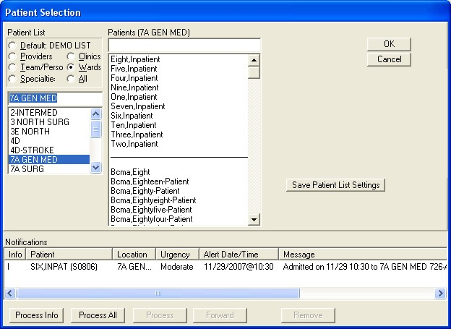

### Assessment of To-Be Changes to Print Patient List

#### Description of Recommendations

In order to verify the clinician suggestions iterated in Section 2.1.1, the BI Team incorporated the following recommended modifications into the CPRS Patient Selection Screen and patient list:

* Modify the CPRS Patient Selection Screen to include a button to print the clinician’s patient list (RCMD PPL #001).
* Modify the list to display basic information tailored to clinician preference (e.g., an outpatient clinician could see complete/incomplete status and appointment times while an inpatient clinician could view patient location and priority status) (RCMD PPL #002).

For a visual representation of these recommendations please see Figures 2 and 3 below.

#### To-Be Screen Shots

The To-Be model of the Patient Selection screen (Figure 2) maintains current CPRS functionality but allows a clinician to instantly print a patient list by pressing the Print Patient List button. Clinicians also have the option of entering a dashboard (discussed in Section 2 below) by pressing an added Dashboard button.

**Figure 2. To-Be model of the CPRS Patient Selection screen**

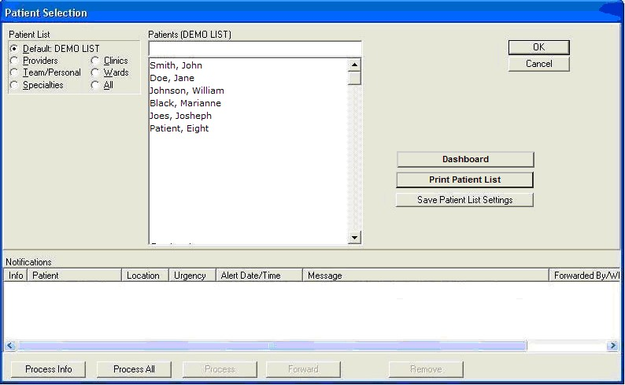

Figure 3 shows two possible options for a patient list. The first is for inpatient clinicians and shows the patient name, location, and priority status (for further information on priority status, please see the Dashboard in Section 3.1.2 below). The second example is for outpatient clinicians and shows the patient name, appointment time, and encounter completion status. Ideally and within reason, clinicians would be able to set preferences as to what information they wanted printed on this list. Also, if the list is printed from the Dashboard (discussed in Section 3.1.2 below), the order of the patients would reflect the order on the Dashboard.

**Figure 3. To-Be model of an inpatient list and an outpatient list**

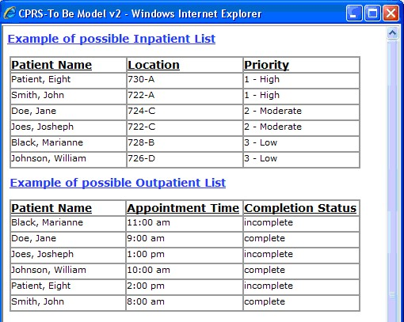

#### To-Be Scenario

The BI Team captured the steps a clinician would use to print a patient list and created the To-Be scenario shown in Table 2. The BI Team then verified that the changes could potentially increase clinician efficiency by executing a timing study between the As-Is scenario and the To-Be scenario (see the Impacts Section below).

**Table 2. To-Be Scenario Instructions for Printing a Patient List**

|  |  |  |
| --- | --- | --- |
| **Step** | **Description** | **Clicks** |
| 1. | From the Patient Select screen, press the Print Patient List button | 1 |
| 2. | Close the patient list | 1 |
|  | **Total Clicks** | **2** |

### Impacts

Findings from the impact analysis are broken down in to three categories: clinical impact, time and keystroke efficiencies and task ranking. The following sections provide commentary on the specific findings.

#### Clinical Impact

The clinical impacts of the recommended changes are based on clinician comments and insights recorded during the two site visits.

The key clinical benefits of implementing the recommended changes to printing a patient list and the Patient Selection screen are:

Eliminates the need to leave the CPRS environment;



Potentially reduces the amount of time spent on administrative tasks (fewer keystrokes); and

Promotes ease-of-use of the system (single button access).



#### Time and Keystroke Efficiencies

The BI Team conducted an execution timing comparison study utilizing task scenarios representing the As-Is and To-Be states. The analysis showed that the execution timesaving for the To-Be scenario was on average 49 seconds plus or minus 9 seconds.

Table 3 shows a summary of the results. Full calculations and statistical definitions are provided in Appendixes B and G.

**Table 3. Time Data Results for Execution Timings for Printing a Patient List**

|  |  |  |  |  |  |
| --- | --- | --- | --- | --- | --- |
| **Scenario** | **Sample Size** | **Mean**  **Execution Time**  **(Seconds)** | **Difference between the Means**  **(Seconds)** | **Lower 95%**  **Confidence**  **Interval**  **(Seconds)** | **Upper 95%**  **Confidence**  **Interval**  **(Seconds)** |
| As-Is | 30 | 55 |  |  |  |
| To-Be | 30 | 6 |  |  |  |
|  |  |  | **49** | 40 | 58 |

The BI Team also calculated keystroke differentials between the To-Be and As-Is scenarios and found there to be a 90 percent reduction between the current CPRS system and the recommended changes to accomplish the same task (Table 4).

**Table 4. Keystroke Count for Printing a Patient List**

|  |  |
| --- | --- |
| **Scenario** | **Keystrokes** |
| As-Is | 21 |
| To-Be | 2 |
| **Difference** | **19** |

#### Task Ranking

The BI Team asked clinicians to rank from one to eight (with one being the most important) the eight ―To-Be‖ solution tasks in terms of importance to the individual clinician.

The Print Patient List task ranked in the lower half of order preference for both nurses and doctors.

* Of the 18 nurses, only one ranked it a 1, while seven ranked it an 8 and six ranked it a 7.

The remaining four ranked it either a 4 or 5.

* Of the 16 doctors, none ranked it a one, four ranked it between a 3 and 4 and eleven ranked it between 5 and 8.

### Requirements Statements

Based on the key findings, the BI Team has prepared a set of recommended requirements for VHA consideration.

* The system shall provide the ability to print a list of patients from the patient select screen (REQ PPL #001).
* The system shall provide the ability to print a list of the clinician’s assigned patients (REQ PPL #002).
* The system shall provide the ability to print a patient list based on location (REQ PPL #003).
* The system shall provide the ability to print a date specific list of patients scheduled for a specific outpatient clinic (REQ PPL #004).
* The system shall print a patient list that contains the appointment times for each outpatient (REQ PPL #005).
* The system shall print a patient list that contains the completion status for each outpatient (REQ PPL #006).
* The system shall print a patient list that contains the location for each inpatient (REQ PPL #007).
* The system shall print a patient list that contains the priority level for each inpatient (REQ PPL #008).
* The system shall print the patient list in a logical grouping (REQ PPL #009).

### Supporting Data

The supporting data, detailed analysis, and relevant references are found in Appendixes A-E.

## Recommended Modifications to CPRS – addition of a Dashboard

The recommendations provided in this section focus on the ―Dashboard Functionality‖ highvalue, frequently performed task. It addresses the accessing of information from multiple patients as performed by VHA clinicians in the inpatient settings that were observed during the site visits conducted for this analysis.

### Assessment of As-Is State of Dashboard Functionality

#### Clinician Feedback

During the initial observations and subsequent discussions, clinician feedback provided the suggestion to create a dashboard that would display high level, patient-specific clinical information for a group of patients. The suggested changes are:

Display multiple patients’ data to allow for quick triaging of patients and easy prioritization of the day’s clinician responsibilities; Highlight critical or abnormal values; and



Provide clinicians the ability to customize the display of patient data.

Incorporating these suggested changes would allow for a quicker assessment of multiple patients, reduce keystrokes and provide an overall view of a clinician’s patients. Clinicians theorize that these changes will increase their efficiency while triaging the day’s patients and allow more time for patient care.

#### As-Is Scenario

To document the projected efficiencies related to the recommended changes, the BI Team devised a pair of parallel scenarios that represent the task of a clinician viewing data for multiple patients at a time. The first scenario, which is described in this section, mimics current CPRS functionality (As-Is) while the other represents the recommended changes (To-Be).

The As-Is scenario shown in Table 5 shows one example of the steps a clinician would have to take to view information for one patient and then immediately check information for another patient. As the scenario shows, a clinician must continuously select the new patient to navigate through multiple charts.

**Table 5. As-Is scenario for viewing information for more than one patient in a single interaction with CPRS**

|  |  |  |  |
| --- | --- | --- | --- |
| **Step** | **Description** |  | **Clicks** |
| 1. | Starting from the Patient Select Screen, select the first patient |  | 2 |
| 2. | Click on the ―Labs‖ Tab |  | 1 |
| 3. | View first lab value |  | - |
| 4. | Select the second patient |  | 4 |
| 5. | Select the cover page |  | 1 |
| 6. | Open the first ―Vitals‖ value |  | 1 |
| 7. | Close the vitals information screen |  | 1 |
|  |  | **Total Clicks** | **10** |

#### As-Is Screen Shot

CPRS does not currently have a dashboard therefore there is no screen shot available. Though the BI Team acknowledges that there is a dashboard in the VistA care management package, clinician feedback from the site visits indicate that it was not used for a variety of reason. This includes reasons such as: the dashboard was not fully launched or advertised in certain sites; when an alert is resolved in Care Management it does not resolve in CPRS; a clinician must leave CPRS to use it, and there has been no formal training offered on the use of the dashboard.

### Assessment of To-Be Changes to Dashboard Functionality

#### Description of Recommendations

In order to verify the clinician suggestions iterated in Section 2.2.1, the BI Team incorporated the following recommended modifications into the To-Be model:

Modify CPRS to contain a single dashboard screen that displays multiple patients’ data (RCMD DB #001).



Highlight critical individual patient information (RCMD DB #002).



Allow clinicians to specify the Dashboard data columns (RCMD DB #003).

Allow clinicians to set data retrieval parameters (RCMD DB #004).

Allow clinicians to see expanded data from Dashboard links (RCMD DB #005).

Allow clinicians to sort information by specific column headers (RCMD DB #006). Link the dashboard to the patient selection screen (RCMD DB #007).

For a visual representation of these recommendations please see Figures 4-7 below.

#### To-Be Screen Shots

Figure 4 represents a possible customization screen, which would allow a clinician to choose the patient information they would like to have displayed on the dashboard by clicking or unclicking a box next to column choices. The model also allows a clinician to choose which clinician’s last note would be displayed and the date range for lab and vitals results display. Once this is set, it would become the default view for the clinician. Alternatively, changes could be made to allow clinicians to right click on the dashboard in order to add or delete columns.

**Figure 4. To-Be model of the Dashboard Customization screen**

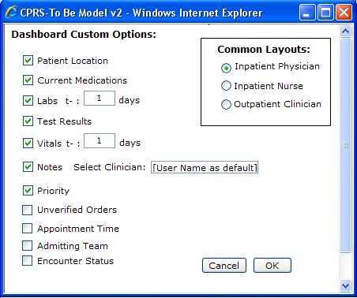

Figure 5 is one possible example of an inpatient physician’s dashboard. The dashboard contains columns for the patient name, admitting diagnosis, patient location, current medications, labs, test results, vitals, physician’s last note and patient priority. When a link in a column is selected the data appears in the lower half of the screen.

**Figure 5. To-Be model of a possible inpatient physician’s Dashboard**

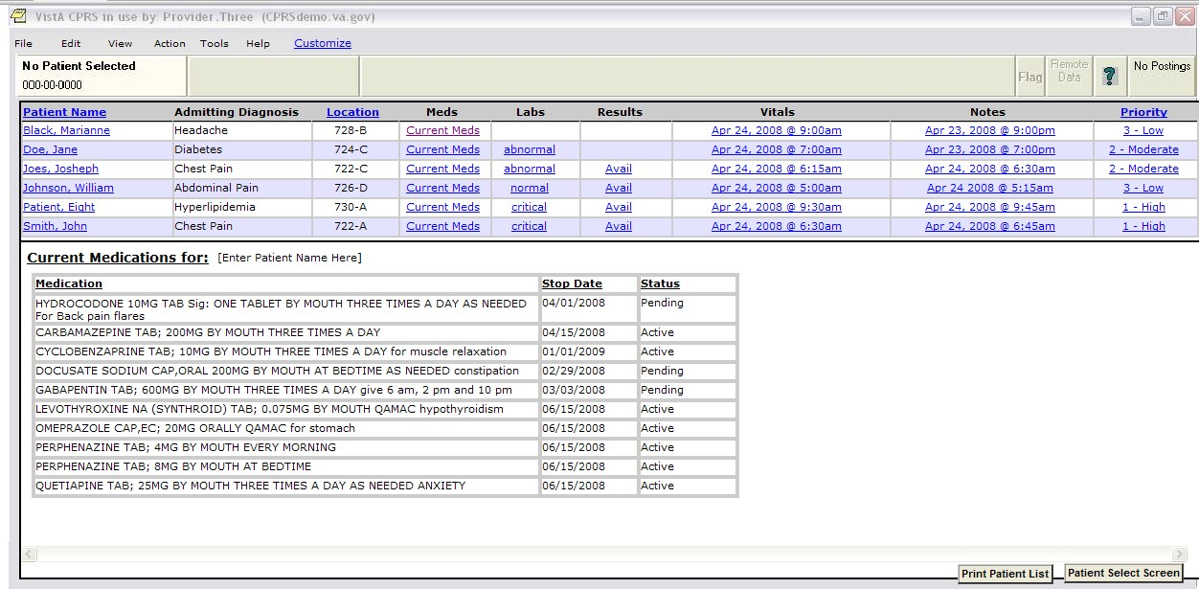

Figure 6 is one possible example of an inpatient nurse’s dashboard. The dashboard contains columns for the patient name, admitting diagnosis, patient location, current medications, labs, STAT and unverified orders, vitals, attending physician’s last note and patient priority. When a link in a column is selected the data appears in the lower half of the screen.

**Figure 6. To-Be model of a possible inpatient nurse’s Dashboard**

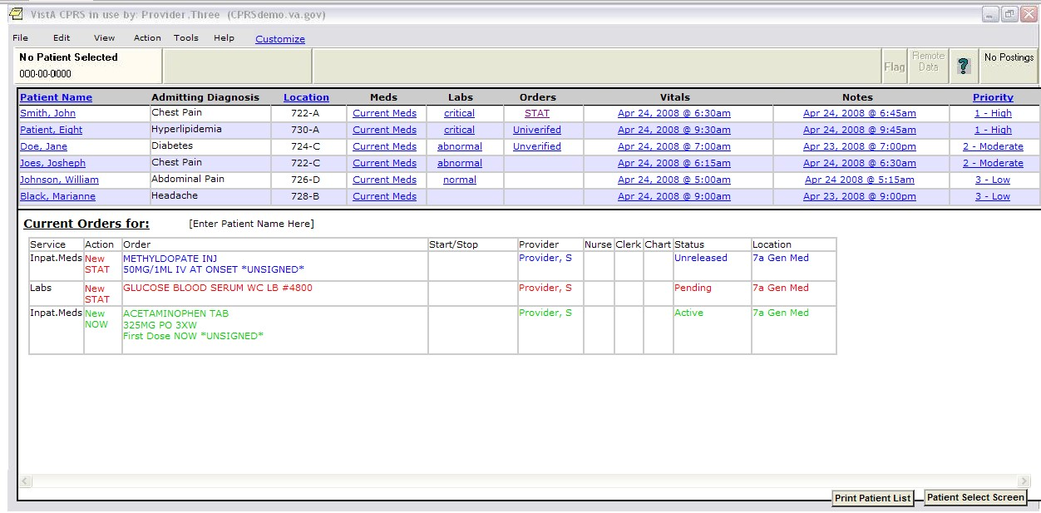

Figure 7 is one possible example of an outpatient clinician’s dashboard. The dashboard contains columns for the patient name, appointment time current medications, labs, encounter status and physician’s last note. When a link in a column is selected, the data appears in the lower half of the screen.

**Figure 7. To-Be model of a possible outpatient clinician’s Dashboard**

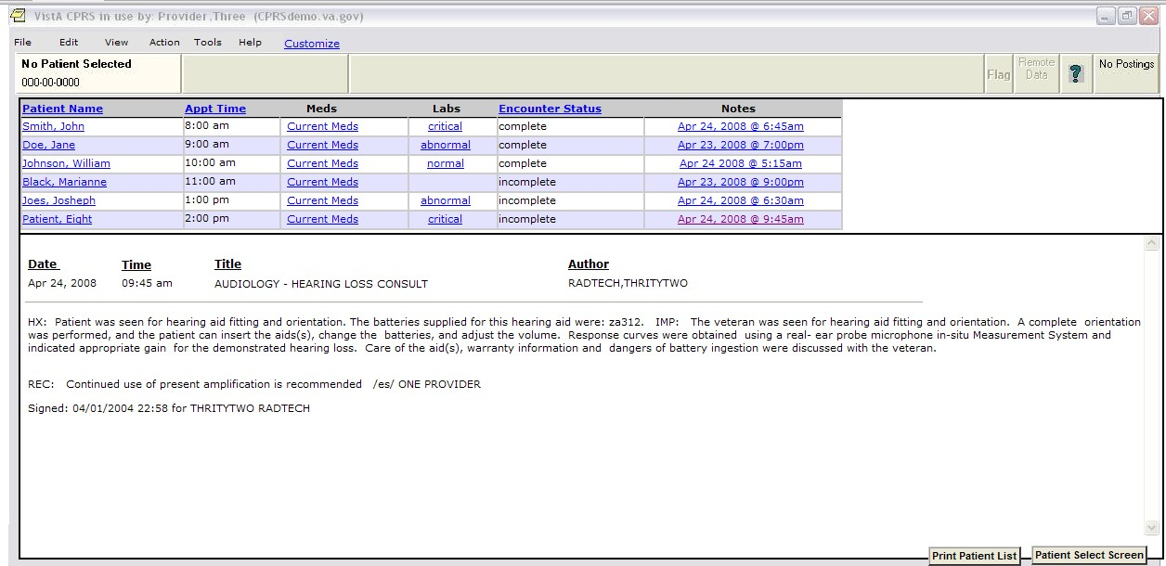

#### To-Be Scenario

The BI Team captured the changes to the steps a clinician would use to access multiple patients' information and created the To-Be scenario shown in Table 6. As the scenario demonstrates, a clinician can access different information for different patients without leaving the dashboard. The BI Team then verified that the changes had the potential of increasing clinician efficiency by executing a timing study between the As-Is scenario and the To-Be scenario (see the Impacts Section 2.2.3 below).

**Table 6. To-Be scenario for viewing information for more than one patient in a single interaction with CPRS**

|  |  |  |  |
| --- | --- | --- | --- |
| **Step** | **Description** |  | **Clicks** |
| 1. | From the Patient Select Screen, press the ―Dashboard‖ button |  | 1 |
| 2. | Order the patients by ―Patient Name‖ |  | 1 |
| 3. | Select the ―Labs‖ result link for Doe, Jane |  | 1 |
| 4. | View first lab value |  | - |
| 5. | Select the ―Vitals‖ result link for Patient, Eight |  | 1 |
| 6. | View the first vitals value |  | - |
|  |  | **Total Clicks** | **4** |

### Impacts

Findings from the impact analysis are broken down into three categories: clinical impact, time and keystroke efficiencies and task ranking. The following sections provide commentary on the specific findings.

#### Clinical Impact

The clinical impact of the recommended changes is based on clinician comments and insights recorded during the two rounds of site visits.

The key clinical benefits of implementing a dashboard are:

Quicker triaging of patients (better visualization of critical data);



Quicker analysis of patient data (fewer keystrokes and less searching); and Customization potentially increases utilization (tailored to clinician).

#### Time and Keystroke Efficiencies

The BI Team conducted an execution timing comparison study utilizing task scenarios representing the As-Is and To-Be states. The analysis showed that the execution timesaving for the To-Be scenario was on average 14 seconds plus or minus 4 seconds.

Table 7 results shows a summary of the results with full calculations and statistical definitions provided in Appendixes B and G.

**Table 7. Time Data Results for Execution Timings for viewing information for more than one patient in a single interaction with CPRS**

|  |  |  |  |  |  |
| --- | --- | --- | --- | --- | --- |
| **Scenario** | **Sample Size** | **Mean**  **Execution Time**  **(Seconds)** | **Difference between the Means**  **(Seconds)** | **Lower 95%**  **Confidence**  **Interval**  **(Seconds)** | **Upper 95%**  **Confidence**  **Interval**  **(Seconds)** |
| As-Is | 34 | 37 |  |  |  |
| To-Be | 34 | 23 |  |  |  |
|  |  |  | **14** | 10 | 18 |

The BI Team also calculated keystroke differentials between the To-Be and As-Is scenarios and found there to be a 60 percent reduction between the current CPRS system and recommended changes to accomplish the same task (Table 8).

**Table 8. Keystroke Count for viewing information for more than one patient in a single interaction with CPRS**

|  |  |
| --- | --- |
| **Scenario** | **Keystrokes** |
| As-Is | 10 |
| To-Be | 4 |
| **Difference** | **6** |

#### Task Ranking

The BI Team asked clinicians to rank from one to eight (with one being the most important) the eight ―To-Be‖ solution tasks in terms of importance to the individual clinician.

The Dashboard Functionality task ranked in the upper half of order preference for both nurses and doctors.

* Of the 18 nurses, eight ranked it a 1 or 2 while five ranked it a 5 or above. The remaining four ranked it a 7.
* Of the 16 doctors, six ranked it a 1 or 2 while nine ranked it a 5 or above. The remaining individual ranked it a 7.

### Requirements Statements

Based on the key findings, BI has prepared a set of recommended requirements for VHA consideration.

* The Dashboard shall display patients selected on the patient selection screen (REQ DB #001).

The system shall maintain role based default configurations (REQ DB #002). The system shall display a dashboard of clinicians’ assigned patients (REQ DB #003). The system shall display multiple patients on a single dashboard (REQ DB #004).



The system shall provide the ability to sort data (REQ DB #005).

The system shall display sorted patient data in a logical format (REQ DB #006).

The system shall allow clinicians to set data retrieval parameters (REQ DB #007).

The system shall provide a link to the patient selection screen (REQ DB #008).

The system shall allow clinicians to customize the dashboard screen (REQ DB #009). The system shall allow clinicians to customize the dashboard list of patients by inpatient location (REQ DB #010).

* The system shall allow clinicians to customize the dashboard list of patients by outpatient location (REQ DB #011).

The system shall display the patient’s name (REQ DB #012).



The system shall display the patient’s admitting diagnosis (REQ DB #013).

The system shall display the patient’s room number (REQ DB #014).

The system shall display the patient encounter status as complete or incomplete (REQ DB #015).

The system shall display a link to a patient's list of current medications (REQ DB #016). The system shall provide the ability to view the patient's list of medications when the link is clicked (REQ DB #017).



The system shall display a link to the patient's laboratory results (REQ DB #018). The system shall provide the ability to view the patient's laboratory results when the link is clicked (REQ DB #019).



The system shall display a link to the patient's vital signs (REQ DB #020).



The system shall display the vital signs link with the last date and time of the vital sign (REQ DB #021).

The system shall provide the ability to view the patient's last vital signs (REQ DB #022).



The system shall display a link notes (REQ DB #023).

The system shall provide the ability for clinicians to set the default note to view (REQ DB #024).

The system shall display the default note when clicked (REQ DB #025).



The system shall display a priority level for all laboratory results (REQ DB #026). The system shall display a link to laboratory tests from the priority level

(REQ DB #027).

The system shall display the laboratory result when the link is clicked (REQ DB #028). The system shall display a priority level of high if a laboratory alert is identified as critical (REQ DB #029).



* The system shall display a priority level of one if a laboratory alert is identified as critical (REQ DB #030).
* The system shall display a priority level of moderate if a laboratory alert is identified as abnormal (REQ DB #031).
* The system shall display a priority level of two if a laboratory alert is identified as abnormal (REQ DB #032).
* The system shall display a priority level of low if a laboratory alert is identified as normal (REQ DB #033).
* The system shall display a priority level of three if a laboratory alert is identified as normal (REQ DB #034).

The system shall display an indicator when there are unverified orders (REQ DB #035).



The system shall display a link to unverified orders (REQ DB #036).

The system shall display all unverified orders when the link is clicked (REQ DB #037).

The system shall display appointment times for outpatients (REQ DB #038).

The system shall display the names of the admitting team (REQ DB #039). The system shall link the dashboard to the print patient list (REQ DB #40).

### Supporting Data

The supporting data, detailed analysis, and relevant references are found in Appendixes A-E.

## Recommended Modifications to the CPRS Cover Sheet Postings

The recommendations provided in this section focus on the ―Cover Sheet (Postings)‖ high-value, frequently performed task. It is focused on raising the visibility of selected information and eliminating the need to view additional screens (e.g., the DNR status of the patient) as performed by VHA clinicians in the inpatient and outpatient settings observed during the site visits conducted for this analysis.

### Assessment of As-Is State of Cover Sheet Postings

#### Clinician Feedback

During the initial observations and subsequent discussions, clinician feedback suggested the following:

Cover Sheet Postings section display additional information in the title of the posting in the posting’s section of the cover sheet (including but not limited to: DNR status and basic HIPAA information).



Making this change would enable the clinician to quickly confirm specific posting information providing potential timesavings and efficiencies.

#### As-Is Scenario

To document the projected efficiencies related to the recommended changes, the BI Team devised a pair of parallel scenarios that represent the task of a clinician trying to find an order. The first scenario, described below, mimics current CPRS functionality (As-Is), while the other represents the recommended changes (To-Be).

The scenario described in Table 9 represents a best-case situation in trying to determine posting information. It assumes that the information needed is actually located in the posting itself. What BI observed and what this scenario does not reflect, is that if the information exists in a scanned image, a clinician must go into VistA imaging to retrieve the necessary information. The purpose of this scenario is to highlight efficiencies in the use of well-placed first-glance data.

**Table 9. As-Is Scenario Instructions for Finding Specific Posting Information**

|  |  |  |  |
| --- | --- | --- | --- |
| **Step** | **Description** |  | **Clicks:** |
| 1. | From the cover sheet, re-select the first patient |  | 4 |
| 2. | Open the Advanced Directive posting |  | 1 |
| 3. | Close information screen |  | 1 |
|  |  | **Total Clicks** | **6** |

#### As-Is Screen Shot

Figure 8 is a screen capture of the current state of the Postings section of the Cover Sheet screen. As is evidenced by the screen capture, currently a clinician must click on the posting title in order to ascertain a patient’s posting information (e.g., DNR, HIPAA or PCP information). In the best case scenario the information will be contained in the pop-up window (Figure 9 below).

**Figure 8. As-Is example of a default view of the Postings section of CPRS Cover Sheet screen.**

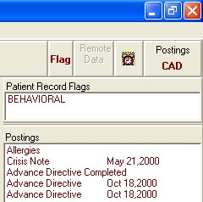

Figure 9 displays a pop-up window containing specific information regarding a patient’s posting information. In this example, the information screen states explicitly that the patient does not wish to be resuscitated.

**Figure 9. As-Is example of a Postings Pop-up Information Window.**

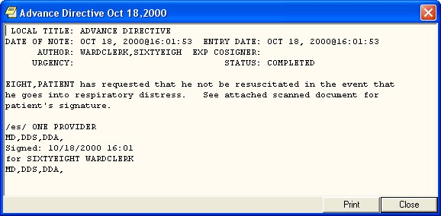

Figure 10 is an example of a posting’s information pop-up window that does not contain the specific information regarding the patient’s posting but rather directs the clinician to VistA imaging.

**Figure 10. As-Is example of a Postings Pop-up Information Window.**

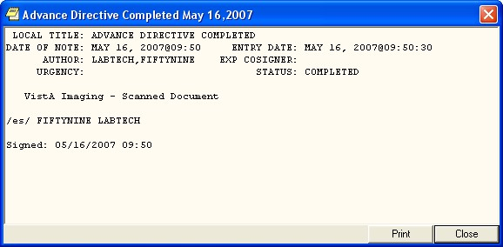

### Assessment of To-Be Changes to Cover Sheet Postings

#### Description of Recommendations

In order to verify the clinician suggestions iterated in Section 2.3.1, the BI Team incorporated the following recommended modifications into the To-Be model Cover Sheet Postings:

* Modify the Posting’s section to include specific DNR status information in the Advanced Directives record header (RCMD CS #001).
* Modify the Posting’s section to include the HIPAA designees’ information in the HIPAA record header (RCMD CS #002).
* Modify the Posting’s section to include the patient’s non-VA Primary Healthcare Provider (PCP) name and phone number in the Non-VA PCP record header (RCMD CS #003).

For a visual representation of these recommendations please see Figure 11.

#### To-Be Screen Shot

As Figure 11 shows, the To-Be postings section gives more first glance information in the each posting’s title, including the Advanced Directive status, HIPAA designees, and Non-VA Primary Care physician name and number. Details and scanned image information will still be designated in the posting information pop-up window.

**Figure 11. To-Be model of the Postings section on the CPRS Cover Sheet screen.**

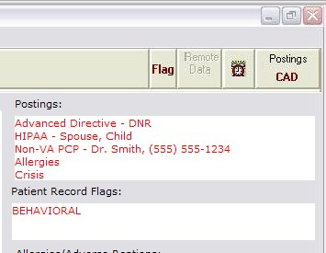

#### To-Be Scenario

The BI Team captured the changes to the steps a clinician would use to find certain posting information and created the To-Be scenario shown in Table 10. The BI Team then verified that the changes had the potential of increasing clinician efficiency by executing a timing study between the As-Is scenario and the To-Be scenario (see the Impacts Section 2.3.3 below).

**Table 10. To-Be Scenario Instructions for Finding Specific Posting Information**

|  |  |  |  |
| --- | --- | --- | --- |
| **Step** | **Description** |  | **Clicks** |
| 1. | From the Dashboard, select the link for Patient, Eight |  | 1 |
| 2. | View HIPAA approved persons |  | - |
|  |  | **Total Clicks** | **1** |

### Impacts

Findings from the impact analysis are broken down in to three categories: clinical impact, time and keystroke efficiencies and task ranking. The following sections provide commentary on the specific findings.

#### Clinical Impact

The clinical impact of the recommended changes is based on clinician comments and insights recorded during the two site visits.

The key clinical benefits of implementing the recommended changes to the Cover Sheet Postings are:

Quicker access to information (increased timesaving);



Less searching time; and

Quicker confirmation of specific posting information.

**Time and Keystroke Efficiencies:**

The BI Team conducted an execution timing comparison study utilizing task scenarios representing the As-Is and To-Be states. The analysis showed that the execution timesaving for the To-Be scenario was on average 15 seconds plus or minus 7 seconds.

Table 11 shows a summary of the results. Full calculations and definitions are provided in Appendixes B and G.

**Table 11. Time Data Results for Execution Timings for Finding Specific Posting Information**

|  |  |  |  |  |  |
| --- | --- | --- | --- | --- | --- |
| **Scenario** | **Sample Size** | **Mean**  **Execution Time**  **(Seconds)** | **Difference between the Means**  **(Seconds)** | **Lower 95%**  **Confidence**  **Interval**  **(Seconds)** | **Upper 95%**  **Confidence**  **Interval**  **(Seconds)** |
| As-Is | 34 | 21 |  |  |  |
| To-Be | 34 | 6 |  |  |  |
|  |  |  | **15** | 8 | 21 |

The BI Team also calculated keystroke differentials between the To-Be and As-Is scenarios and found there to be an 83 percent reduction between the current CPRS system and recommended changes to accomplish the same task (Table 12).

**Table 12. Keystroke Count for Finding Specific Posting Information**

|  |  |
| --- | --- |
| **Scenario** | **Keystrokes** |
| As-Is | 6 |
| To-Be | 1 |
| **Difference** | **5** |

#### Task Ranking

The BI Team asked clinicians to rank from one to eight (with one being the most important) the eight ―To-Be‖ solution tasks in terms of importance to the individual clinician.

The Cover Sheet (Postings) task ranked in the lower half of order preference for both nurses and doctors.

Of the 18 nurses, ten ranked it a 4 or above, and eight ranked it between a 5 and 7.



Of the 16 doctors, eleven ranked it a five, six, seven or eight, four ranked it a 3 or 4 and on one individual ranked it a 1.

### Requirements Statements

Based on the key findings, the BI Team has prepared a set of recommended requirements for VHA consideration.

* The system shall display ―DNR‖ within the record header of the Posting’s section, in the patient’s cover sheet, if a do not resuscitate order has been written (REQ CS #001).
* The system shall display the patient’s HIPAA designee within the record header of the Posting’s section, in the patient’s cover sheet (REQ CS #002).
* The system shall display the patient’s non-VA Primary Healthcare Provider (PCP) within the record header of the Posting’s section, in the patient’s cover sheet (REQ CS #003).

### Supporting Data

The supporting data, detailed analysis, and relevant references are found in Appendixes A-E.

## Recommended Modifications to CPRS Cover Screen

The recommendations provided in this section focus on the ―Cover Sheet (Functionality)‖ highvalue, frequently performed task. It addresses the functionality of the Cover Sheet as performed by VHA clinicians in the inpatient settings that were observed during the site visits conducted for this analysis.

### Assessment of As-Is State of CPRS Cover Sheet Screen Functionality

#### Clinician Feedback

During the initial observations and subsequent discussions, clinicians provided suggested changes to the Cover Sheet screen that would afford potential clinician timesavings and further improve patient care. The suggested changes are:

* Increase the functionality of the Cover Sheet screen in order to decrease the need to leave the Cover Sheet screen; and
* Modify the information on the Cover Sheet screen to make it more informative (e.g., add the lab values as opposed to collection time).

Incorporating these recommended changes would move some of the current functionality from the Tabs to the Cover Sheet and provide further first glance information to the screen thus enabling the clinician to conduct the patient encounter without leaving the cover screen and reducing keystrokes. Clinicians theorize that these changes will increase their efficiency while interacting with the system and allow more time for patient care.

#### As-Is Scenario

To document the projected efficiencies related to the recommended changes, the BI Team devised a pair of parallel scenarios that represent the task of a clinician trying to find an order. The first scenario below mimics current CPRS functionality (As-Is), while the other represents the recommended changes (To-Be).

The scenario in Table 13 describes the steps a clinician would need to change a medication based on information found on the Cover Sheet screen. As is indicated by the scenario, a clinician cannot change the medication order from the Cover Sheet but must go to the medications screen (or orders screen) to do so.

**Table 13. As-Is Scenario Instructions for changing a medication order from the Cover Sheet screen**

|  |  |  |  |
| --- | --- | --- | --- |
| **Step** | **Description** |  | **Clicks:** |
|  | From the cover sheet, click on the first medication |  | 1 |
|  | Note the dosage |  | - |
|  | Close the medication information screen |  | 1 |
|  | Click on the Meds tab |  | 1 |
|  | Highlight first medication |  | 1 |
|  | Right click |  | 1 |
|  | Select ―change‖ |  | 1 |
|  | Select ―cancel‖ |  | 1 |
|  |  | Total Clicks | 7 |

#### As-Is Screen Shot

The current CPRS Cover Screen, as shown in Figure 12, contains non-interactive information. A clinician can click on a listing to get more information but in order to act upon that information (e.g. create a new order or change a medication), a clinician must go into one of the other tabbed screens.

**Figure 12. As-Is example of a default view of the CPRS Cover Sheet screen.**

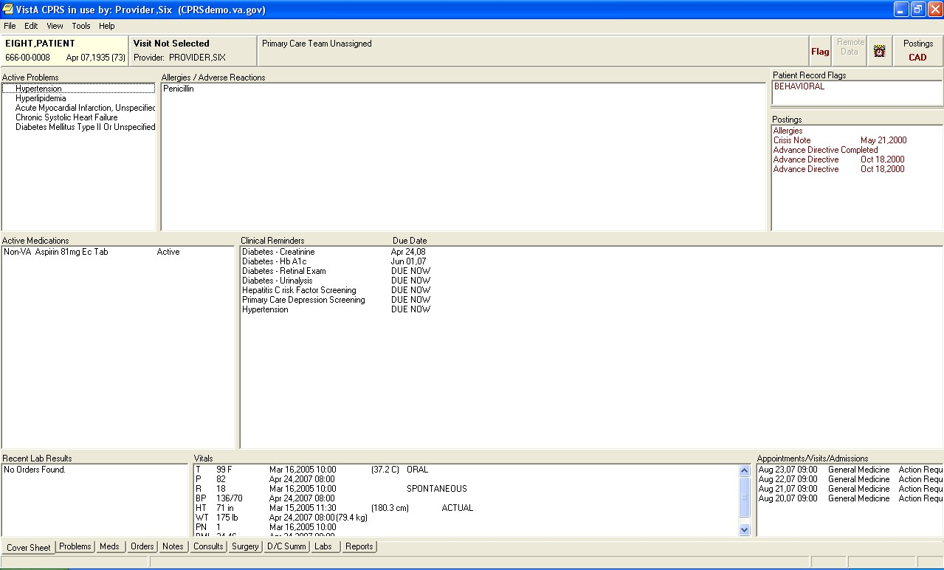

### Assessment of To-Be Changes to the CPRS Cover Sheet Screen

#### Description of Recommendations

In order to verify the clinician suggestions iterated in Section 2.4.1, the BI Team incorporated the following recommended modifications into the To-Be model Cover Sheet screen:

* Provide clinicians with the same ability to view the details and administration history, change, discontinue, refill, renew or create a medication order with the same shortcut menu selections that are currently available when right clicking highlighted medications on the CPRS Medications screen (RCMD CSF #001).
* Provide the clinicians with the same ability to view the details, results, results history, change, change release event, copy to new order, discontinue, renew or sign a laboratory order with the same shortcut menu selections that are currently available when right clicking highlighted orders on the CPRS Orders screen (RCMD CSF #002). Allow a clinician to start, edit an unsigned note and sign a new note from the cover screen (RCMD CSF #003).



* Display actual lab results as opposed to collection dates (RCMD CSF #004).

For a visual representation of these recommendations please see Figures 12 and 13.

#### To-Be Screen Shots

The To-Be model of the CPRS Cover Screen (Figure 13) contains more functionality than currently exists. As in current CPRS functionality, a clinician can click on a data point to get more information; however, the To-Be model allows a clinician to act upon that information, such as order a new lab or change a medication, from the pop-up information window. The new cover sheet also allows a clinician to view the last note or start and edit a new note as well as sign all new orders, all without leaving the cover sheet screen.

**Figure 13. To-Be example of a default view of the CPRS Cover Sheet screen.**

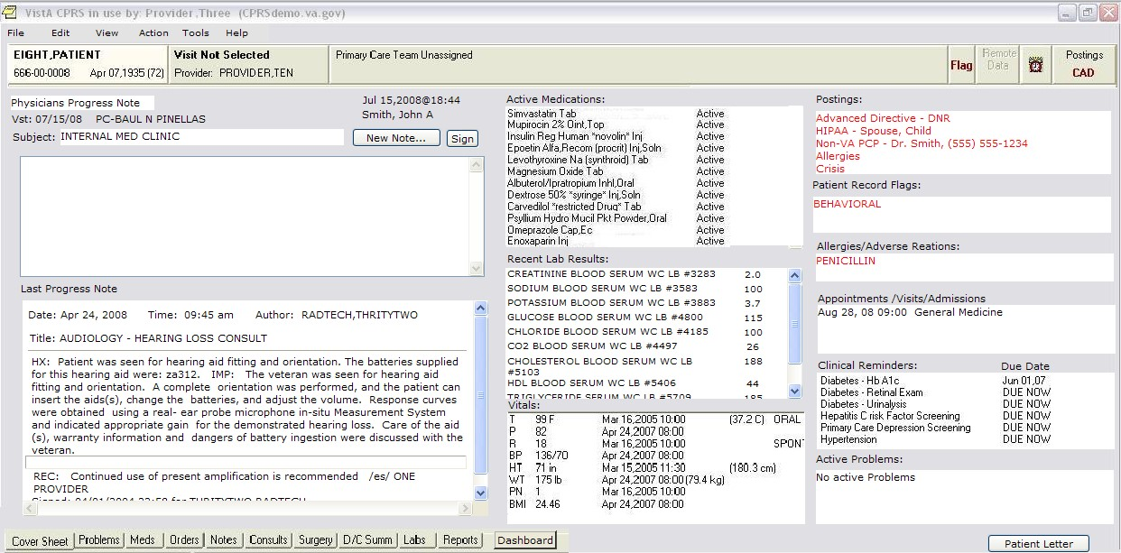

Figure 14 shows an example of a redesigned Medication Information screen. When a clinician right clicks on the information screen an option menu appears and allows the clinician to have the same functionality as right clicking on a medication on the main Medication screen. The same would be true if a clinician clicked on a lab or vital on the coversheet.

**Figure 14. Be example of a Medication Information screen with option menu.**

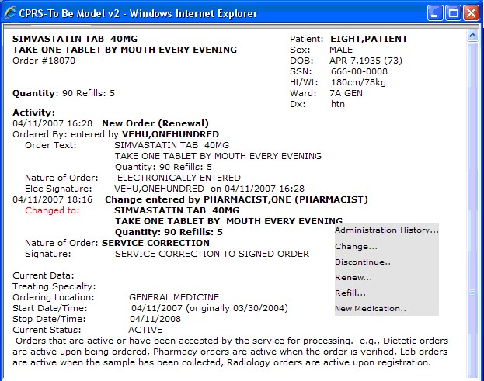

#### To-Be Scenario

The BI Team captured the changes to the steps a clinician would use to change a medication starting from the Cover Screen and created the To-Be scenario shown in Table 14. The BI Team then verified that the changes had the potential of increasing clinician efficiency by executing a timing study between the As-Is scenario and the To-Be scenario (see Impacts below).

**Table 14. To-Be Scenario Instructions for changing a medication from the Cover Sheet screen**

|  |  |  |  |
| --- | --- | --- | --- |
| **Step** | **Description** |  | **Clicks** |
| 1. | From the cover sheet, click on the first Medication |  | 1 |
| 2. | Note the dosage |  | - |
| 3. | Right click |  | 1 |
| 4. | Select ―change‖ |  | 1 |
| 5. | Select cancel |  | 1 |
|  |  | **Total Clicks** | **4** |

### Impacts

Findings from the impact analysis are broken down in to three categories: clinical impact, time and keystroke efficiencies and task ranking. The following sections provide commentary on the specific findings.

#### Clinical Impact

The clinical impact of the recommended changes is based on clinician comments and insights recorded during the two rounds of site visits.

The key clinical benefits of decreasing the need to leave the Cover Sheet screen during a patient encounter results in:

Reduction of system interaction time to complete a task (fewer keystrokes); and Increase ease of use (information is visible while a clinician is performing other functions).



#### Time and Keystroke Efficiencies

The BI Team conducted an execution timing comparison study utilizing task scenarios representing the As-Is and To-Be states. The analysis showed that the execution timesaving for the To-Be scenario was on average 19 seconds plus or minus 6 seconds.

Table 15 shows a summary of the results. Full calculations and statistical definitions are provided in Appendixes B and G.

**Table 15. Time Data Results for Execution Timings for changing a medication order from the Cover Sheet screen**

|  |  |  |  |  |  |
| --- | --- | --- | --- | --- | --- |
| **Scenario** | **Sample Size** | **Mean**  **Execution Time**  **(Seconds)** | **Difference between the Means**  **(Seconds)** | **Lower 95%**  **Confidence**  **Interval**  **(Seconds)** | **Upper 95%**  **Confidence**  **Interval**  **(Seconds)** |
| As-Is | 34 | 34 |  |  |  |
| To-Be | 34 | 15 |  |  |  |
|  |  |  | **19** | 13 | 25 |

The BI Team also calculated keystroke differentials between the To-Be and As-Is scenarios and found there to be a 43 percent reduction between the current CPRS system and recommended changes to accomplish the same task (Table 16).

**Table 16. Keystroke Count for changing a medication order from the Cover Sheet screen**

|  |  |
| --- | --- |
| **Scenario** | **Keystrokes** |
| As-Is | 7 |
| To-Be | 4 |
| **Difference** | **3** |

#### Task Ranking

The BI Team asked clinicians to rank from one to eight (with one being the most important) the eight ―To-Be‖ solution tasks in terms of importance to the individual clinician.

The Cover Sheet (Functionality) task ranked highest overall by doctors and nurses.

Of the 18 nurses, eleven ranked it a 1 or a 2, the remaining seven ranked it above a 6. Of the 16 doctors, half ranked it a 1 or a 2, the remaining ranked it 5 or above.



### Requirements Statements

Based on the key findings, BI has prepared a set of recommended requirements for VHA consideration.

* The system shall provide clinicians with the same ability to view the details and administration history utilizing the current shortcut menu selections that are available when right clicking highlighted medications on the CPRS Medications screen (REQ CSF #001).
* The system shall provide clinicians with the same ability to discontinue a medication utilizing the current shortcut menu selections that are available when right clicking highlighted medications on the CPRS Medications screen (REQ CSF #002).
* The system shall provide clinicians with the same ability to refill a medication order utilizing the current shortcut menu selections that are available when right clicking highlighted medications on the CPRS Medications screen (REQ CSF #003). The system shall provide clinicians with the same ability a renew a medication order utilizing the current shortcut menu selections that are available when right clicking highlighted medications on the CPRS Medications screen (REQ CSF #004).



* The system shall provide clinicians with the same ability create a medication order utilizing the current shortcut menu selections that are available when right clicking highlighted medications on the CPRS Medications screen (REQ CSF #005).
* The system shall provide clinicians with the same ability to view the details of a laboratory order utilizing the current shortcut menu selections that are available when right clicking highlighted orders on the CPRS Orders screen (REQ CSF #006).
* The system shall provide clinicians with the same ability to view results history of a laboratory order utilizing the current shortcut menu selections that are available when right clicking highlighted orders on the CPRS Orders screen (REQ CSF #007). The system shall provide clinicians with the same ability to change a medication order utilizing the current shortcut menu selections that are available when right clicking highlighted orders on the CPRS Orders screen (REQ CSF #008).



* The system shall provide clinicians with the same ability to change a laboratory order utilizing the current shortcut menu selections that are available when right clicking highlighted orders on the CPRS Orders screen (REQ CSF #09).
* The system shall provide clinicians with the same ability to change a release event of a laboratory order utilizing the current shortcut menu selections that are available when right clicking highlighted orders on the CPRS Orders screen (REQ CSF #010).
* The system shall provide clinicians with the same ability to copy to new laboratory order utilizing the current shortcut menu selections that are available when right clicking highlighted orders on the CPRS Orders screen (REQ CSF #011).
* The system shall provide clinicians with the same ability to discontinue a laboratory order utilizing the current shortcut menu selections that are available when right clicking highlighted orders on the CPRS Orders screen (REQ CSF #012).
* The system shall provide clinicians with the same ability to renew a laboratory order utilizing the current shortcut menu selections that are available when right clicking highlighted orders on the CPRS Orders screen (REQ CSF #013).
* The system shall provide clinicians with the same ability to sign a laboratory order utilizing the current shortcut menu selections that are available when right clicking highlighted orders on the CPRS Orders screen (REQ CSF #014).
* The system shall allow clinicians to start a new note from the cover sheet screen (REQ CSF #015).
* The system shall allow clinicians to edit an unsigned note from the cover sheet screen (REQ CSF #016).
* The system shall allow clinicians to sign a note from the cover sheet screen (REQ CSF #017).
* The system shall display the actual laboratory results on the cover sheet screen (REQ CSF #018).
* The system shall not display the collection dates of the laboratory test on the cover sheet screen. (REQ CSF #019).

### Supporting Data

The supporting data, detailed analysis, and relevant references are found in Appendixes A-E.

## Recommended Modifications to CPRS Template and Consult Screens

The recommendations provided in this section focus on the ―Accessibility of Data behind Templates and Consults‖ high-value, frequently performed task. It addresses the accessing of additional information while in a template or consult as performed by VHA clinicians in the inpatient and outpatient settings that were observed during the site visits conducted for this analysis.

### Assessment of As-Is State of Templates and Consults

#### Clinician Feedback

During the initial observations and subsequent discussions, clinicians provided suggested changes to the Templates screen and the Consults screen that would provide potential clinician timesaving and further improve patient care. The suggested changes are:

* Provide the ability to access information outside of the template (either add functionality to minimize the templates or consults, or add the ability to temporarily remove focus from the template or consult); and
* Ensure that data is not lost if a template or consult is minimized or focus is temporarily removed.

Incorporating this feedback would ensure that necessary information is no more than a click or two away, and would increase efficiency by significantly decreasing the times a clinician must re-enter lost data. Clinicians theorize that these changes will increase their efficiency while interacting with the system and allow more time for patient care.

#### As-Is Scenario

To document the projected efficiencies related to the recommended changes, the BI Team devised a pair of parallel scenarios that represent the task of a clinician trying to find an order. The first scenario described below mimics current CPRS functionality (As-Is), while the other represents the recommended changes (To-Be).

**Table 17. As-Is Scenario Instructions for gathering data while completing a locally developed template**

|  |  |  |
| --- | --- | --- |
| **Step** | **Description** | **Clicks:** |
| 1. | From the cover sheet, click on the Notes tab | 1 |
| 2. | Select the _____ template* | 3 |
| 3. | Choose the first title | 2 |
| 4. | Click the first two boxes | 2 |
| 5. | Type in the following sentence in the first text box ―Lab Value‖ | - |
| 6. | Cancel the template | 1 |
| 7. | Click Labs Tabs | 1 |
| 8. | View first Lab value | - |
| 9. | Click Notes tab | 1 |
| 10. | Re-select the template | 1 |
| 11. | Choose the first title | 2 |
| 12. | Click the first two boxes | 2 |
| **Step** | **Description** | **Clicks:** |
| 13. | Type in the following sentences in the first text box ―Lab value ok‖ | - |
| 14. | Click ok | 1 |
|  | **Total Clicks** | **17** |

*The template name varied from site to site.

The scenario described in Table 17 highlights the time lost by a clinician who, while completing a template, must exit the template to seek out additional data and then re-access the template and re-enter the data in order to complete it. The potential for time and click savings increases sharply with respect to the length and complexity of the template as well as by how much of the template the clinician has completed.

#### As-Is Screen Shot

Figure 15 is an example of a locally designed template. In current CPRS functionality, once a template is opened it locks CPRS and cannot be minimized. This forces a user to complete the template or lose data by exiting the template when attempting to find information in or interact with another part of CPRS. Once a user gathers the data, the user must then reopen and reenter the data into the template.

**Figure 15. To-Be example of an active Template.**

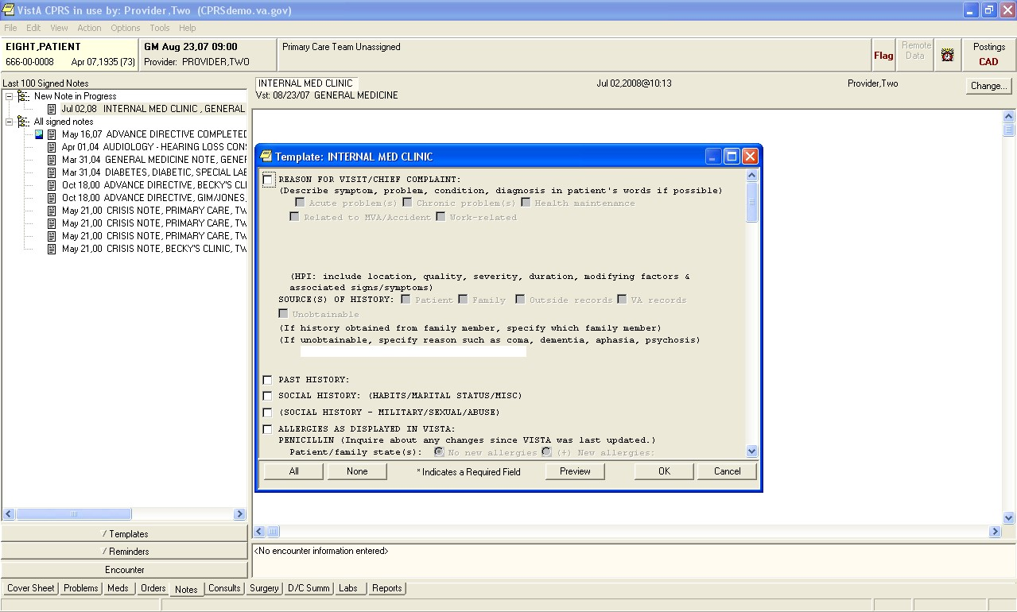

### Assessment of To-Be Changes to Templates and Consults

#### Description of Recommendations

In order to verify the clinician suggestions iterated in Section 2.5.1, the BI Team incorporated the following recommended modifications into the To-Be model Templates functionality:

* Allow clinicians to switch to other Tabs within CPRS without closing out of the template or consult (RCMD TC #001).
* Allow clinicians to change window focus and, or minimize the template or consult without losing data already entered in the template or consult (RCMD TC #002). Allow clinicians the ability to expand the template (or consult) screen itself when the template (or consult) window is maximized to the full screen (RCMD TC #003)



For a visual representation of these recommendations please see Figure 16 below.

#### To-Be Screen Shots

In the To-Be model of a template, a clinician can minimize and move the template in order to see information behind the template (or consult) and in other parts of CPRS. The clinician can then maximize the template (or consult) to complete it (Figure 16).

**Figure 16. To-Be example of a template that can be minimized.**

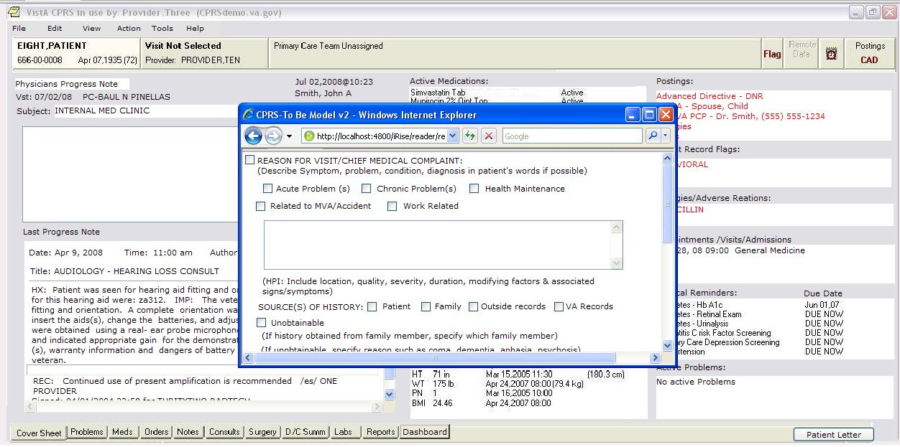

#### To-Be Scenario

The BI Team captured the changes to the steps a clinician would use to access additional patient data in CPRS while completing a locally developed template and created the To-Be scenario shown in Table 18. The BI Team then verified that the changes had the potential of increasing clinician efficiency by executing a timing study between the As-Is scenario and the To-Be scenario (see the Impacts Section below).

**Table 18. As-Is Scenario Instructions for gathering data while completing a locally developed template**

|  |  |  |  |
| --- | --- | --- | --- |
| **Step** | **Description** |  | **Clicks** |
| 1. | From the cover sheet, click on the ―Notes‖ tab |  | 1 |
| 2. | Select the ____ template* |  | 3 |
| 3. | Choose the first title |  | 2 |
| 4. | Click the first two boxes |  | 2 |
| 5. | Type in the following sentence in the first text box ―Lab value‖ |  | - |
| 6. | Minimize the template |  | 1 |
| 7. | Click ―Labs‖ Tabs |  | 1 |
| 8. | View first Lab value |  | - |
| 9. | Maximize the template |  | 1 |
| 10. | Type in the following sentence after the first sentence ―ok‖ |  | - |
| 11. | Click ok |  | 1 |
|  |  | **Total Clicks** | **12** |

*The template name changed from site to site

### Impacts

Findings from the impact analysis are broken down in to three categories: clinical impact, time and keystroke efficiencies and task ranking. The following sections provide commentary on the specific findings.

**Clinical Impact:**

The clinical impact of the recommended changes is based on clinician comments and insights recorded during the two rounds of site visits.

The key clinical benefits of implementing the recommend changes to the locally developed template and consult functionality are:

Decreases the potential for error (e.g. eliminates multiple sign-ons and manual workarounds);



Increases efficiency (eliminates the need to reenter data); and



Simplifies the process of entering data in the template and consults.

**Time and Keystroke Efficiencies:**

The BI Team conducted an execution timing comparison study utilizing task scenarios representing the As-Is and To-Be states. The analysis showed that the execution timesaving for the To-Be scenario was on average 17 seconds plus or minus 6 seconds.

Table 19 shows a summary of the results. Full calculations and definitions are provided in Appendixes B and G. It should be noted that the 17 seconds represents the "best case" scenario. Because templates are developed locally, they vary in length and complexity. The timesavings are based on closing out the template after the first two questions; observational comments indicated that in many cases template close out happens well into the completion of the template.

**Table 19. Time Data Results for Execution Timings for gathering data while completing a locally developed template**

|  |  |  |  |  |  |
| --- | --- | --- | --- | --- | --- |
| **Scenario** | **Sample Size** | **Mean**  **Execution Time**  **(Seconds)** | **Difference between the Means**  **(Seconds)** | **Lower 95%**  **Confidence**  **Interval**  **(Seconds)** | **Upper 95%**  **Confidence**  **Interval**  **(Seconds)** |
| As-Is | 34 | 71 |  |  |  |
| To-Be | 34 | 54 |  |  |  |
|  |  |  | **17** | 11 | 23 |

The BI Team also calculated keystroke differentials between the To-Be and As-Is scenarios and found there to be a 29 percent reduction between the current CPRS system and recommended changes to accomplish the same task (Table 20).

**Table 20. Keystroke Count for gathering data while completing a locally developed template**

|  |  |
| --- | --- |
| **Scenario** | **Keystrokes** |
| As-Is | 17 |
| To-Be | 12 |
| **Difference** | **5** |

#### Task Ranking

The BI Team asked clinicians to rank from one to eight (with one being the most important) the eight ―To-Be‖ solution tasks in terms of importance to the individual clinician.

The Accessibility of Data behind Templates and Consults task ranked in the upper half of order preference for both nurses and doctors.

Of the 18 nurses half ranked it a 1 or a 2, the remaining ranked it 7 or higher.



Of the 16 doctors fourteen ranked it 4 or higher, while two ranked it 6 and 7.

### Requirements Statements

Based on the key findings, BI has prepared a set of recommended requirements for VHA consideration.

* The system shall allow clinicians to switch to other Tabs within CPRS without closing the template screen (REQ TC #001).
* The system shall provide the ability for all CPRS template screens to be minimized or allow window focus to be shifted (REQ TC #002).
* The system shall provide the ability for all CPRS template screens to be maximized after having been minimized (REQ TC #003).
* The system shall remain active and provide the ability to navigate throughout the patient’s medical record when the template screen is minimized or window focus is shifted (REQ TC #004).
* The system shall provide the ability to expand template screen itself (data entry area) when the window is maximized to the full screen (REQ TC #005).
* The system shall retain any information that is entered by the clinician into the template before it is minimized or window focus is shifted (REQ TC #006).
* The system shall allow clinicians to switch to other Tabs within CPRS without closing the consult screen (REQ TC #007).
* The system shall provide the ability for all CPRS consult order screens to be minimized or allow window focus to be shifted (REQ TC #008).
* The system shall provide the ability for all CPRS consult order screens to be maximized after having been minimized (REQ TC #009).
* The system shall remain active and provide the ability to navigate throughout the patient’s medical record when the consult order screen is minimized or window focus is shifted (REQ TC #010).
* The system shall provide the ability to expand the consult order screen itself (data entry area) when the window is maximized to the full screen. (REQ TC #011).
* The system shall retain any information that is entered by the clinician into the consult order before it is minimized or window focus is shifted (REQ TC #012).

### Supporting Data

The supporting data, detailed analysis, and relevant references are found in Appendixes A-E.

## Recommended Modifications to the CPRS Medications Screen

This recommendation focuses on the Sorting and Comparing Medications high-value, frequently performed task. It addresses the portion of the medication reconciliation task that involves sorting and comparing medications as performed by VHA clinicians in the inpatient setting that were observed during the site visits conducted for this analysis.

### Assessment of As-Is State of Medications Screen

#### Clinician Feedback

During the initial observations and subsequent discussions, clinicians suggested changes to the Medication screen that would afford potential clinician timesaving and further improve patient care. The suggested changes are:

Allow for easier comparison of inpatient and outpatient medications; Allow for easier comparison of current and past medications; and Allow clinicians to sort medications with a single click.



Incorporating this feedback would change a manual process to a more automatic process and eliminate the workarounds devised by clinicians to complete this task. Clinicians theorize that these changes will increase their efficiency while interacting with the system, reduce the potential for medication errors and allow more time for patient care.

#### As-Is Scenario

The scenario for this recommendation requires no clicks as it is based on a manual process. The process for reconciling medications varied from site to site and this represents one of the many workaround processes clinicians used to reconcile medications. The reason for the manual process is that there is no automatic process in CPRS for sorting medications or instantly comparing inpatient to outpatient medications. (See Table 21.)

**Table 21. As-Is scenario for Sorting and Comparing Medications**

|  |  |  |
| --- | --- | --- |
| **Step** | **Description** | **Clicks:** |
| 1. | On the paper printouts of medications, highlight all inpatient and outpatient medications which match in name, form and dosage | N/A |
|  | **Total Clicks** | **N/A** |

#### As-Is Screen Shot

Figure 17 is of an example of the current CPRS medications screen. Clinicians cannot sort the medications with a single click. It is also visually difficult to compare inpatient to outpatient medications.

**Figure 17. As-Is example of the CPRS Medications screen.**

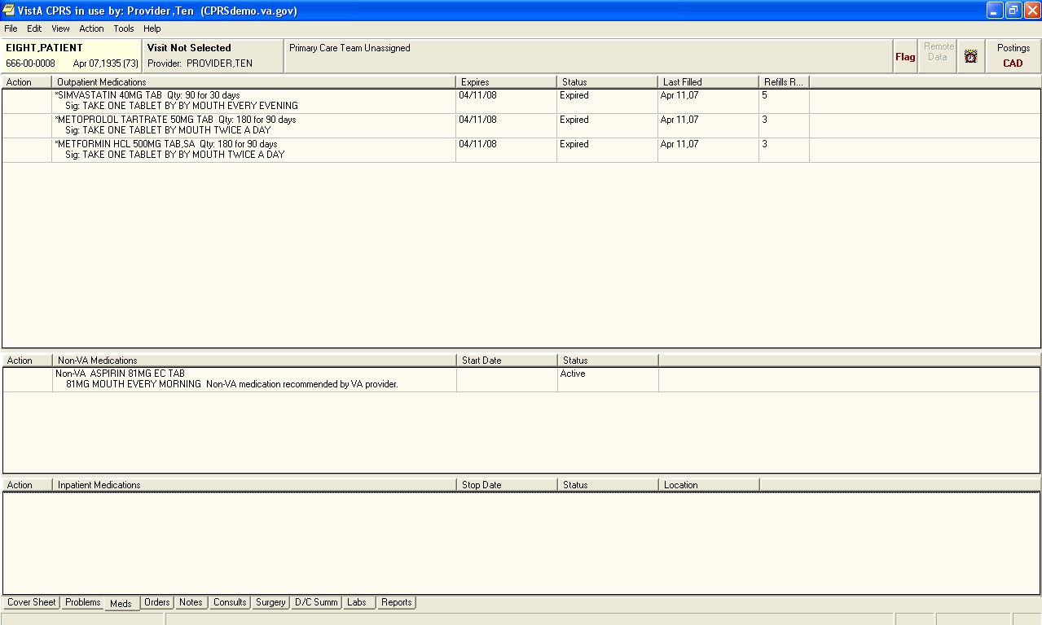

### Assessment of To-Be Changes to Medications Screen

#### Description of Recommendations

In order to verify the clinician suggestions iterated in Section 2.6.1, the BI Team incorporated the following recommended modifications into the To-Be model Medications screen:

* Modify the system to allow clinicians to sort orders by each column header (RCMD MS #001).
* Allow clinicians to navigate easily between Medication List, Medication Reconciliation and Medication History views with a single click (RCMD MS #002).
* Modify the system so medication orders can be custom color-coded by the clinician using a system wide standard color palette (for example, STAT orders displayed in Red and New orders in Green) (RCMD MS #003).
* Modify the screen to allow clinicians to compare medications side-by-side (RCMD MS #004).

Allow clinicians to compare inpatient to outpatient medications (RCMD MS #005).



Allow clinicians to compare current inpatient medications to medication history of the current hospitalization (RCMD MS #006).

For a visual representation of these recommendations please see Figure 18 below.

#### To-Be screen shots

Figure 18 is an example of a To-Be medication reconciliation screen, which compares inpatient medications on the left to outpatient medications on the right. The medication comparisons are distinguished as ―Match‖ (where medication name, dosage and form match between the inpatient side and outpatient side), ―LM‖ (Limited Match – where the medication name matches but the form and/or dosage do not match) and a blank square, which indicates that the medication does not have a match.

**Figure 18. To-Be example of a medication reconciliation screen comparing inpatient and outpatient medications.**

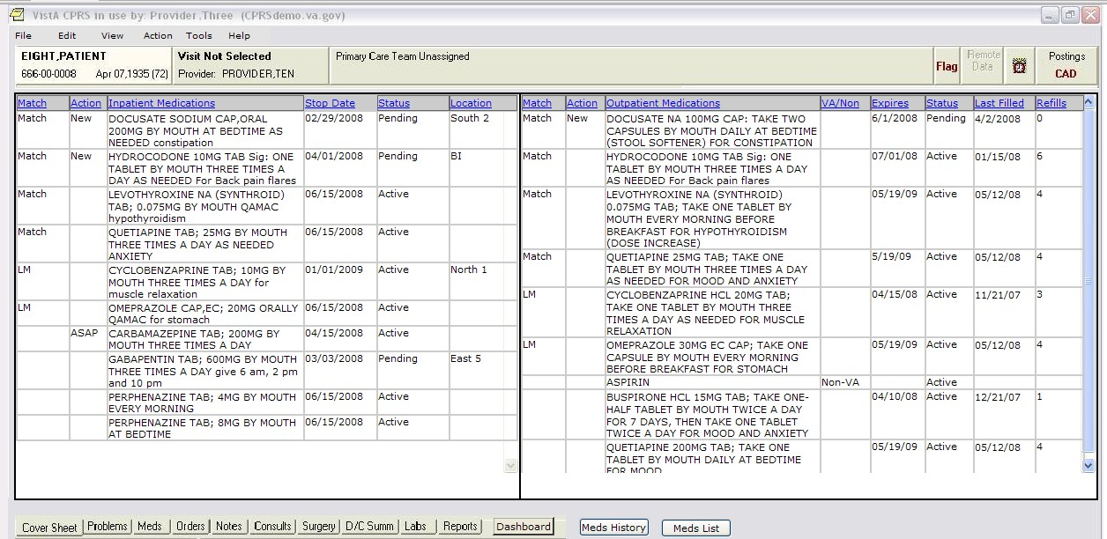

Figure 19 is an example of a To-Be medication reconciliation screen, which compares current inpatient medications on the left to inpatient medications ordered for the patient in the last 24 hours on the right. The clinician could change the time parameter of the right side of the screen to reflect medication orders older than 24 hours. This screen is designed to give the clinician a snap shot of a patient’s medication history that can facilitate the complete and proper ordering and administration of a patient’s medications if a patient is moved between wards.

**Figure 19. To-Be example of a medication reconciliation screen comparing current and past medications.**

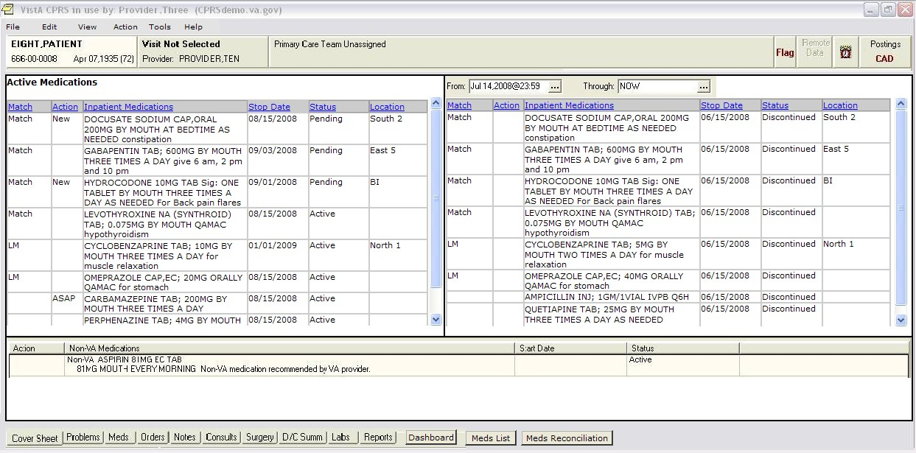

Because there are situations where the clinician only needs a list of medications (e.g., outpatient clinics), the BI Team included the current CPRS screen in the model but modified the screen to allow the clinician to sort the medications by column header (Figure 20). The BI Team also designed the screen to be accessible to and from the other two medication screens.

**Figure 20. To-Be example of a medication list.**

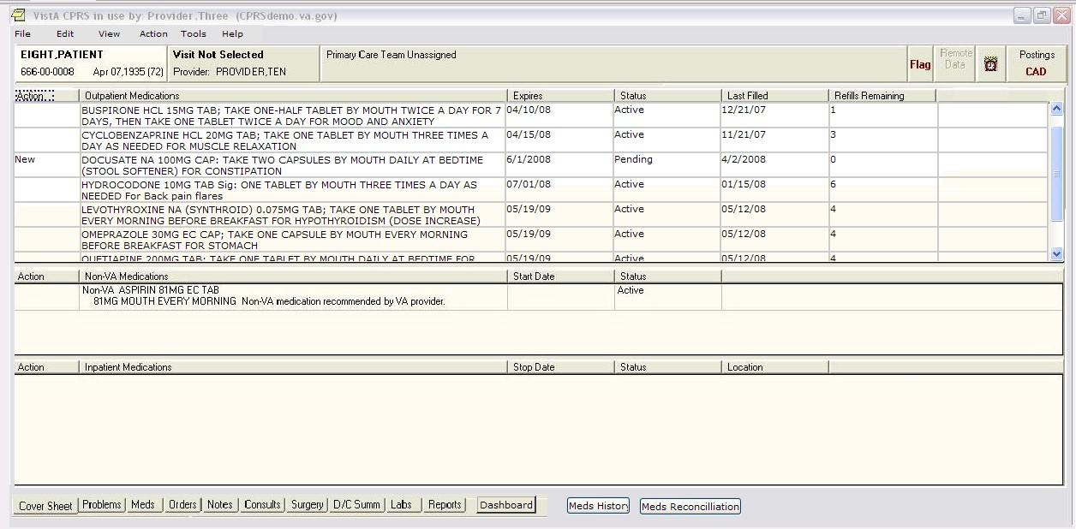

#### To-Be scenario

The BI Team captured the changes to the steps a clinician would use to sort and compare inpatient to outpatient medications and created the To-Be scenario shown in Table 22. The BI Team then verified that the changes had the potential of increasing clinician efficiency by executing a timing study between the As-Is scenario and the To-Be scenario (see *Impacts*).

**Table 22. To-Be scenario for Sorting and Comparing Medications**

|  |  |  |  |
| --- | --- | --- | --- |
| **Step** | **Description** |  | **Clicks** |
| 1. | From the cover sheet, select the ―Meds‖ Tab |  | 1 |
| 2. | Sort the Medications by the ―Match‖ category |  | 1 |
| 3. | Answer the question: How many matching medications are there? |  | - |
|  |  | **Total Clicks** | **2** |

### Impacts

#### Clinical Impacts

The clinical impact of the recommended changes is based on clinician comments and insights recorded during the two rounds of site visits.

The key clinical benefits of implementing the recommended changes to the Medications screen are:

Reduce the potential for medication errors of omission when trying to match medications; Reduce the potential for medication errors having to do with the wrong dosage, route and time of administration;



* Increase the efficiency of the clinician’s workflow processes (eliminate manual workarounds); and
* Reduce medication reconciliation time (automate process).

#### Time and Keystroke Efficiencies

The BI Team conducted an execution timing comparison study utilizing task scenarios representing the As-Is and To-Be states. The analysis showed that the execution timesaving for the To-Be scenario was on average 104 seconds plus or minus 17 seconds.

Table 23 shows a summary of the results. Full calculations and statistical definitions are provided in Appendixes B and G. It should be noted that the 104 seconds represents the manual process captured in the As-Is scenario. Because medication reconciliation workarounds vary from clinician to clinician as do the number of medications from patient to patient, the timesaving could vary greatly depending on the situation.

No keystroke comparisons are identified because the BI Team compared a manual and automated process.

**Table 23. Time Data Results for Execution Timings for Sorting and Comparing Medications**

|  |  |  |  |  |  |
| --- | --- | --- | --- | --- | --- |
| **Scenario** | **Sample Size** | **Mean**  **Execution Time**  **(Seconds)** | **Difference between the Means**  **(Seconds)** | **Lower 95%**  **Confidence**  **Interval**  **(Seconds)** | **Upper 95%**  **Confidence**  **Interval**  **(Seconds)** |
| As-Is | 34 | 119 |  |  |  |
| To-Be | 34 | 15 |  |  |  |
|  |  |  | **104** | 87 | 121 |

#### Task Ranking

The BI Team asked clinicians to rank from one to eight (with one being the most important) the eight ―To-Be‖ solution tasks in terms of importance to the individual clinician.

The Sorting and Comparing Medications task ranked in the upper half of order preference for both nurses and doctors.

Of the 18 nurses, twelve ranked it between a 1 and 6, with five ranking it a 6 and one a 7. Of the 16 doctors, nine ranked it either a 1 or a 2, with the remaining seven ranking it between 6 and 3.



### Requirements Statements

Based on the key findings, BI has prepared a set of recommended requirements for VHA consideration.

The system shall allow clinicians to sort orders by each column header (REQ MS #001). The system shall allow clinicians to navigate using one click between the Medication List, Medication Reconciliation and Medication History view (REQ MS #002). The system shall display inpatient, outpatient, and non-VA medications on one screen (REQ MS #003).



* The CPRS system shall distinguish between outpatient medications and inpatient medications (REQ MS #004).
* The CPRS system shall display all outpatient and inpatient medications side-by-side on the same screen (REQ MS #005).
* The system shall provide the ability to compare inpatient to outpatient medications on the same screen (REQ MS #006).
* The system shall provide the ability to compare current inpatient medications to medication history of the current hospitalization (REQ MS #007).
* The system shall display each medication in full context with the specific name, dosage, and route of administration (REQ MS #008).
* The system shall display an identifier that designates a match between inpatient and outpatient medications if the medication exactly matches the name, dosage and route of administration (REQ MS #009).
* The system shall display an identifier that when name only is matched between inpatient and outpatient medications (REQ MS #010).
* The system shall allow clinicians to custom color-code medication orders utilizing a system wide standard color palette (for example, STAT orders displayed in Red and New orders in Green) (REQ MS #011).
* The system shall display the key medication order indicators (STAT, ASAP, New, Now and Flagged) as a separate and distinct column (REQ MS #012).

### Supporting Data

The supporting data, detailed analysis, and relevant references are found in Appendixes A-E.

## Recommended Modifications to CPRS Orders Screen

The recommendations provided in this section focus on the ―Finding and Sorting Orders‖ highvalue, frequently performed task. It addresses the sorting and finding of orders as performed by VHA clinicians in the inpatient settings that were observed during the site visits conducted for this analysis.

### Assessment of As-Is State of Orders Screen

#### Clinician Feedback

During the initial observations and subsequent discussions, clinicians suggested changes to the Orders screen that would provide potential clinician timesaving and allow clinicians more time with the patient. The suggested changes are:

* Modify the screen to include a column that lists order type (e.g. STAT, ASAP, new, now and flagged);

Modify the screen to include the capability to use column headers to sort information. Allow clinicians to automatically graph a specific value by selecting a specific medication or lab and right clicking;



* Allow users to access the graphing application from the orders screen with a single click; and
* Modify the screen to show clarifications between the various statuses, (specifically between pending and active) by showing a small pop-up box containing the definition of the status when the cursor hovers over the word.

Incorporating these suggestions would move current functionality from the menus to the screen thus reducing keystrokes and increasing system intuitiveness. Clinicians theorize that these changes will increase their efficiency while interacting with the system and allow more time for patient care.

#### As-Is Scenario

To document the projected efficiencies related to the recommended changes, the BI Team devised a pair of parallel scenarios that represent the task of a clinician trying to find an order. The first scenario described below mimics current CPRS functionality (As-Is), while the other represents the recommended changes (To-Be).

The scenario in Table 24 describes the steps a clinician might take to find specific order information.

**Table 24. As-Is Scenario Instructions for Finding and Sorting Orders**

|  |  |  |
| --- | --- | --- |
| **Step** | **Description** | **Clicks:** |
| 1. | From the cover sheet, select ―Orders‖ Tab | 1 |
| 2. | Answer the question: Does an order exist for a ―Cardiology Consult‖? | - |
| 3. | Answer the question: How many STAT orders are there? | - |
| 4. | Click view | 1 |
| 5. | Click Custom Order View | 1 |
| 6. | Click Laboratory | 1 |
| 7. | Click Ok | 1 |
| 8. | Answer the question: Does an order exist for a lab titled ―Glucose Blood Serum‖? | - |
|  | **Total Clicks** | **5** |

#### As-Is Screen Shot

Figure 21 is a screen capture of the current state of the Orders screen. In order to change the data displayed in the main window, a clinician must choose new parameters by using the tool bar at the top of the screen. The capability to sort the data by columns or access the graphing application on the main screen does not exist.

**Figure 21. As-Is example of a default view of the CPRS Orders screen.**

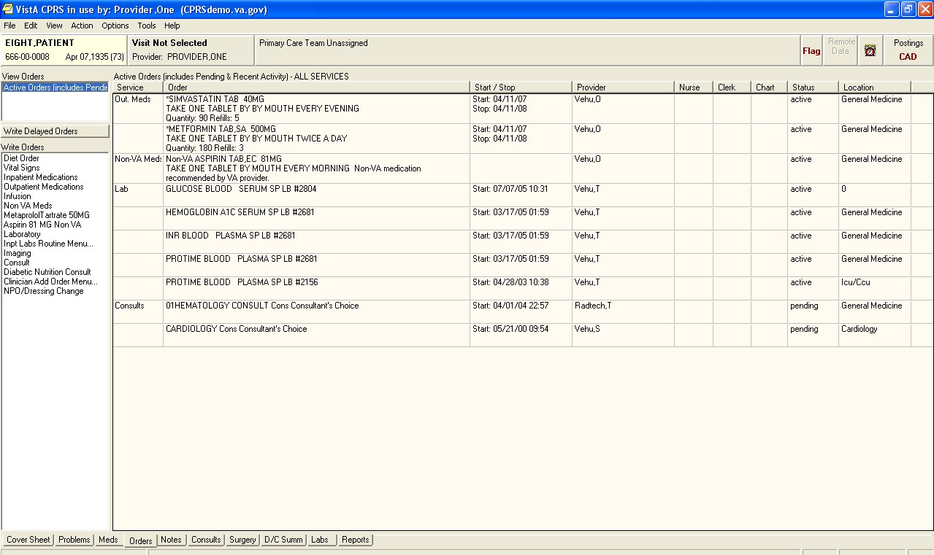

### Assessment of To-Be Changes to Orders screen

#### Description of Recommendations

In order to verify the clinician suggestions iterated in Section 2.7.1, the BI Team incorporated the following recommended modifications into the To-Be model Orders screen:

* Modify the system to allow clinicians to sort orders by each column header (RCMD OS #001).
* Modify the system to allow clinicians to create multiple custom views to save on the Orders screen for future use (RCMD OS #002).
* Allow clinicians to navigate easily between multiple preferred views with a single click (RCMD OS #003).
* Modify the system so orders can be custom color-coded by the clinician using a system wide standard color palette (for example, STAT orders displayed in Red and New orders in Green) (RCMD OS #004).
* Modify the system so that the order key indicators: STAT, ASAP, New, Now and Flagged are visually distinct and separate from the order (RCMD OS #005).

Allow clinicians to sort by order key indicator (RCMD OS #006).



Modify the system so that clinicians are allowed to access CPRS Graphing with a single click (RCMD OS #007).

* Modify the system so that the definition of the Status (e.g. ―pending‖ or ―active‖) when the cursor hovers over the word in the column (RCMD OS #008).

For a visual representation of these recommendations please see Figures 22-26 below.

#### To-Be Screen Shot

In the To-Be model, the default view (Figure 22) is set by the clinician preferences (current CPRS functionality) and is the first available view selection option. Beneath this option are two additional saved view options that a clinician can toggle between quickly and easily. A clinician is also able to sort the orders by category by clicking any of the column headers. The column Type shows the key indicators STAT, New and Flagged. (CPRS currently shows these delineators as the last field in an order under the Order column.) Additionally, the current CPRS graphing application is also accessible from the Write Orders box. [1]

**Figure 22. To-Be model of a default view of the CPRS Orders screen.**

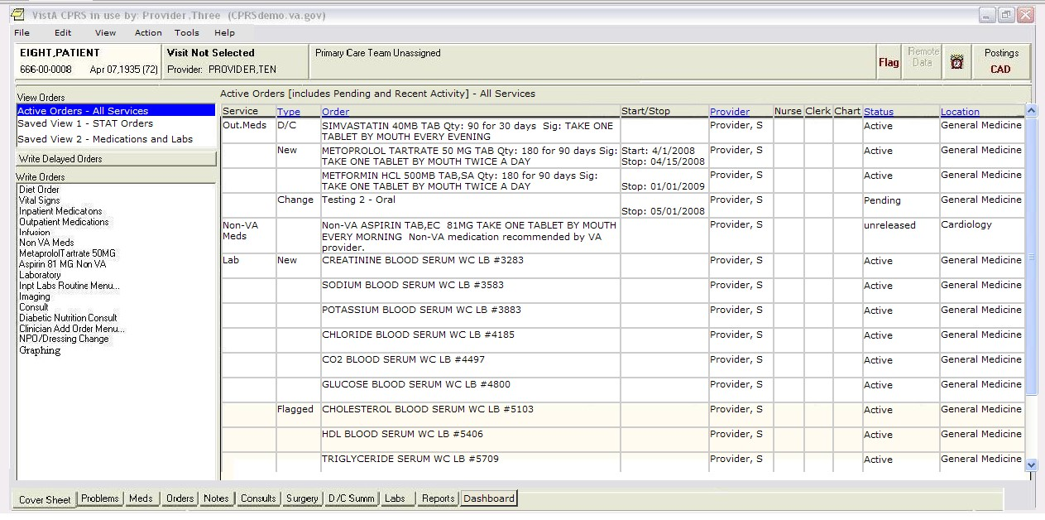

Figure 23 shows an example of a definition appearing when the clinician rolls over a word in the Status columns.

**Figure 23. To-Be model of the pop-up definition in the CPRS Orders screen.**

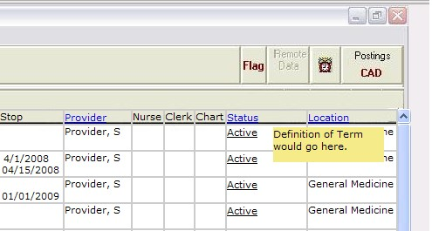

Figure 24 shows one example of a possible saved view. A clinician accesses the view by selecting a saved view in the View Orders box on the CPRS Orders screen. In this example, the view is of all STAT orders. The object of the saved view is to allow a clinician to determine the specific criteria they wish to save and make it available with a single click. [2]

**Figure 24. To-Be example of a possible saved view.**

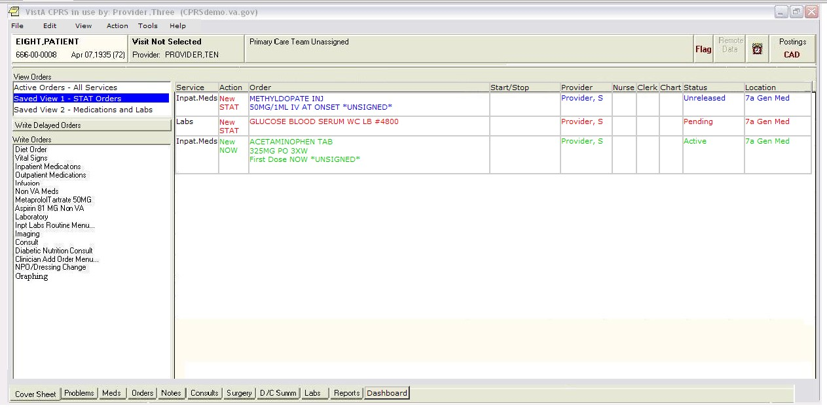

In the example shown in Figure 25, only medications and labs are shown in the main window. The model also shows an example of a possible color scheme where STAT orders are red, New orders are green, Unsigned orders are blue, and Flagged orders are back-colored in red. The orders can be sorted by column.

**Figure 25. To-Be example of a second possible saved view.**

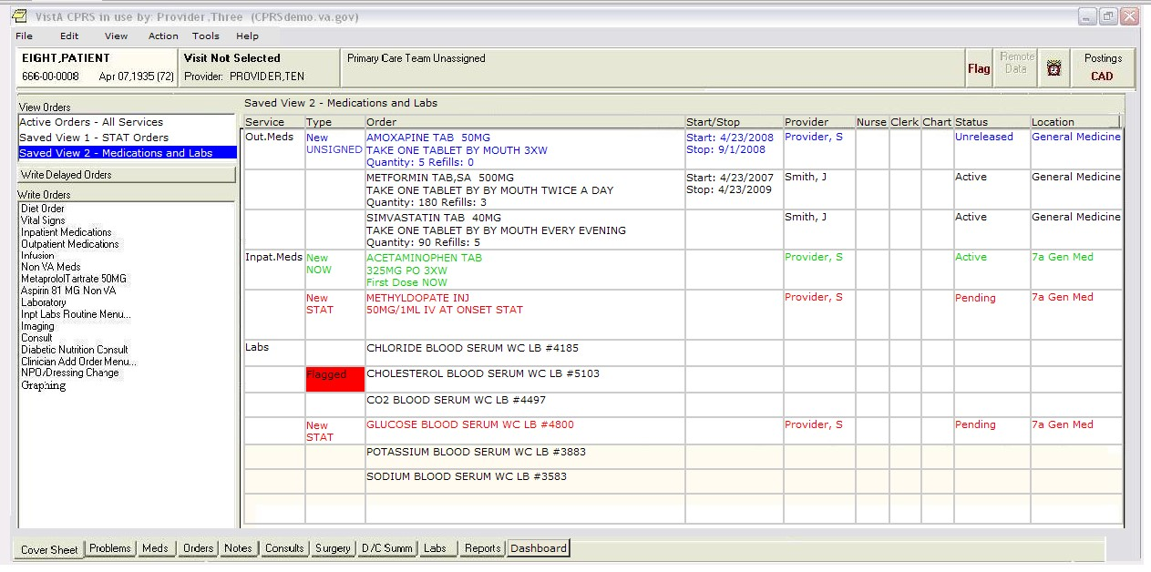

Figure 26 shows one possible method of saving criteria for a saved view. The Custom Order

View dialog box (current CPRS) allows a clinician to choose the criteria to determine which

orders to display. The To-Be model includes the ability to save it as one of the saved view options on the CPRS Orders screen.

**Figure 26. To-Be Model of Custom Order View screen with Save View button.**

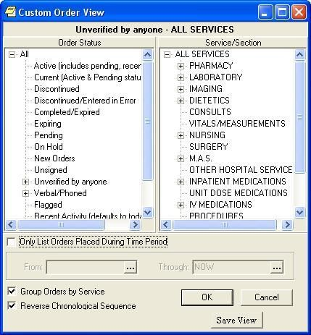

#### To-Be Scenario

The BI Team captured the changes to the steps a clinician would use to find an order and created the To-Be scenario shown in Table 25. The BI Team then verified that the changes had the potential of increasing clinician efficiency by executing a timing study between the As-Is scenario and the To-Be scenario (see the Impacts Section below).

**Table 25. To-Be Scenario Instructions for Finding and Sorting Orders**

|  |  |  |
| --- | --- | --- |
| **Step** | **Description** | **Clicks** |
| 1. | From the cover sheet, select Orders screen | 1 |
| 2. | Sort by ―Location‖ | 1 |
| 3. | Answer the question: Does an order exist for a ―Cardiology Consult‖? | - |
| 4. | Change view to Saved View 1 - Stat Orders | 1 |
| 5. | Answer the question: How many STAT orders are there? | - |
| 6. | Change view to Saved View 2 - Medications and Labs | 1 |
| 7. | Answer the question: Does an order exist for a lab titled ―Glucose Blood Serum‖? | - |
|  | **Total Clicks** | **4** |

### Impacts

Findings from the impact analysis are broken down in to three categories: clinical impact, time and keystroke efficiencies and task ranking. The following sections provide commentary on the specific findings.

**Clinical Impact:**

The clinical impact of the recommended changes is based on clinician comments and insights recorded during the two rounds of site visits.

The key clinical benefits of implementing the recommended changes to the order screen are:

Decreases the possibility of missing or not seeing new or STAT orders;



Improves visualization and reduces search time and keystrokes to locate data; and Increases intuitiveness that facilitates easier staff training.

**Time and Keystroke Efficiencies:**

The BI Team conducted an execution timing comparison study utilizing task scenarios representing the As-Is and To-Be states. The analysis showed that the execution timesaving for the To-Be scenario was on average 60 seconds plus or minus 14 seconds.

Table 26 results shows a summary of the results with full calculations and statistical definitions provided in Appendixes B and G.

**Table 26. Time Data Results for Execution Timings for Finding and Sorting Orders**

|  |  |  |  |  |  |
| --- | --- | --- | --- | --- | --- |
| **Scenario** | **Sample Size** | **Mean**  **Execution Time**  **(Seconds)** | **Difference between the Means**  **(Seconds)** | **Lower 95%**  **Confidence**  **Interval**  **(Seconds)** | **Upper 95%**  **Confidence**  **Interval**  **(Seconds)** |
| As-Is | 34 | 95 |  |  |  |
| To-Be | 34 | 34 |  |  |  |
|  |  |  | **60** | 46 | 74 |

The BI Team also calculated keystroke differentials between the To-Be and As-Is scenarios and found there to be a 20 percent reduction between the current CPRS system and recommended changes to accomplish the same task (Table 27).

**Table 27. Keystroke Count for Finding and Sorting Orders**

|  |  |
| --- | --- |
| **Scenario** | **Keystrokes** |
| As-Is | 5 |
| To-Be | 4 |
| **Difference** | **1** |

#### Task Ranking

The BI Team asked clinicians to rank from one to eight (with one being the most important) the eight ―To-Be‖ solution tasks in terms of importance to the individual clinician.

The Finding and Sorting Orders task was low in the rank order preference for both nurses and doctors.

* Of the 18 nurses none of them ranked Sorting and Finding Orders as a 1 or a 2. Five nurses ranked it a 3, the remainder ranked it between 4 and 7.
* Of the 16 doctors only one ranked it as a 2, four ranked as a 3 or 4, three ranked as a 6 and eight ranked it as a 7.

### Requirements Statements

Based on the key findings, BI has prepared a set of recommended requirements for VHA consideration.

* The system shall provide the ability to sort medical orders on the Order screen by the column header (REQ OS #001).
* The system shall allow clinicians to create custom views that will be accessible from the View Orders box (REQ OS #002).
* The system shall enable clinicians to save a new custom order sort view from the custom view order screen (REQ SO #003).
* The system shall provide the ability to display saved custom views in the view orders box of the Orders screen for future use (REQ OS #004).
* The system shall allow clinicians to navigate easily between multiple custom views with a single click (REQ OS #005).
* The system shall allow clinicians to custom color-code medication orders utilizing a system wide standard color palette (for example, STAT orders displayed in Red and New orders in Green) (REQ OS #006).
* The system shall display order key indicators: STAT, ASAP, New, Now and Flagged so they are visually distinct and separate from the order (REQ OS #007).

The system shall allow clinicians to sort by order key indicator (REQ OS #008).



The system allows clinicians to access CPRS Graphing with a single click (REQ OS #009).

* The system shall display the definition of the Status (e.g. ―pending‖ or ―active‖) when the cursor hovers over the word in the column (REQ OS #010).

### Supporting Data

The supporting data, detailed analysis, and relevant references are found in Appendixes A-E.

## Recommended Modifications to CPRS interaction with BCMA

The recommendations provided in this section focus on the ―CPRS interaction with BCMA‖ high-value, frequently performed task. It addresses the needed link between two separate applications, BCMA and CPRS.

### Assessment of As-Is State of CPRS interaction with BCMA

#### Clinician Feedback

During the initial observations and subsequent discussions, clinician feedback indicated a need for BCMA and CPRS to be linked. The clinicians suggested that:

BCMA and an open session of CPRS should synchronize to the same patient medical record if a patient bracelet is scanned in BMCA.



Incorporating this change has the potential to reduce the possibility of a patient medication error.

#### As-Is Scenario

Because the simulation tool could not accurately simulate a clinician encounter with BCMA, the BI Team did not create a scenario for timing purposes.

#### As-Is Screen Shot

Figure 27 is of the current BCMA screen while scanning in a wristband. Currently, a nurse must manually select the new patient in CPRS.

**Figure 27. As-Is Model of the Bar Code Medication Administration Screen with Wristband Scan.**

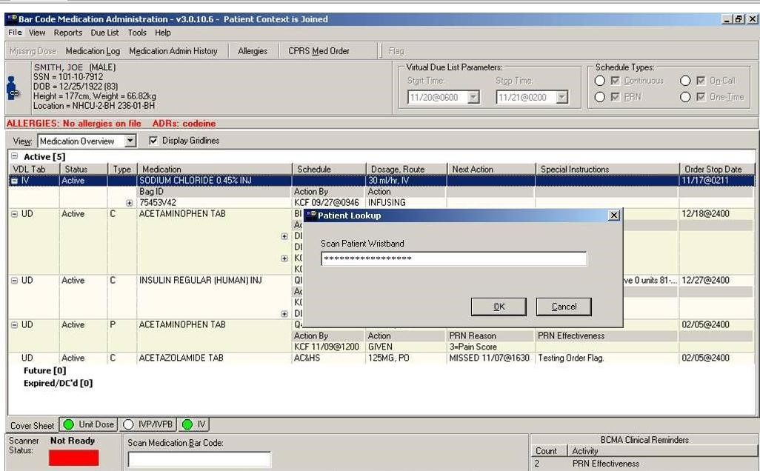

### Assessment of To-Be Changes to CPRS Interaction with BCMA

The BI Team recommends the following:

Modify the system to provide a link between an open session of CPRS and BCMA to automatically synchronize to the same patient medical record if a patient bracelet is scanned in BMCA (RCMD BCMA #001).



Due to the restrictions of the simulation tool and the nature of the recommendation, the BCMA screen and additional functionality were not modeled and therefore no screen shot exists.

### Impacts

The clinical impact of the recommended changes is based on clinician comments and insights recorded during the two rounds of site visits.

The key clinical benefits of implementing the recommended changes to the order screen are:

Reduces potential for medication errors;



Reduces key strokes in CPRS (clinician does not need to select new patient); and Reduces the time required to administer medications (fewer keystrokes).

#### Clicks

Though the BI Team could not accurately simulate test scenarios, average clicks could be determined based on task analysis. If CPRS were to automatically update, a clinician would save the 4 clicks needed to select a new patient.

#### Task Ranking

The BI Team asked clinicians to rank from one to eight (with one being the most important) the eight ―To-Be‖ solution tasks in terms of importance to the individual clinician.

The CPRS interaction with BCMA task was low in the rank order preference for both nurses and doctors.

The results of the ranking indicated that fifteen doctors ranked it an 8 and one ranked it a 7. Eleven of the nurses ranked it as an 8 and one ranked it a 7. One explanation for the low ranking is the majority of the participating clinicians do not use it in their daily workflow. The nurses who use BCMA on a daily basis ranked it much higher, including one nurse who ranked it a 1, and another nurse who ranked it a 3. Four other nurses ranked it either a 4 or a 5.

### Requirements Statements

Based on the key findings, BI has prepared a set of recommended requirements for VHA consideration.

* CPRS and the BCMA application shall automatically synchronize to the same patient when a wristband is scanned (REQ BCMA #001).
* When synchronization occurs, the CPRS system shall display the cover sheet of the patient whose wristband was scanned by BCMA (REQ BCMA #002).

### Supporting Data

The supporting data, detailed analysis, and relevant references are found in Appendixes A-E.

# Out of Scope Findings & Recommendations

The BI Team was directed to stay within the current functional framework of CPRS and make recommendations that did not involve new development. The intent was to capitalize on current CPRS functionality. The functional recommendations that were derived from the clinician feedback that did not meet this requirement were captured and identified as either secondary recommendations or for future development.

The secondary recommendations met the requirement to stay within the functionality of CPRS, but were not identified in the primary grouping of high value frequently performed tasks. Those tasks that were identified as future development did not meet the requirement and required new development work within CPRS. As with all the high value tasks, the secondary and future development recommendations were documented, and are presented here.

## Secondary Findings

The following secondary recommendations in Table 28 are based upon interactions with the clinicians at each site visited and are presented here for further consideration.

**Table 28. Secondary Recommendations**

|  |  |  |
| --- | --- | --- |
| **Task** | **Issue** | **Proposed Functional Recommendations** |
| **Cover Sheet**  **Customization** | CPRS cover sheet is ―one size fits all‖ and does not allow for the differences between various clinician roles. | 1. Allow for individual customization of screen by providing clinicians the ability to add, delete or move the type of information displayed and alter the data retrieval parameters. |
| **Templates:**  **(Auto-Populate)**  **(Presentation)**  **(Check boxes)**  **(Calculations)**  **(Tracking)**  **(Readability)** | Templates do not pre-populate data, (e.g. contact number, life events) or maintain static information. (Note: This is also true for consult templates.) | 1. Provide the ability to pre-populate data. 2. Provide ability to easily import static information. |
| Templates are not linked to CPRS. Data entered in the template does not flow back to (change) CPRS data. | 4. Provide link between CPRS and templates so that data is bi-directional. |
| Complicated, complex and long templates are difficult to complete efficiently due to formatting issues. | 1. Templates must be able to be dynamically resized. 2. Data entry fields should reflect the true field limits. |
| Templates allow for a clinician to select all check boxes on a template but there is not a check-all box for specific sections. | 7. Add a ―check all‖ or ―uncheck all‖ box to any section of templates that have multiple check boxes. |
| Templates do not automatically calculate where needed (e.g. for Braden Scale, KATZ Scale, Depression Scale or Fall Risk). | 8. Provide auto-calculation of totals and scores. |

Business Intelligence, Inc.

|  |  |  |
| --- | --- | --- |
| **Task** | **Issue** | **Proposed Functional Recommendations** |
|  | Templates are developed but not tracked for volume of use, which has lead to over abundance of templates. | 9. Provide a method to track development and usage. |
| It is time consuming to locate information within the note created by template. | 10. Provide the ability to tailor the order of information on a template. |
| **CPRS Auto Refresh** | CPRS does not notify the clinician that new values are available. CPRS also does not automatically refresh data. | 1. Provide a pop-up alert to indicate that new values are available while automatically refreshing the information. 2. Indicate the date and time of the autorefresh event. 3. Move the manual patient refresh function from the drop down menu to a single click button on the toolbar. |
| **Patient Problem**  **List** | The Patient Problem List is not maintained to reflect active problems. | 1. Provide problem expiration dates. 2. Provide sort capability to display by active and historical data |
| **Remote Data View (Response Time)**  **(Sort and Search)** | System response time to retrieve remote data is too long. | 16. Conduct an examination of the cause of the data delays and remedy the problem, architecture, hardware, etc. |
| Presentation of remote data is non-interactive (e.g. a clinician cannot sort the data). | 17. Provide the ability to sort and search results. |
| **Reminders &**  **Alerts** | Too many reminders with no way to prioritize or categorize them. | 18. Provide the ability to categorize and prioritize reminders and alerts. |
| No ability to save the alert and address it later, or use it as a personal reminder to create a task list. | 1. Provide the ability to save and recall alerts. 2. Provide the ability to create a task list from reminders. |
| Only the primary provider receives the alert—medical specialties and supervising attendees do not. ED is not removed from the recipient list when a patient changes care status. | 21. Provide the ability to create and edit reminder/alert distribution lists. |
| Cannot resolve and answer reminder on the same screen that displays the reminder. | 22. Provide the ability to resolve reminders from the display screen. |
| **Consults** | When ordering consults that requires a lab or medication, there is no automatic link to the orders functionality. | 23. Provide a required link between consult orders and lab/pharmacy orders. |
| No feedback on order/consult completion to the requesting clinician**.** | 24. Provide a completion email back to the requesting clinician. |

## Future CPRS Recommendations

The BI Team captured clinician suggested changes that fall out of scope of the analysis. These changes are not within current CPRS functionality. These proposed functionalities, shown in Table 29, were identified as desired advanced capabilities that would enhance clinician productivity.

**Table 29. Capabilities Identified by Clinicians for Future Consideration**

|  |  |
| --- | --- |
| **Proposed Functionality** | **Requested Capability** |
| **Search Engine Functionality** | 1. Provide "Google-like" search to retrieve patient data. |
| **Image Retrieval** | 2. Allow for images to be displayed in CPRS so that a clinician does not need to go into VistA imaging to retrieve images or results. |
| **Closed Loop Communication for image alerts** | 3. Provide a feedback methodology for alert read-response, so that the radiologist initiating the alert has confirmation that the image alert has been read and acknowledged. |
| **Identify Priority Patient Data** | 4. Provide the ability to highlight, bold, move, or underline text to assist with identification of high priority patient data. |
| **Notes** | 1. Enable note prioritization, better sort capabilities, and a search function to find specific notes. 2. Assign highlight codes, identify cut and pasted text, age notes by date, and tag notes for later action. 3. Enable a highlighting function for parts of notes clinicians deem important. 4. Create multiple views of note sorting that can be toggled between with one click. |
| **Clinical Tasks** | 9. Enable creation of clinician task lists, allowing clinicians to track their tasks. |
| **Insufficient Computer Resources** | 10. Enable multiuser logon functions, as, when computers are in demand, the clinicians would like the ability to share one computer with another clinician, without losing their data or their "place" within CPRS. |
| **Decision Support for**  **Clinical Decision**  **Making** | 11. Provide more robust decision support tools that use intelligence to control execution of business rules/decision tree logic (e.g., diagnosis, controls available drugs that match to patient allergies and potential drug interactions, links to relevant test results, and associations to system templates and applications). |
| **Data Integration and Display** | 12. Enable integration of data so that laboratory results, medications, and vital signs crosspopulate in the different functionalities (e.g. into BCMA). |
| **Physiological Display of Data** | 13. Computerize flow sheets and contain them within CPRS. |
| **Interdisciplinary Notes** | 14. Implement more user-friendly interdisciplinary notes and care planning. |
| **Orders Management in**  **BCMA** | 15. Enable order verification in BCMA for nurses. |
| **Patient Lists** | 1. Create resident lists and allow attending physicians to see their residents’ lists. 2. Allow clinicians to add or delete patients instantaneously from the CPRS print patient list. |

The BI Team makes the above secondary and future recommendations based on the observations and discussions from the site visits. Modeling the recommendations and repeating this study could further validate these recommendations.

**Appendixes**

Business Intelligence, Inc. Page 1

**Appendix A. Site Demographics and Participant Profile**

This appendix provides basic information on the participating facilities and the participant profile. The BI Team traveled to each of these sites twice.

**Site**: Bay Pines VAMC

**Location:** Bay Pines, Florida

**Visit Dates**: January 15-17, 2008 and May 21, 2008

**Facility Overview**: The Bay Pines VA Healthcare System provides comprehensive medical care including acute/in-patient medical, surgical, and psychiatric care; extended/long-term medical and psychiatric care, rehabilitative inpatient care; and comprehensive outpatient care with multiple specialty services available. In addition, the Medical Center supervises a community nursing home care program, which that is one of the largest in the VA system. The facility also operates a large outpatient clinic in Fort Myers and Community Based Outpatient Clinics (CBOCs) in Dunedin, St. Petersburg, Ellenton, Sarasota, Port Charlotte, Naples, and Sebring, Florida.

**Site**: West Roxbury Campus VAMC

**Location:** Boston, MA

**Visit Dates**: February 5-7, 2008 and May 29, 2008

**Facility Overview**: The VA Boston Healthcare System, the largest consolidated facility in VISN 1, encompasses three main campuses and six outpatient clinics within a 40- mile radius of the greater Boston area. The consolidated facility consists of the Jamaica Plain Campus, located in the heart of Boston’s Longwood Medical Community; the West Roxbury Campus, located on the Dedham line; and the Brockton Campus, located 20 miles south of Boston in the City of

Brockton. In addition to the three main medical centers, six Community Based Outpatient Clinics (CBOCs) located in Worcester, Framingham, Lowell, Quincy, Causeway Street (Boston), and Dorchester make up the VA Boston Healthcare System (VA BHS). The VA Boston Healthcare System is the proud recipient of five Centers of Excellence Awards for the following programs: Cardiac Surgery, PTSD, Women’s Health, Seriously Mentally Ill, and Substance Abuse.

**Site**: Baltimore VAMC

**Location:** Baltimore, Maryland

**Visit Dates**: February 5-7, 2008 and June 5, 2008

**Facility Overview**: Baltimore Veterans Affairs Medical Center (VAMC**)** offers veterans stateof-the-art medical technology, clinical services and research programs. The Medical Center, part of the VA Capitol Health Care Network (VISN 5), is home to the world’s first filmless radiology department, which allows health care providers to have nearly instant access to patient radiology images from anywhere in the facility and throughout the health care system. The Baltimore VAMC is the acute medical and surgical care facility for the VA Maryland Health Care System (VAMHCS) and offers a full range of inpatient, outpatient, and primary care services. Located next to the University of Maryland Medical Center, with a walkway connecting the two facilities, the Medical Center maintains an active affiliation with the University of Maryland School of Medicine in the sharing of staff, resources, and technology. Having one of the largest funded research and development programs in the VA system, including studies in diabetes,

Page A-1

immunology, oncology, virology, cellular biology, and infectious diseases, enhances the Medical Center’s ability to provide state-of-the-art medical techniques and treatments to Maryland’s veterans. A Geriatric Research, Education, and Clinical Center, one of only 21 in the VA system nationwide, conducts research on the prevention of stroke and cardiovascular disease through exercise and nutrition therapy in older veterans. In response to a growing demand for specialized care for veterans with Multiple Sclerosis (MS), the Baltimore VAMC coordinates one of only two MS Centers of Excellence throughout the VA. The Center is responsible for facilitating clinical care, research and education for patients with MS in the Eastern part of the country. The

Baltimore VAMC is also the home base for one of VA’s ten 10 Mental Illness Research, Education, and Clinical Centers. This program is dedicated to improving the provision of health care to veterans suffering from severe mental illness, with a special emphasis on the treatment of individuals with schizophrenia.

**Site:** Albany VAMC

#### Location: Albany, New York

**Visit Dates**: March 4-6, 2008 and June 11, 2008

**Facility Overview**: The Stratton VA Medical Center, part of the VA Healthcare Network

Upstate New York, is located in the heart of Albany, New York. Opened in 1951, the Medical

Center serves veterans in 22 counties of upstate New York, western Massachusetts, and

Vermont. In 1990 this facility was named in honor of Samuel S. Stratton, U.S. Congressman for 30 years of the 23rd District, a staunch supporter of veterans and a frequent visitor to the hospital.

Page A-2

##### Participants

The following Table A-1 depicts each site visited and the participants, and their medical service within each hospital:

**Table A-1. Site and Participant List**

|  |  |  |  |  |
| --- | --- | --- | --- | --- |
| **Facility** | **Name** | **MD/RN** | **Service** | **In/Out patient** |
| Albany | Participant #1 | MD | Geriatric Primary Care Clinic | Outpatient |
| Albany | Participant #2 | MD | General Surgery | Inpatient |
| Albany | Participant #3 | MD | Primary Care | Outpatient |
| Albany | Participant #4 | MD | Specialty Clinics/ ICU | Inpatient |
| Albany | Participant #5 | MD | Emergency | Outpatient |
| Albany | Participant #6 | RN | Behavioral | Inpatient |
| Albany | Participant #7 | RN | Medical/Surgery | Inpatient |
| Albany | Participant #8 | RN | Primary Care | Outpatient |
| Albany | Participant #9 | RN | Medicine/Emergency | Outpatient |
| Baltimore | Participant #10 | MD | Managed Care | Outpatient |
| Baltimore | Participant #11 | MD | Surgery | Inpatient |
| Baltimore | Participant #12 | MD | Psychiatry | Outpatient |
| Baltimore | Participant #13 | RN | Primary Care | Outpatient |
| Baltimore | Participant #14 | RN | MICU | Inpatient |
| Baltimore | Participant #15 | RN | 5B Surgical | Inpatient |
| Baltimore | Participant #16 | RN/CAC | CIS | Inpatient |
| Bay Pines | Participant #17 | MD | Medicine | Inpatient |
| Bay Pines | Participant #18 | MD | Surgery | Inpatient |
| Bay Pines | Participant #19 | MD | Primary Care | Outpatient |
| Bay Pines | Participant #20 | RN | Psychiatry | Inpatient |
| Bay Pines | Participant #21 | RN | Geriatrics | Outpatient |
| Bay Pines | Participant #22 | RN | Medical/Surgery/ Neurology | Inpatient |
| Bay Pines | Participant #23 | RN | Primary Care | Outpatient |
| West Roxbury | Participant #24 | MD | Medical Service | Inpatient |
| West Roxbury | Participant #25 | MD | Primary Care | Outpatient |
| West Roxbury | Participant #26 | MD | Primary Care | Outpatient |
| West Roxbury | Participant #27 | MD | Medical Service | Inpatient |
| West Roxbury | Participant #28 | MD | Primary Care | Outpatient |
| West Roxbury | Participant #29 | NP | Medical Service | Outpatient |
| West Roxbury | Participant #30 | RN | Primary Care | Outpatient |
| West Roxbury | Participant #31 | RN | Primary Care | Outpatient |
| West Roxbury | Participant #32 | RN | NVR | Inpatient |
| West Roxbury | Participant #33 | RN | 3 North | Inpatient |
| West Roxbury | Participant #34 | RN | NSG | Inpatient |

Page A-3

**Appendix B. Performance Data and Calculations**

#### *Confidence Interval for the difference of two means*

Table B-1 shows the calculations used to determine the confidence interval for the difference of the two means for the Print Patient

List Scenario (As-Is and To-Be scenarios). The sample size (n) for both groups was thirty. It should be noted that four clinician's VistA sign-on menu was not set up to allow the functions necessary to perform the scripted scenario, so their timings were not used in the calculations. The sample mean (M) was 55 seconds for the As-Is scenario and 6 seconds for the To-Be scenario. The sample standard deviation for the As-Is scenario was 25 and 2 for the To-Be scenario. The difference between the means was 49 seconds. The confidence interval was calculated to be 9 seconds. To establish the lower confidence interval, 9 seconds was subtracted from the difference between the means. To establish the upper confidence interval, 9 seconds was added to the difference between the means.

**Table B-1 Confidence Calculations for Print Patient List Task**

|  |  |  |  |  |  |  |  |  |  |  |
| --- | --- | --- | --- | --- | --- | --- | --- | --- | --- | --- |
|  |  |  |  | **Print Patient List** | |  |  |  |  |  |
| **Scenario** | **Sample n** | **Sample**  **Mean (M)**  **(Seconds)** | **Sample s** | **(Masis -Mtobe) (Seconds)** | **SQs/n** | **SQRT (sasis+**  **stobel)** | **Z**0.95 | **1.96\***  **SQRT**  **(sasis + stobe)** | **LCI (Seconds)** | **UCI (Seconds)** |
| As-Is | 30 | 55 | 25 |  | 21 |  |  |  |  |  |
| To-Be | 30 | 6 | 2 |  | 0 |  |  |  |  |  |
|  |  |  |  | 49 |  | 5 | 1.96 | 9 | 40 | 58 |

Table B-2 shows the calculations used to determine the confidence interval for the difference of the two means for the Dashboard Scenario (As-Is and To-Be scenarios). The sample size (n) for both groups was thirty-four. The sample mean (M) was 37 seconds for the As-Is scenario and 23 seconds for the To-Be scenario. The sample standard deviation for the As-Is scenario was 9 and 6 for the To-Be scenario. The difference between the means was 14 seconds. The confidence interval was calculated to be 4 seconds. To establish the lower confidence interval, 4 seconds was subtracted from the difference between the means. To establish the upper confidence interval, 4 seconds was added to the difference between the means.

Business Intelligence, Inc. Page B-1 **Table B-2. Confidence Calculations for Dashboard Functionality**

|  |  |  |  |  |  |  |  |  |  |  |
| --- | --- | --- | --- | --- | --- | --- | --- | --- | --- | --- |
|  |  |  |  | **Dashboard Functionality** | |  |  |  |  |  |
| **Scenario** | **Sample n** | **Sample**  **Mean (M)**  **(Seconds)** | **Sample s** | **(Masis -Mtobe) (Seconds)** | **SQs/n** | **SQRT (sasis+**  **stobel)** | **Z**0.95 | **1.96\***  **SQRT**  **(sasis + stobe)** | **LCI (Seconds)** | **UCI (Seconds)** |
| As-Is | 34 | 37 | 9 |  | 3 |  |  |  |  |  |
| To-Be | 34 | 23 | 6 |  | 1 |  |  |  |  |  |
|  |  |  |  | 14 |  | 2 | 1.96 | 4 | 10 | 18 |

Table B-3 shows the calculations used to determine the confidence interval for the difference of the two means for the Cover Sheet (Postings) Scenario (As-Is and To-Be scenarios). The sample size (n) for both groups was 34. The sample mean (M) was 21 seconds for the As-Is scenario and 6 seconds for the To-Be scenario. The sample standard deviation for the As-Is scenario was 20 and 2 for the To-Be scenario. The difference between the means was 15 seconds. The confidence interval was calculated to be 7 seconds. To establish the lower confidence interval, 7 seconds was subtracted from the difference between the means. To establish the upper confidence interval, 7 seconds was added to the difference between the means.

**Table B-3. Confidence Calculations for Cover Sheet (Postings)**

|  |  |  |  |  |  |  |  |  |  |  |
| --- | --- | --- | --- | --- | --- | --- | --- | --- | --- | --- |
|  |  |  |  | **Cover Sheet (Postings)** | |  |  |  |  |  |
| **Scenario** | **Sample n** | **Sample**  **Mean (M)**  **(Seconds)** | **Sample s** | **(Masis -Mtobe) (Seconds)** | **SQs/n** | **SQRT (sasis+**  **stobel)** | **Z**0.95 | **1.96\***  **SQRT**  **(sasis + stobe)** | **LCI (Seconds)** | **UCI (Seconds)** |
| As-Is | 34 | 21 | 20 |  | 12 |  |  |  |  |  |
| To-Be | 34 | 6 | 2 |  | 0 |  |  |  |  |  |
|  |  |  |  | 15 |  | 3 | 1.96 | 7 | 8 | 22 |

Table B-4 shows the calculations used to determine the confidence interval for the difference of the two means for the Cover Sheet (Interactive Functionality) Scenario (As-Is and To-Be scenarios). The sample size (n) for both groups was 34. The sample mean (M) was 34 seconds for the As-Is scenario and 15 seconds for the To-Be scenario. The sample standard deviation for the As-Is scenario was 16 and 3 for the To-Be scenario. The difference between the means was 19 seconds. The confidence interval was calculated to be 6 seconds. To establish the lower confidence interval, 6 seconds was subtracted from the difference between the means. To establish the upper confidence interval, 6 seconds was added to the difference between the means.

**Table B-4. Confidence Calculations for Cover Sheet (Interactive Functionality)**

|  |  |  |  |  |  |  |  |  |  |  |
| --- | --- | --- | --- | --- | --- | --- | --- | --- | --- | --- |
|  |  |  | **Cover Sheet (Interactive Functionality)** | | | |  |  |  |  |
| **Scenario** | **Sample n** | **Sample**  **Mean (M)**  **(Seconds)** | **Sample s** | **(Masis -Mtobe) (Seconds)** | **SQs/n** | **SQRT (sasis+**  **stobel)** | **Z**0.95 | **1.96\***  **SQRT**  **(sasis + stobe)** | **LCI (Seconds)** | **UCI (Seconds)** |
| As-Is | 34 | 34 | 16 |  | 8 |  |  |  |  |  |
| To-Be | 34 | 15 | 3 |  | 0 |  |  |  |  |  |
|  |  |  |  | 19 |  | 3 | 1.96 | 6 | 13 | 25 |

Table B-5 shows the calculations used to determine the confidence interval for the difference of the two means for the Accessibility of Data behind Templates and Consults Scenario (As-Is and To-Be scenarios). The sample size (n) for both groups was 34. The sample mean (M) was 71 seconds for the As-Is scenario and 54 seconds for the To-Be scenario. The sample standard deviation for the As-Is scenario was 15 and 12 for the To-Be scenario. The difference between the means was 17 seconds. It should be noted that the 17 seconds represents the ―"best case"‖ scenario. Because templates are developed locally, they vary in length and complexity. The timesavings are based on closing out the template after the first two questions; observational comments indicated that in many cases template close out happens well into completing the template, thus timesavings could be greater. The confidence interval was calculated to be 6 seconds. To establish the lower confidence interval, 6 seconds was subtracted from the difference between the means. To establish the upper confidence interval, 6 seconds was added to the difference between the means.

**Table B-5. Confidence Calculations for Accessibility of Data behind Templates and Consults**

|  |  |  |  |  |  |  |  |  |  |  |
| --- | --- | --- | --- | --- | --- | --- | --- | --- | --- | --- |
|  |  |  | **Accessibility of Data behind Templates and Consults** | | | |  |  |  |  |
| **Scenario** | **Sample n** | **Sample**  **Mean (M)**  **(Seconds)** | **Sample s** | **(Masis -Mtobe) (Seconds)** | **SQs/n** | **SQRT (sasis+**  **stobel)** | **Z**0.95 | **1.96\***  **SQRT**  **(sasis + stobe)** | **LCI (Seconds)** | **UCI (Seconds)** |
| As-Is | 34 | 71 | 15 |  | 6 |  |  |  |  |  |
| To-Be | 34 | 54 | 12 |  | 4 |  |  |  |  |  |
|  |  |  |  | 17 |  | 3 | 1.96 | 6 | 11 | 23 |

Table B-6 shows the calculations used to determine the confidence interval for the difference of the two means for the Sorting and

Comparing Medications Scenario (As-Is and To-Be scenarios). The sample size (n) for both groups was 34. The sample mean (M) was

119 seconds for the As-Is scenario and 15 seconds for the To-Be scenario. The sample standard deviation for the As-Is scenario was 49 and 6 for the To-Be scenario. The difference between the means was 104 seconds. The confidence interval was calculated to be 17 seconds. To establish the lower confidence interval, 17 seconds was subtracted from the difference between the means. To establish the upper confidence interval, 17 seconds was added to the difference between the means.

**Table B-6. Confidence Calculations for Sorting and Comparing Medications**

|  |  |  |  |  |  |  |  |  |  |  |
| --- | --- | --- | --- | --- | --- | --- | --- | --- | --- | --- |
|  |  |  |  | **Sorting and Comparing Medications** | | |  |  |  |  |
| **Scenario** | **Sample n** | **Sample**  **Mean (M)**  **(Seconds)** | **Sample s** | **(Masis -Mtobe) (Seconds)** | **SQs/n** | **SQRT (sasis+**  **stobel)** | **Z**0.95 | **1.96\***  **SQRT**  **(sasis + stobe)** | **LCI (Seconds)** | **UCI (Seconds)** |
| As-Is | 34 | 119 | 49 |  | 70 |  |  |  |  |  |
| To-Be | 34 | 15 | 6 |  | 1 |  |  |  |  |  |
|  |  |  |  | 104 |  | 8 | 1.96 | 17 | 87 | 121 |

Table B-7 shows the calculations used to determine the confidence interval for the difference of the two means for the Sorting and

Finding Orders Scenario (As-Is and To-Be scenarios). The sample size (n) for both groups was 34. The sample mean (M) was 94 seconds for the As-Is scenario and 34 seconds for the To-Be scenario. The sample standard deviation for the As-Is scenario was 42 and 9 for the To-Be scenario. The difference between the means was 60 seconds. The confidence interval was calculated to be 14 seconds. To establish the lower confidence interval, 14 seconds was subtracted from the difference between the means. To establish the upper confidence interval, 14 seconds was added to the difference between the means.

**Table B-7. Confidence Calculations for Sorting and Finding Orders**

|  |  |  |  |  |  |  |  |  |  |  |
| --- | --- | --- | --- | --- | --- | --- | --- | --- | --- | --- |
|  |  |  |  | **Sorting and Finding Orders** | |  |  |  |  |  |
| **Scenario** | **Sample n** | **Sample**  **Mean (M)**  **(Seconds)** | **Sample s** | **(Masis -Mtobe) (Seconds)** | **SQs/n** | **SQRT (sasis+**  **stobel)** | **Z**0.95 | **1.96\***  **SQRT**  **(sasis + stobe)** | **LCI (Seconds)** | **UCI (Seconds)** |
| As-Is | 34 | 94 | 42 |  | 51 |  |  |  |  |  |
| To-Be | 34 | 34 | 9 |  | 2 |  |  |  |  |  |
|  |  |  |  | 60 |  | 7 | 1.96 | 14 | 46 | 74 |

#### *Raw Scenario Execution Timing Data*

Table B-8 below provides the execution timing data for the Print Patient List Scenarios. It should be noted that four clinicians' VistA sign-on menu did not allow the functions necessary to execute the scripted scenario, so not all timings were collected. The collected data are rounded to the nearest second.

**Table B-8. Execution Timing Data for the Print Patient List Scenarios**

|  |  |  |  |  |  |  |
| --- | --- | --- | --- | --- | --- | --- |
| **Facility** | **Name** | **MD/RN** | **Service** | **AS-IS Time (Seconds)** | **TO-BE Time (Seconds)** | **Delta (Seconds)** |
| Albany | Participant #1 | MD | Geriatric Primary Care Clinic | 38 | 12 | 26 |
| Albany | Participant #2 | MD | General Surgery | 52 | 6 | 46 |
| Albany | Participant #3 | MD | Primary Care | * | 5 | * |
| Albany | Participant #4 | MD | Specialty Clinics/ ICU | * | 8 | * |
| Albany | Participant #5 | MD | Emergency | * | 7 | * |
| Albany | Participant #6 | RN | Behavioral | 13 | 5 | 8 |
| **Facility** | **Name** | **MD/RN** | **Service** | **AS-IS Time (Seconds)** | **TO-BE Time (Seconds)** | **Delta (Seconds)** |
| Albany | Participant #7 | RN | Medical/Surgery | 20 | 5 | 15 |
| Albany | Participant #8 | RN | Primary Care | 25 | 8 | 17 |
| Albany | Participant #9 | RN | Medicine/Emergency | * | 6 | * |
| Baltimore | Participant #10 | MD | Managed Care | 44 | 4 | 40 |
| Baltimore | Participant #11 | MD | Surgery | 48 | 6 | 42 |
| Baltimore | Participant #12 | MD | Psychiatry | 56 | 6 | 50 |
| Baltimore | Participant #13 | RN | Primary Care | 67 | 6 | 61 |
| Baltimore | Participant #14 | RN | MICU | 84 | 5 | 79 |
| Baltimore | Participant #15 | RN | 5B Surgical | 87 | 5 | 82 |
| Baltimore | Participant #16 | RN/CAC | CIS | 77 | 5 | 72 |
| Bay Pines | Participant #17 | MD | Medicine | 32 | 4 | 28 |
| Bay Pines | Participant #18 | MD | Surgery | 57 | 5 | 52 |
| Bay Pines | Participant #19 | MD | Primary Care | 58 | 5 | 53 |
| Bay Pines | Participant #20 | RN | Psychiatry | 30 | 5 | 25 |
| Bay Pines | Participant #21 | RN | Geriatrics | 34 | 7 | 27 |
| Bay Pines | Participant #22 | RN | Medical/Surgery/ Neurology | 35 | 4 | 31 |
| Bay Pines | Participant #23 | RN | Primary Care | 35 | 7 | 28 |
| West Roxbury | Participant #24 | MD | Medical Service | 36 | 4 | 32 |
| West Roxbury | Participant #25 | MD | Primary Care | 52 | 5 | 47 |
| West Roxbury | Participant #26 | MD | Primary Care | 65 | 5 | 60 |
| West Roxbury | Participant #27 | MD | Medical Service | 91 | 6 | 85 |
| West Roxbury | Participant #28 | MD | Primary Care | 102 | 5 | 97 |
| West Roxbury | Participant #29 | NP | Medical Service | 55 | 6 | 49 |
| West Roxbury | Participant #30 | RN | Primary Care | 41 | 6 | 35 |
| West Roxbury | Participant #31 | RN | Primary Care | 46 | 5 | 41 |
| West Roxbury | Participant #32 | RN | NVR | 89 | 5 | 84 |
| West Roxbury | Participant #33 | RN | 3 North | 95 | 7 | 88 |
| West Roxbury | Participant #34 | RN | NSG | 100 | 10 | 90 |

Table B-9 below provides the execution timing data for the Dashboard Functionality Scenarios. All timings are rounded to the nearest second.

**Table B-9. Execution Timing Data for the Dashboard Functionality Scenarios**

|  |  |  |  |  |  |  |
| --- | --- | --- | --- | --- | --- | --- |
| **Facility** | **Name** | **MD/RN** | **Service** | **AS-IS Time (Seconds)** | **TO-BE Time (Seconds)** | **Delta (Seconds)** |
| Albany | Participant #1 | MD | Geriatric Primary Care Clinic | 57 | 35 | 22 |
| Albany | Participant #2 | MD | General Surgery | 46 | 24 | 22 |
| Albany | Participant #3 | MD | Primary Care | 34 | 25 | 9 |
| Albany | Participant #4 | MD | Specialty Clinics/ ICU | 45 | 23 | 22 |
| Albany | Participant #5 | MD | Emergency | 47 | 25 | 22 |
| Albany | Participant #6 | RN | Behavioral | 38 | 26 | 12 |
| Albany | Participant #7 | RN | Medical/Surgery | 39 | 23 | 16 |
| Albany | Participant #8 | RN | Primary Care | 37 | 30 | 7 |
| Albany | Participant #9 | RN | Medicine/Emergency | 64 | 26 | 38 |
| Baltimore | Participant #10 | MD | Managed Care | 26 | 24 | 2 |
| Baltimore | Participant #11 | MD | Surgery | 28 | 27 | 1 |
| Baltimore | Participant #12 | MD | Psychiatry | 33 | 20 | 13 |
| Baltimore | Participant #13 | RN | Primary Care | 28 | 15 | 13 |
| Baltimore | Participant #14 | RN | MICU | 31 | 21 | 10 |
| Baltimore | Participant #15 | RN | 5B Surgical | 33 | 22 | 11 |
| Baltimore | Participant #16 | RN/CAC | CIS | 37 | 19 | 18 |
| Bay Pines | Participant #17 | MD | Medicine | 32 | 15 | 17 |
| Bay Pines | Participant #18 | MD | Surgery | 34 | 21 | 13 |
| Bay Pines | Participant #19 | MD | Primary Care | 55 | 36 | 19 |
| Bay Pines | Participant #20 | RN | Psychiatry | 32 | 18 | 14 |
| Bay Pines | Participant #21 | RN | Geriatrics | 32 | 22 | 10 |
| Bay Pines | Participant #22 | RN | Medical/Surgery/ Neurology | 21 | 17 | 4 |
| Bay Pines | Participant #23 | RN | Primary Care | 46 | 21 | 25 |
| West Roxbury | Participant #24 | MD | Medical Service | 32 | 17 | 15 |
| West Roxbury | Participant #25 | MD | Primary Care | 30 | 22 | 8 |
| West Roxbury | Participant #26 | MD | Primary Care | 29 | 11 | 18 |
| West Roxbury | Participant #27 | MD | Medical Service | 34 | 18 | 16 |
| West Roxbury | Participant #28 | MD | Primary Care | 40 | 20 | 20 |
| West Roxbury | Participant #29 | NP | Medical Service | 31 | 25 | 6 |
| West Roxbury | Participant #30 | RN | Primary Care | 34 | 30 | 4 |
| **Facility** | **Name** | **MD/RN** | **Service** | **AS-IS Time (Seconds)** | **TO-BE Time (Seconds)** | **Delta (Seconds)** |
| West Roxbury | Participant #31 | RN | Primary Care | 28 | 21 | 7 |
| West Roxbury | Participant #32 | RN | NVR | 42 | 20 | 22 |
| West Roxbury | Participant #33 | RN | 3 North | 34 | 37 | -3 |
| West Roxbury | Participant #34 | RN | NSG | 45 | 26 | 19 |

Table B-10 below provides the execution timing data for the Cover Sheet Postings Scenarios. All timings are rounded to the nearest second.

**Table B-10. Execution Timing Data for the Cover Sheet (Postings) Scenarios**

|  |  |  |  |  |  |  |
| --- | --- | --- | --- | --- | --- | --- |
| **Facility** | **Name** | **MD/RN** | **Service** | **AS-IS Time (Seconds)** | **TO-BE Time (Seconds)** | **Delta (Seconds)** |
| Albany | Participant #1 | MD | Geriatric Primary Care Clinic | 20 | 5 | 15 |
| Albany | Participant #2 | MD | General Surgery | 31 | 6 | 25 |
| Albany | Participant #3 | MD | Primary Care | 16 | 3 | 13 |
| Albany | Participant #4 | MD | Specialty Clinics/ ICU | 18 | 13 | 5 |
| Albany | Participant #5 | MD | Emergency | 25 | 6 | 19 |
| Albany | Participant #6 | RN | Behavioral | 18 | 6 | 12 |
| Albany | Participant #7 | RN | Medical/Surgery | 29 | 7 | 22 |
| Albany | Participant #8 | RN | Primary Care | 22 | 6 | 16 |
| Albany | Participant #9 | RN | Medicine/Emergency | 23 | 5 | 18 |
| Baltimore | Participant #10 | MD | Managed Care | 13 | 5 | 8 |
| Baltimore | Participant #11 | MD | Surgery | 11 | 5 | 6 |
| Baltimore | Participant #12 | MD | Psychiatry | 11 | 6 | 5 |
| Baltimore | Participant #13 | RN | Primary Care | 13 | 13 | 0 |
| Baltimore | Participant #14 | RN | MICU | 10 | 9 | 1 |
| Baltimore | Participant #15 | RN | 5B Surgical | 11 | 5 | 6 |
| Baltimore | Participant #16 | RN/CAC | CIS | 11 | 5 | 6 |
| Bay Pines | Participant #17 | MD | Medicine | 17 | 4 | 13 |
| Bay Pines | Participant #18 | MD | Surgery | 18 | 6 | 12 |
| Bay Pines | Participant #19 | MD | Primary Care | 21 | 9 | 12 |
| Bay Pines | Participant #20 | RN | Psychiatry | 9 | 7 | 2 |
| Bay Pines | Participant #21 | RN | Geriatrics | 17 | 6 | 11 |
| Bay Pines | Participant #22 | RN | Medical/Surgery/ Neurology | 14 | 7 | 7 |
| **Facility** | **Name** | **MD/RN** | **Service** | **AS-IS Time (Seconds)** | **TO-BE Time (Seconds)** | **Delta (Seconds)** |
| Bay Pines | Participant #23 | RN | Primary Care | 17 | 5 | 12 |
| West Roxbury | Participant #24 | MD | Medical Service | 31 | 4 | 27 |
| West Roxbury | Participant #25 | MD | Primary Care | 16 | 9 | 7 |
| West Roxbury | Participant #26 | MD | Primary Care | 11 | 6 | 5 |
| West Roxbury | Participant #27 | MD | Medical Service | 25 | 6 | 19 |
| West Roxbury | Participant #28 | MD | Primary Care | 128 | 9 | 119 |
| West Roxbury | Participant #29 | NP | Medical Service | 14 | 6 | 8 |
| West Roxbury | Participant #30 | RN | Primary Care | 12 | 6 | 6 |
| West Roxbury | Participant #31 | RN | Primary Care | 15 | 5 | 10 |
| West Roxbury | Participant #32 | RN | NVR | 19 | 4 | 15 |
| West Roxbury | Participant #33 | RN | 3 North | 34 | 6 | 28 |
| West Roxbury | Participant #34 | RN | NSG | 23 | 7 | 16 |

Table B-11 below provides the execution timing data for the Cover Sheet (Interactive Functionality) Scenarios. All timings are rounded to the nearest second.

**Table B-11. Execution Timing Data for the Cover Sheet (Interactive Functionality) Scenarios**

|  |  |  |  |  |  |  |
| --- | --- | --- | --- | --- | --- | --- |
| **Facility** | **Name** | **MD/RN** | **Service** | **AS-IS Time (Seconds)** | **TO-BE Time (Seconds)** | **Delta (Seconds)** |
| Albany | Participant #1 | MD | Geriatric Primary Care Clinic | 18 | 13 | 5 |
| Albany | Participant #2 | MD | General Surgery | 20 | 12 | 8 |
| Albany | Participant #3 | MD | Primary Care | 28 | 13 | 15 |
| Albany | Participant #4 | MD | Specialty Clinics/ ICU | 43 | 14 | 29 |
| Albany | Participant #5 | MD | Emergency | 29 | 13 | 16 |
| Albany | Participant #6 | RN | Behavioral | 30 | 11 | 19 |
| Albany | Participant #7 | RN | Medical/Surgery | 34 | 18 | 16 |
| Albany | Participant #8 | RN | Primary Care | 30 | 13 | 17 |
| Albany | Participant #9 | RN | Medicine/Emergency | 32 | 11 | 21 |
| Baltimore | Participant #10 | MD | Managed Care | 22 | 12 | 10 |
| Baltimore | Participant #11 | MD | Surgery | 33 | 16 | 17 |
| Baltimore | Participant #12 | MD | Psychiatry | 30 | 16 | 14 |

|  |  |  |  |  |  |  |
| --- | --- | --- | --- | --- | --- | --- |
| **Facility** | **Name** | **MD/RN** | **Service** | **AS-IS Time (Seconds)** | **TO-BE Time (Seconds)** | **Delta (Seconds)** |
| Baltimore | Participant #13 | RN | Primary Care | 18 | 23 | -5 |
| Baltimore | Participant #14 | RN | MICU | 35 | 11 | 24 |
| Baltimore | Participant #15 | RN | 5B Surgical | 41 | 21 | 20 |
| Baltimore | Participant #16 | RN/CAC | CIS | 25 | 13 | 12 |
| Bay Pines | Participant #17 | MD | Medicine | 78 | 12 | 66 |
| Bay Pines | Participant #18 | MD | Surgery | 29 | 17 | 12 |
| Bay Pines | Participant #19 | MD | Primary Care | 60 | 19 | 41 |
| Bay Pines | Participant #20 | RN | Psychiatry | 39 | 14 | 25 |
| Bay Pines | Participant #21 | RN | Geriatrics | 26 | 16 | 10 |
| Bay Pines | Participant #22 | RN | Medical/Surgery/ Neurology | 38 | 12 | 26 |
| Bay Pines | Participant #23 | RN | Primary Care | 35 | 18 | 17 |
| West Roxbury | Participant #24 | MD | Medical Service | 31 | 13 | 18 |
| West Roxbury | Participant #25 | MD | Primary Care | 28 | 18 | 10 |
| West Roxbury | Participant #26 | MD | Primary Care | 16 | 19 | -3 |
| West Roxbury | Participant #27 | MD | Medical Service | 29 | 16 | 13 |
| West Roxbury | Participant #28 | MD | Primary Care | 98 | 20 | 78 |
| West Roxbury | Participant #29 | NP | Medical Service | 28 | 15 | 13 |
| West Roxbury | Participant #30 | RN | Primary Care | 28 | 13 | 15 |
| West Roxbury | Participant #31 | RN | Primary Care | 26 | 13 | 13 |
| West Roxbury | Participant #32 | RN | NVR | 34 | 17 | 17 |
| West Roxbury | Participant #33 | RN | 3 North | 28 | 22 | 6 |
| West Roxbury | Participant #34 | RN | NSG | 40 | 17 | 23 |

Table B-12 below provides the execution timing data for the Accessibility of Data behind Templates and Consults Scenarios. All timings are rounded to the nearest second.

**Table B-12. Execution Timing Data for the Accessibility of Data behind Templates and Consults Scenarios**

|  |  |  |  |  |  |  |
| --- | --- | --- | --- | --- | --- | --- |
| **Facility** | **Name** | **MD/RN** | **Service** | **AS-IS Time (Seconds)** | **TO-BE Time (Seconds)** | **Delta (Seconds)** |
| Albany | Participant #1 | MD | Geriatric Primary Care Clinic | 56 | 71 | -15 |
| Albany | Participant #2 | MD | General Surgery | 54 | 41 | 13 |
| Albany | Participant #3 | MD | Primary Care | 58 | 41 | 17 |
| Albany | Participant #4 | MD | Specialty Clinics/ ICU | 64 | 53 | 11 |
| Albany | Participant #5 | MD | Emergency | 63 | 47 | 16 |
| Albany | Participant #6 | RN | Behavioral | 57 | 42 | 15 |
| Albany | Participant #7 | RN | Medical/Surgery | 61 | 52 | 9 |
| Albany | Participant #8 | RN | Primary Care | 60 | 56 | 4 |
| Albany | Participant #9 | RN | Medicine/Emergency | 70 | 49 | 21 |
| Baltimore | Participant #10 | MD | Managed Care | 58 | 49 | 9 |
| Baltimore | Participant #11 | MD | Surgery | 60 | 34 | 26 |
| Baltimore | Participant #12 | MD | Psychiatry | 74 | 66 | 8 |
| Baltimore | Participant #13 | RN | Primary Care | 86 | 52 | 34 |
| Baltimore | Participant #14 | RN | MICU | 70 | 47 | 23 |
| Baltimore | Participant #15 | RN | 5B Surgical | 95 | 66 | 29 |
| Baltimore | Participant #16 | RN/CAC | CIS | 80 | 54 | 26 |
| Bay Pines | Participant #17 | MD | Medicine | 83 | 52 | 31 |
| Bay Pines | Participant #18 | MD | Surgery | 72 | 63 | 9 |
| Bay Pines | Participant #19 | MD | Primary Care | 114 | 72 | 42 |
| Bay Pines | Participant #20 | RN | Psychiatry | 95 | 62 | 33 |
| Bay Pines | Participant #21 | RN | Geriatrics | 68 | 54 | 14 |
| Bay Pines | Participant #22 | RN | Medical/Surgery/ Neurology | 66 | 42 | 24 |
| Bay Pines | Participant #23 | RN | Primary Care | 98 | 52 | 46 |
| West Roxbury | Participant #24 | MD | Medical Service | 57 | 46 | 11 |
| West Roxbury | Participant #25 | MD | Primary Care | 68 | 57 | 11 |
| West Roxbury | Participant #26 | MD | Primary Care | 61 | 47 | 14 |
| West Roxbury | Participant #27 | MD | Medical Service | 79 | 50 | 29 |
| West Roxbury | Participant #28 | MD | Primary Care | 58 | 47 | 11 |
| West Roxbury | Participant #29 | NP | Medical Service | 56 | 52 | 4 |
| West Roxbury | Participant #30 | RN | Primary Care | 60 | 43 | 17 |
| **Facility** | **Name** | **MD/RN** | **Service** | **AS-IS Time (Seconds)** | **TO-BE Time (Seconds)** | **Delta (Seconds)** |
| West Roxbury | Participant #31 | RN | Primary Care | 70 | 48 | 22 |
| West Roxbury | Participant #32 | RN | NVR | 80 | 58 | 22 |
| West Roxbury | Participant #33 | RN | 3 North | 74 | 62 | 12 |
| West Roxbury | Participant #34 | RN | NSG | 91 | 101 | -10 |

Table B-13 below provides the execution timing data for the Sorting and Comparing Medications scenarios. All timings are rounded to the nearest second.

**Table B-13. Execution Timing Data for the Sorting and Comparing Medications Scenarios**

|  |  |  |  |  |  |  |
| --- | --- | --- | --- | --- | --- | --- |
| **Facility** | **Name** | **MD/RN** | **Service** | **AS-IS Time (Seconds)** | **TO-BE Time (Seconds)** | **Delta (Seconds)** |
| Albany | Participant #1 | MD | Geriatric Primary Care Clinic | 168 | 15 | 153 |
| Albany | Participant #2 | MD | General Surgery | 125 | 16 | 109 |
| Albany | Participant #3 | MD | Primary Care | 82 | 19 | 63 |
| Albany | Participant #4 | MD | Specialty Clinics/ ICU | 88 | 10 | 78 |
| Albany | Participant #5 | MD | Emergency | 59 | 27 | 32 |
| Albany | Participant #6 | RN | Behavioral | 145 | 9 | 136 |
| Albany | Participant #7 | RN | Medical/Surgery | 192 | 15 | 177 |
| Albany | Participant #8 | RN | Primary Care | 62 | 26 | 36 |
| Albany | Participant #9 | RN | Medicine/Emergency | 185 | 11 | 174 |
| Baltimore | Participant #10 | MD | Managed Care | 155 | 38 | 117 |
| Baltimore | Participant #11 | MD | Surgery | 152 | 10 | 142 |
| Baltimore | Participant #12 | MD | Psychiatry | 68 | 12 | 56 |
| Baltimore | Participant #13 | RN | Primary Care | 129 | 15 | 114 |
| Baltimore | Participant #14 | RN | MICU | 75 | 13 | 62 |
| Baltimore | Participant #15 | RN | 5B Surgical | 198 | 22 | 176 |
| Baltimore | Participant #16 | RN/CAC | CIS | 56 | 10 | 46 |
| Bay Pines | Participant #17 | MD | Medicine | 116 | 14 | 102 |
| Bay Pines | Participant #18 | MD | Surgery | 198 | 5 | 193 |
| Bay Pines | Participant #19 | MD | Primary Care | 127 | 16 | 111 |
| Bay Pines | Participant #20 | RN | Psychiatry | 74 | 15 | 59 |
| **Facility** | **Name** | **MD/RN** | **Service** | **AS-IS Time (Seconds)** | **TO-BE Time (Seconds)** | **Delta (Seconds)** |
| Bay Pines | Participant #21 | RN | Geriatrics | 75 | 16 | 59 |
| Bay Pines | Participant #22 | RN | Medical/Surgery/ Neurology | 74 | 8 | 66 |
| Bay Pines | Participant #23 | RN | Primary Care | 65 | 10 | 55 |
| West Roxbury | Participant #24 | MD | Medical Service | 150 | 18 | 132 |
| West Roxbury | Participant #25 | MD | Primary Care | 95 | 12 | 83 |
| West Roxbury | Participant #26 | MD | Primary Care | 41 | 14 | 27 |
| West Roxbury | Participant #27 | MD | Medical Service | 125 | 19 | 106 |
| West Roxbury | Participant #28 | MD | Primary Care | 180 | 11 | 169 |
| West Roxbury | Participant #29 | NP | Medical Service | 126 | 19 | 107 |
| West Roxbury | Participant #30 | RN | Primary Care | 118 | 11 | 107 |
| West Roxbury | Participant #31 | RN | Primary Care | 53 | 14 | 39 |
| West Roxbury | Participant #32 | RN | NVR | 191 | 12 | 179 |
| West Roxbury | Participant #33 | RN | 3 North | 130 | 15 | 115 |
| West Roxbury | Participant #34 | RN | NSG | 174 | 18 | 156 |

Table B-14 below provides the execution timing data for the Sorting and Finding Orders scenarios. All timings are rounded to the nearest second.

**Table B-14. Execution Timing Data for the Finding and Sorting Orders Scenarios**

|  |  |  |  |  |  |  |
| --- | --- | --- | --- | --- | --- | --- |
| **Facility** | **Name** | **MD/RN** | **Service** | **AS-IS Time (Seconds)** | **TO-BE Time (Seconds)** | **Delta (Seconds)** |
| Albany | Participant #1 | MD | Geriatric Primary Care Clinic | 91 | 53 | 38 |
| Albany | Participant #2 | MD | General Surgery | 38 | 28 | 10 |
| Albany | Participant #3 | MD | Primary Care | 50 | 32 | 18 |
| Albany | Participant #4 | MD | Specialty Clinics/ ICU | 189 | 26 | 163 |
| Albany | Participant #5 | MD | Emergency | 117 | 33 | 84 |
| Albany | Participant #6 | RN | Behavioral | 80 | 39 | 41 |
| Albany | Participant #7 | RN | Medical/Surgery | 39 | 32 | 7 |
| Albany | Participant #8 | RN | Primary Care | 38 | 28 | 10 |
| Albany | Participant #9 | RN | Medicine/Emergency | 41 | 28 | 13 |
| Baltimore | Participant #10 | MD | Managed Care | 59 | 34 | 25 |
| **Facility** | **Name** | **MD/RN** | **Service** | **AS-IS Time (Seconds)** | **TO-BE Time (Seconds)** | **Delta (Seconds)** |
| Baltimore | Participant #11 | MD | Surgery | 55 | 29 | 26 |
| Baltimore | Participant #12 | MD | Psychiatry | 97 | 31 | 66 |
| Baltimore | Participant #13 | RN | Primary Care | 97 | 38 | 59 |
| Baltimore | Participant #14 | RN | MICU | 118 | 21 | 97 |
| Baltimore | Participant #15 | RN | 5B Surgical | 75 | 45 | 30 |
| Baltimore | Participant #16 | RN/CAC | CIS | 104 | 39 | 65 |
| Bay Pines | Participant #17 | MD | Medicine | 129 | 27 | 102 |
| Bay Pines | Participant #18 | MD | Surgery | 94 | 50 | 44 |
| Bay Pines | Participant #19 | MD | Primary Care | 146 | 54 | 92 |
| Bay Pines | Participant #20 | RN | Psychiatry | 115 | 35 | 80 |
| Bay Pines | Participant #21 | RN | Geriatrics | 151 | 35 | 116 |
| Bay Pines | Participant #22 | RN | Medical/Surgery/ Neurology | 111 | 25 | 86 |
| Bay Pines | Participant #23 | RN | Primary Care | 215 | 37 | 178 |
| West Roxbury | Participant #24 | MD | Medical Service | 110 | 25 | 85 |
| West Roxbury | Participant #25 | MD | Primary Care | 64 | 27 | 37 |
| West Roxbury | Participant #26 | MD | Primary Care | 56 | 28 | 28 |
| West Roxbury | Participant #27 | MD | Medical Service | 115 | 31 | 84 |
| West Roxbury | Participant #28 | MD | Primary Care | 139 | 29 | 110 |
| West Roxbury | Participant #29 | NP | Medical Service | 103 | 38 | 65 |
| West Roxbury | Participant #30 | RN | Primary Care | 83 | 25 | 58 |
| West Roxbury | Participant #31 | RN | Primary Care | 64 | 29 | 35 |
| West Roxbury | Participant #32 | RN | NVR | 69 | 47 | 22 |
| West Roxbury | Participant #33 | RN | 3 North | 76 | 43 | 33 |
| West Roxbury | Participant #34 | RN | NSG | 95 | 49 | 46 |

**Appendix C. Rank Order Analysis**

Table C-1 shows consolidated results for both physicians and nurses' task order ranking of the simulated high- value frequently performed tasks. Ranking was done on a scale of 1 to 8, with 1 being the most important to their daily work functions. There were a total of 34 respondents to the survey. Data are presented by individual count totals and corresponding percentages in parentheses. Survey results indicated that the top four tasks in rank order were Cover Sheet (Interactive Functionality), Dashboard Functionality, Sorting and Comparing Medications, and Accessibility of Data behind Templates and Consults. CPRS Interaction with BCMA ranked lowest, but is should be noted that this application is only used by nurses in the in-patient setting and thus is not relevant to physicians or nurses who work in an outpatient setting.

**Table C-1. Consolidated Task Order Ranking Results**

|  |  |  |  |  |  |  |  |  |
| --- | --- | --- | --- | --- | --- | --- | --- | --- |
|  |  |  |  | **Consolidated Task Order Ranking Results** | |  |  |  |
| Scale | Print Patient List | Dashboard  Functionality | Cover Sheet (Postings) | Cover Sheet  (Interactive  Functionality) | Accessibility of Data behind Templates and  Consults | Sorting and Comparing  Medications | Sorting and Finding Orders | CPRS  Interaction with  BCMA |
| 1 | 1 (3%) | 7 (21%) | 2 (6%) | 10 (29%) | 6 (18%) | 7 (21%) | 0 (0%) | 1 (3%) |
| 2 | 1 (3%) | 7 (21%) | 2 (6%) | 9 (26%) | 9 (26%) | 5 (15%) | 1 (3%) | 0 (0%) |
| 3 | 3 (9%) | 4 (12%) | 5 (15%) | 3 (9%) | 7 (21%) | 4 (12%) | 7 (21%) | 1 (3%) |
| 4 | 4 (12%) | 7 (21%) | 6 (18%) | 3 (9%) | 5 (15%) | 3 (9%) | 4 (12%) | 2 (6%) |
| 5 | 6 (18%) | 4 (12%) | 4 (12%) | 7 (21%) | 2 (6%) | 6 (18%) | 3 (9%) | 2 (6%) |
| 6 | 2 (6%) | 0 (0%) | 10 (29%) | 2 (6%) | 3 (9%) | 8 (24%) | 9 (26%) | 0 (0%) |
| 7 | 10 (29%) | 5 (15%) | 4 (12%) | 0 (0%) | 2 (6%) | 1 (3%) | 10 (29%) | 2 (6%) |
| 8 | 7 (21%) | 0 (0%) | 1 (3%) | 0 (0%) | 0 (0%) | 0 (0%) | 0 (0%) | 26 (76%) |

Table C-2 shows the Albany facility's consolidated results for both physicians and nurses' task order ranking of the simulated high- value frequently performed tasks. Ranking was done on a scale of 1 to 8, with 1 being the most important to their daily work functions. There were a total of nine respondents to the survey. Data are presented by individual count totals and corresponding percentages in parentheses. Survey results indicated that the top three tasks in rank order were Cover Sheet (Interactive Functionality),

Accessibility of Data behind Templates and Consults, and Dashboard Functionality. Cover Sheet (Posting) and Sorting and

Comparing Medications both received two number 1 ratings and two number 2 ratings. Cover Sheet (postings) did receive four

Page C-1

number 3 ratings, which indicates a slight preference over the Sorting and Comparing Medications task. CPRS Interaction with BCMA ranked lowest, but is should be noted that this application is only used only by nurses in the in-patient setting and thus is not relevant to physicians or nurses in an outpatient setting. (Note: due to rounding, not all column percentages add up to 100.)

**Table C-2. Albany Task Order Ranking Results**

|  |  |  |  |  |  |  |  |  |
| --- | --- | --- | --- | --- | --- | --- | --- | --- |
|  |  |  |  | **Combined Albany Task Order Ranking Results** | |  |  |  |
| Scale | Print  Patient List | Dashboard  Functionality | Cover Sheet (Postings) | Cover Sheet  (Interactive  Functionality) | Accessibility of Data behind Templates and Consults | Sorting and Comparing  Medications | Sorting and  Finding  Orders | CPRS  Interaction with  BCMA |
| 1 | 0 (0%) | 1 (11%) | 1 (11%) | 4 (44%) | 2 (22%) | 1 (11%) | 0 (0%) | 0 (0%) |
| 2 | 0 (0%) | 2 (22%) | 1 (11%) | 2 (22%) | 3 (33%) | 1 (11%) | 0 (0%) | 0 (0%) |
| 3 | 1 (11%) | 1 (11%) | 4 (44%) | 0 (0%) | 1 (11%) | 0 (0%) | 2 (22%) | 0 (0%) |
| 4 | 0 (0%) | 3 (33%) | 1 (11%) | 1 (11%) | 1 (11%) | 1 (11%) | 1 (11%) | 1 (11%) |
| 5 | 1 (11%) | 2 (22%) | 0 (0%) | 2 (22%) | 0 (0%) | 4 (44%) | 0 (0%) | 0 (0%) |
| 6 | 0 (0%) | 0 (0%) | 1 (11%) | 0 (0%) | 1 (11%) | 2 (22%) | 5 (56%) | 0 (0%) |
| 7 | 5 (56%) | 0 (0%) | 1 (11%) | 0 (0%) | 1 (11%) | 0 (0%) | 1 (11%) | 1 (11%) |
| 8 | 2 (22%) | 0 (0%) | 0 (0%) | 0 (0%) | 0 (0%) | 0 (0%) | 0 (0%) | 7 (78%) |

Table C-3 shows the Baltimore facility's consolidated results for both physicians and nurses' task order ranking of the simulated high- value frequently performed tasks. Ranking was done on a scale of 1 to 8, with 1 being the most important to their daily work functions. There were a total of seven respondents to the survey. Data are presented by individual count totals and corresponding percentages in parentheses. Survey results indicated that Cover Sheet (Interactive Functionality) and Dashboard Functionality was the two top ranked tasks. Accessibility of Data behind Templates and Consults did not receive any number 1 ratings; however it did receive five (72%) number 2 ratings suggesting it was high on the clinician's preference list. (Note: due to rounding, not all columns percentages add up to 100.)

**Table C-3. Baltimore Task Order Ranking Results**

|  |  |  |  |  |  |  |  |  |
| --- | --- | --- | --- | --- | --- | --- | --- | --- |
|  |  |  |  | **Combined Baltimore Task Order Ranking Results** | |  |  |  |
| Scale | Print  Patient List | Dashboard  Functionality | Cover Sheet (Postings) | Cover Sheet  (Interactive  Functionality) | Accessibility of Data behind Templates and Consults | Sorting and Comparing  Medications | Sorting and  Finding  Orders | CPRS  Interaction with  BCMA |
| 1 | 0 (0%) | 2 (29%) | 0 (0%) | 3 (43%) | 0 (0%) | 1 (14%) | 0 (0%) | 1 (14%) |
| 2 | 0 (0%) | 1 (14%) | 0 (0%) | 1 (14%) | 5 (72%) | 0 (0%) | 0 (0%) | 0 (0%) |
| 3 | 1 (14%) | 1 (14%) | 0 (0%) | 0 (0%) | 1 (14%) | 3 (43%) | 1 (14%) | 1 (14%) |
| 4 | 1 (14%) | 0 (0%) | 3 (43%) | 1 (14%) | 0 (0%) | 1 (14%) | 1 (14%) | 0 (0%) |
| 5 | 1 (14%) | 2 (29%) | 0 (0%) | 2 (29%) | 0 (0%) | 1 (14%) | 0 (0%) | 1 (14%) |
| 6 | 0 (0%) | 0 (0%) | 3 (43%) | 0 (0%) | 1 (14%) | 1 (14%) | 2 (29%) | 0 (0%) |
| 7 | 1 (14%) | 1 (14%) | 1 (14%) | 0 (0%) | 0 (0%) | 0 (0%) | 3 (43%) | 0 (0%) |
| 8 | 3 (43%) | 0 (0%) | 0 (0%) | 0 (0%) | 0 (0%) | 0 (0%) | 0 (0%) | 4 (58%) |

Table C-4 shows the Bay Pines facility's consolidated results for both physicians and nurses' task order ranking of the simulated high- value frequently performed tasks. Ranking was done on a scale of 1 to 8, with 1 being the most important to their daily work functions. There were a total of seven respondents to the survey. Data are presented by individual count totals and corresponding percentages in parentheses. Survey results indicated that Cover Sheet (Interactive Functionality) was ranked highest in preference when combining the number 1 (29%) and 2 (43%) rankings. Dashboard Functionality was ranked second and Accessibility of Data behind Templates and Consults was ranked third when applying the same criteria. Sorting and Comparing Medications ranked fourth. (Note: due to rounding not all columns percentages add up to 100.)

**Table C-4. Bay Pines Task Order Ranking Results**

|  |  |  |  |  |  |  |  |  |
| --- | --- | --- | --- | --- | --- | --- | --- | --- |
|  |  |  |  | **Combined Bay Pines Task Order Ranking Results** | |  |  |  |
| Scale | Print  Patient List | Dashboard  Functionality | Cover Sheet (Postings) | Cover Sheet  (Interactive  Functionality) | Accessibility of Data behind Templates and Consults | Sorting and  Comparing  Medications | Sorting and  Finding  Orders | CPRS  Interaction with  BCMA |
| 1 | 0 (0%) | 2 (29%) | 0 (0%) | 2 (29%) | 2 (29%) | 1 (14%) | 0 (0%) | 0 (0%) |
| 2 | 1 (14%) | 2 (29%) | 0 (0%) | 3 (43%) | 1 (14%) | 0 (0%) | 0 (0%) | 0 (0%) |
| 3 | 0 (0%) | 0 (0%) | 1 (14%) | 0 (0%) | 3 (43%) | 2 (29%) | 1 (14%) | 0 (0%) |
| 4 | 2 (29%) | 2 (29%) | 1 (14%) | 0 (0%) | 0 (0%) | 1 (14%) | 1 (14%) | 0 (0%) |
| 5 | 2 (29%) | 0 (0%) | 3 (43%) | 1 (14%) | 1 (14%) | 0 (0%) | 0 (0%) | 0 (0%) |
| 6 | 0 (0%) | 0 (0%) | 1 (14%) | 1 (14%) | 0 (0%) | 3 (43%) | 2 (29%) | 0 (0%) |
| 7 | 2 (29%) | 1 (14%) | 1 (14%) | 0 (0%) | 0 (0%) | 0 (0%) | 3 (43%) | 0 (0%) |
| 8 | 0 (0%) | 0 (0%) | 0 (0%) | 0 (0%) | 0 (0%) | 0 (0%) | 0 (0%) | 7 (100%) |

Table C-5 shows the West Roxbury facility's consolidated results for both physicians and nurses' task order ranking of the simulated high- value frequently performed tasks. Ranking was done on a scale of 1 to 8, with 1 being the most important to their daily work functions. There were a total of 11 respondents to the survey. Data are presented by individual count totals and corresponding percentages in parentheses. Survey results indicated that Sorting and Comparing Medications ranked highest in preference. Dashboard Functionality ranked second and Accessibility of Data behind Templates and Consults was ranked third. (Note: due to rounding not all columns percentages add up to 100.)

**Table C-5. West Roxbury Task Order Ranking Results**

|  |  |  |  |  |  |  |  |  |
| --- | --- | --- | --- | --- | --- | --- | --- | --- |
|  |  |  |  | **Combined West Roxbury Task Order Ranking Results** | |  |  |  |
| Scale | Print  Patient List | Dashboard  Functionality | Cover Sheet (Postings) | Cover Sheet  (Interactive  Functionality) | Accessibility of Data behind Templates and Consults | Sorting and Comparing  Medications | Sorting and  Finding  Orders | CPRS  Interaction with  BCMA |
| 1 | 1 (9%) | 2 (18%) | 1 (9%) | 1 (9%) | 2 (18%) | 4 (36%) | 0 (0%) | 0 (0%) |
| 2 | 0 (0%) | 2 (18%) | 1 (9%) | 3 (27%) | 0 (0%) | 4 (36%) | 1 (9%) | 0 (0%) |
| 3 | 1 (9%) | 2 (18%) | 0 (0%) | 3 (27%) | 2 (18%) | 0 (0%) | 3 (27%) | 0 (0%) |
| 4 | 1 (9%) | 2 (18%) | 1 (9%) | 1 (9%) | 4 (36%) | 0 (0%) | 1 (9%) | 1 (9%) |
| 5 | 2 (18%) | 0 (0%) | 1 (9%) | 2 (18%) | 1 (9%) | 1 (9%) | 3 (27%) | 1 (9%) |
| 6 | 2 (18%) | 0 (0%) | 5 (45%) | 1 (9%) | 1 (9%) | 2 (18%) | 0 (0%) | 0 (0%) |
| 7 | 2 (18%) | 3 (27%) | 1 (9%) | 0 (0%) | 1 (9%) | 0 (0%) | 3 (27%) | 1 (9%) |
| 8 | 2 (18%) | 0 (0%) | 1 (9%) | 0 (0%) | 0 (0%) | 0 (0%) | 0 (0%) | 8 (73%) |

Table C-6 shows the consolidated results for physicians' task order ranking of the simulated high- value frequently performed tasks. Ranking was done on a scale of 1 to 8, with 1 being the most important to their daily work functions. There were a total of sixteen 16 respondents to the survey. Data are presented by individual count totals and corresponding percentages in parentheses. Survey results indicated that Sorting and Comparing Medications and Cover Sheet (Interactive Functionality) ranked highest in preference. Dashboard Functionality ranked second and Accessibility of Data behind Templates and Consults was ranked third. (Note: due to rounding not all columns percentages add up to 100.)

**Table C-6. Combined Physicians Task Order Ranking Results**

|  |  |  |  |  |  |  |  |  |
| --- | --- | --- | --- | --- | --- | --- | --- | --- |
|  |  |  |  | **Combined Physicians Task Order Ranking Results** | |  |  |  |
| Scale | Print  Patient List | Dashboard  Functionality | Cover Sheet (Postings) | Cover Sheet  (Interactive  Functionality) | Accessibility of Data behind Templates and Consults | Sorting and Comparing  Medications | Sorting and  Finding  Orders | CPRS  Interaction with  BCMA |
| 1 | 0 (0%) | 3 (19%) | 1 (6%) | 5 (31%) | 2 (13%) | 5 (31%) | 0 (0%) | 0 (0%) |
| 2 | 1 (6%) | 3 (19%) | 0 (0%) | 3 (19%) | 4 (25%) | 4 (25%) | 1 (6%) | 0 (0%) |
| 3 | 3 (19%) | 2 (13%) | 2 (13%) | 2 (13%) | 4 (25%) | 1 (6%) | 2 (13%) | 0 (0%) |
| 4 | 1 (6%) | 4 (25%) | 2 (13%) | 1 (6%) | 4 (25%) | 2 (13%) | 2 (13%) | 0 (0%) |
| 5 | 5 (31%) | 3 (19%) | 2 (13%) | 5 (31%) | 0 (0%) | 1 (6%) | 0 (0%) | 0 (0%) |
| 6 | 2 (13%) | 0 (0%) | 7 (44%) | 0 (0%) | 1 (6%) | 3 (19%) | 3 (19%) | 0 (0%) |
| 7 | 4 (25%) | 1 (6%) | 1 (6%) | 0 (0%) | 1 (6%) | 0 (0%) | 8 (50%) | 1 (6%) |
| 8 | 0 (0%) | 0 (0%) | 1 (6%) | 0 (0%) | 0 (0%) | 0 (0%) | 0 (0%) | 15 (94%) |

Table C-7 shows the consolidated results for nurses' task order ranking of the simulated high- value frequently performed tasks. Ranking was done on a scale of 1 to 8, with 1 being the most important to their daily work functions. There were a total of 18 respondents to the survey. Data are presented by individual count totals and corresponding percentages in parentheses. Survey results indicated that Cover Sheet (Interactive Functionality) ranked highest in preference. Dashboard Functionality and Accessibility of Data behind Templates and Consults ranked second and Sorting and Comparing Medications ranked third. (Note: due to rounding not all columns percentages add up to 100.)

**Table C-7. Combined Nurse Task Order Ranking Results**

|  |  |  |  |  |  |  |  |  |
| --- | --- | --- | --- | --- | --- | --- | --- | --- |
|  |  |  |  | **Combined Nurse Task Order Ranking Results** | |  |  |  |
| Scale | Print Patient List | Dashboard  Functionality | Cover Sheet (Postings) | Cover Sheet  (Interactive  Functionality) | Accessibility of Data behind Templates and Consults | Sorting and Comparing  Medications | Sorting and Finding Orders | CPRS Interaction with BCMA |
| 1 | 1 (6%) | 4 (22%) | 1 (6%) | 5 (28%) | 4 (22%) | 2 (11%) | 0 (0%) | 1 (6%) |
| 2 | 0 (0%) | 4 (22%) | 2 (11%) | 6 (33%) | 5 (28%) | 1 (6%) | 0 (0%) | 0 (0%) |
| 3 | 0 (0%) | 2 (11%) | 3 (17%) | 1 (6%) | 3 (17%) | 3 (17%) | 5 (28%) | 1 (6%) |
| 4 | 3 (17%) | 3 (17%) | 4 (22%) | 2 (11%) | 1 (6%) | 1 (6%) | 2 (11%) | 2 (11%) |
| 5 | 1 (6%) | 1 (6%) | 2 (11%) | 2 (11%) | 2 (11%) | 5 (28%) | 3 (17%) | 2 (11%) |
| 6 | 0 (0%) | 0 (0%) | 3 (17%) | 2 (11%) | 2 (11%) | 5 (28%) | 6 (33%) | 0 (0%) |
| 7 | 6 (33%) | 4 (22%) | 3 (17%) | 0 (0%) | 1 (6%) | 1 (6%) | 2 (11%) | 1 (6%) |
| 8 | 7 (38%) | 0 (0%) | 0 (0%) | 0 (0%) | 0 (0%) | 0 (0%) | 0 (0%) | 11 (61%) |

Table C-8 is the raw Task Rank Order data.

**Table C-8. Raw Task Rank Order Data**

|  |  |  |  |  |  |  |  |  |  |  |  |
| --- | --- | --- | --- | --- | --- | --- | --- | --- | --- | --- | --- |
| Facility | Name | MD/RN | Service | Print  Patient  List | Dashboard  Functionality | Cover  Sheet  (Postings) | Cover Sheet  (Interactive  Functionality) | Accessibility of Data behind Templates and Consults | Sorting and  Comparing  Medications | Sorting and Finding  Orders | CPRS  Interaction  with BCMA |
| Albany | Participant #1 | MD | Geriatric  Primary Care  Clinic | 5 | 4 | 3 | 1 | 2 | 6 | 7 | 8 |
| Albany | Participant #2 | MD | General  Surgery | 3 | 2 | 4 | 1 | 7 | 5 | 6 | 8 |
| Albany | Participant #3 | MD | Primary Care | 7 | 5 | 1 | 2 | 3 | 6 | 4 | 8 |
| Albany | Participant #4 | MD | Specialty  Clinics/ ICU | 7 | 4 | 6 | 5 | 2 | 1 | 3 | 8 |

|  |  |  |  |  |  |  |  |  |  |  |  |
| --- | --- | --- | --- | --- | --- | --- | --- | --- | --- | --- | --- |
| Facility | Name | MD/RN | Service | Print  Patient  List | Dashboard  Functionality | Cover  Sheet  (Postings) | Cover Sheet  (Interactive  Functionality) | Accessibility of Data behind Templates and Consults | Sorting and  Comparing  Medications | Sorting and Finding  Orders | CPRS  Interaction  with BCMA |
| Albany | Participant #5 | MD | Emergency | 7 | 5 | 3 | 1 | 4 | 2 | 6 | 8 |
| Albany | Participant #6 | RN | Behavioral | 8 | 1 | 3 | 4 | 2 | 5 | 6 | 7 |
| Albany | Participant #7 | RN | Medical/  Surgery | 8 | 2 | 7 | 1 | 6 | 5 | 3 | 4 |
| Albany | Participant #8 | RN | Primary Care | 7 | 3 | 2 | 5 | 1 | 4 | 6 | 8 |
| Albany | Participant #9 | RN | Medicine/  Emergency | 7 | 4 | 3 | 2 | 1 | 5 | 6 | 8 |
| Baltimore | Participant #10 | MD | Managed Care | 5 | 1 | 4 | 2 | 6 | 3 | 7 | 8 |
| Baltimore | Participant #11 | MD | Surgery | 4 | 3 | 6 | 5 | 2 | 1 | 7 | 8 |
| Baltimore | Participant #12 | MD | Psychiatry | 3 | 5 | 6 | 1 | 2 | 4 | 7 | 8 |
| Baltimore | Participant #13 | RN | Primary Care | 7 | 5 | 4 | 1 | 2 | 3 | 6 | 8 |
| Baltimore | Participant #14 | RN | MICU | 8 | 2 | 4 | 1 | 3 | 7 | 6 | 5 |
| Baltimore | Participant #15 | RN | 5B Surgical | 8 | 7 | 6 | 4 | 2 | 5 | 3 | 1 |
| Baltimore | Participant #16 | RN/CAC | CIS | 8 | 1 | 7 | 5 | 2 | 6 | 4 | 3 |
| Bay Pines | Participant #17 | MD | Medicine | 2 | 4 | 6 | 5 | 3 | 1 | 7 | 8 |
| Bay Pines | Participant #18 | MD | Surgery | 7 | 2 | 5 | 1 | 3 | 6 | 4 | 8 |
| Bay Pines | Participant #19 | MD | Primary Care | 5 | 1 | 7 | 2 | 3 | 4 | 6 | 8 |
| Bay Pines | Participant #20 | RN | Psychiatry | 5 | 7 | 4 | 2 | 1 | 3 | 6 | 8 |
| Bay Pines | Participant #21 | RN | Geriatrics | 4 | 2 | 3 | 1 | 5 | 6 | 7 | 8 |
| Bay Pines | Participant #22 | RN | Medical/  Surgery/  Neurology | 7 | 4 | 5 | 2 | 1 | 6 | 3 | 8 |
| Facility | Name | MD/RN | Service | Print  Patient  List | Dashboard  Functionality | Cover  Sheet  (Postings) | Cover Sheet  (Interactive  Functionality) | Accessibility of Data behind Templates and Consults | Sorting and  Comparing  Medications | Sorting and Finding  Orders | CPRS  Interaction  with BCMA |
| Bay Pines | Participant #23 | RN | Primary Care | 4 | 1 | 5 | 6 | 2 | 3 | 7 | 8 |
| West Roxbury | Participant #24 | MD | Medical Service | 6 | 1 | 5 | 3 | 4 | 2 | 7 | 8 |
| West Roxbury | Participant #25 | MD | Primary Care | 6 | 3 | 8 | 5 | 4 | 1 | 2 | 7 |
| West Roxbury | Participant #26 | MD | Primary Care | 5 | 7 | 6 | 4 | 1 | 2 | 3 | 8 |
| West Roxbury | Participant #27 | MD | Medical Service | 3 | 2 | 6 | 5 | 4 | 1 | 7 | 8 |
| West Roxbury | Participant #28 | MD | Primary Care | 5 | 4 | 6 | 3 | 1 | 2 | 7 | 8 |
| West Roxbury | Participant #29 | NP | Medical Service | 1 | 4 | 7 | 2 | 5 | 6 | 3 | 8 |
| West Roxbury | Participant #30 | RN | Primary Care | 4 | 7 | 1 | 6 | 3 | 2 | 5 | 8 |
| West Roxbury | Participant #31 | RN | Primary Care | 7 | 1 | 6 | 2 | 4 | 5 | 3 | 8 |
| West Roxbury | Participant #32 | RN | NVR | 7 | 2 | 4 | 3 | 6 | 1 | 5 | 8 |
| West Roxbury | Participant #33 | RN | 3 North | 8 | 3 | 2 | 1 | 7 | 6 | 5 | 4 |
| West Roxbury | Participant #34 | RN | NSG | 8 | 7 | 6 | 2 | 3 | 1 | 4 | 5 |

**Appendix D. Threshold / Tolerance**

Table D-1 shows the consolidated results of the system tolerance testing that was conducted during the second set of site visits. The test was conducted by randomly incorporating eight different screen change system response times into a CPRS model. The selected response times ranged from 0:25 to 15:00 seconds. System response settings were duplicated so each of the 34 participants would provide a set of 16 data points, totaling a sample size of 68. Clinicians were asked to subjectively rank each system response screen change on a four-point scale:

1. Acceptable Response Time
2. Some What Acceptable Response Time
3. Some What Unacceptable Response Time
4. Unacceptable Response Time

The data are presented by individual count totals and corresponding percentages are shown in parentheses. Test results indicated that the range of Acceptable system response time was highest in the 0.25 to 2:00 seconds interval settings. As system response increased beyond 2:00 seconds, participants’ system acceptability ratings declined. The table shows that system unacceptability ratings increased as the screen change interval settings progressed from 5:00 seconds to 15:00 seconds.

**Table D-1. System Tolerance Testing Results**

|  |  |  |  |  |
| --- | --- | --- | --- | --- |
|  | System Tolerance Testing Results | | |  |
| Time (Seconds) | Acceptable Response Time | Some What  Acceptable  Response Time | Some What  Unacceptable  Response Time | Unacceptable Response Time |
| 0.25 | 58 (86%) | 3 (4%) | 4 (6%) | 3 (4%) |
| 0.50 | 55 (82%) | 7 (10%) | 5 (7%) | 1 (1%) |
| 1:00 | 54 (80%) | 12 (18%) | 1 (1%) | 1 (1%) |
| 2:00 | 28 (41%) | 23 (34%) | 11 (16%) | 6 (9%) |
| 5:00 | 15 (22%) | 27 (40%) | 16 (23%) | 10 (15%) |
| 7:00 | 2 (3%) | 13 (19%) | 21 (31%) | 32 (47%) |
| 10:00 | 2 (3%) | 6 (9%) | 14 (21%) | 46 (67%) |
| 15:00 | 3 (4%) | 0 (0%) | 7 (10%) | 58 (86%) |

Page D-1

Table D-2 below provides the raw data captured during the tolerance testing study.

**Table D-2. Raw data captured during the tolerance testing study**

|  |  |  |  |  |  |  |  |  |  |  |  |  |  |  |  |  |  |  |  |
| --- | --- | --- | --- | --- | --- | --- | --- | --- | --- | --- | --- | --- | --- | --- | --- | --- | --- | --- | --- |
| Facility | Name | MD/  RN | Service | Seconds | | | | | | | | |  |  |  |  |  |  |  |
| 1:00 | 7:00 | 2:00 | 10:00 | 15:00 | 10:00 | 1:00 | 0:25 | 0:50 | 7:00 | 15:00 | 0:25 | 5:00 | 0:50 | 5:00 | 2:00 |
| Albany | Participant #1 | MD | Geriatric  Primary  Care Clinic | 1 | 3 | 2 | 4 | 4 | 4 | 2 | 1 | 1 | 3 | 4 | 1 | 3 | 1 | 3 | 2 |
| Albany | Participant #2 | MD | General  Surgery | 1 | 4 | 1 | 4 | 4 | 4 | 1 | 1 | 1 | 4 | 4 | 4 | 4 | 1 | 2 | 2 |
| Albany | Participant #3 | MD | Primary Care | 1 | 4 | 1 | 4 | 4 | 3 | 1 | 1 | 1 | 4 | 4 | 1 | 3 | 1 | 3 | 2 |
| Albany | Participant #4 | MD | Specialty  Clinics/  ICU | 1 | 4 | 3 | 4 | 4 | 4 | 1 | 1 | 1 | 3 | 4 | 1 | 3 | 1 | 2 | 2 |
| Albany | Participant #5 | MD | Emergency | 1 | 2 | 2 | 4 | 4 | 4 | 2 | 1 | 1 | 2 | 4 | 1 | 2 | 1 | 1 | 1 |
| Albany | Participant #6 | RN | Behavioral | 1 | 4 | 3 | 4 | 4 | 4 | 1 | 1 | 1 | 3 | 4 | 1 | 3 | 1 | 2 | 1 |
| Albany | Participant #7 | RN | Medical / Surgery | 1 | 4 | 2 | 4 | 4 | 4 | 2 | 1 | 1 | 3 | 4 | 1 | 4 | 1 | 3 | 3 |
| Albany | Participant #8 | RN | Primary Care | 1 | 4 | 1 | 4 | 1 | 4 | 4 | 1 | 1 | 1 | 4 | 4 | 1 | 3 | 1 | 3 |
| Albany | Participant #9 | RN | Medicine / Emergency | 1 | 4 | 3 | 4 | 4 | 4 | 2 | 1 | 1 | 4 | 4 | 1 | 1 | 3 | 1 | 4 |
| Baltimore | Participant #10 | MD | Managed Care | 1 | 4 | 2 | 4 | 4 | 4 | 1 | 1 | 1 | 3 | 4 | 1 | 2 | 1 | 2 | 1 |
| Baltimore | Participant #11 | MD | Surgery | 1 | 4 | 2 | 3 | 4 | 3 | 1 | 1 | 1 | 2 | 4 | 1 | 2 | 1 | 3 | 1 |
| Baltimore | Participant #12 | MD | Psychiatry | 1 | 4 | 2 | 4 | 4 | 4 | 2 | 1 | 3 | 4 | 4 | 3 | 3 | 1 | 2 | 1 |
| Baltimore | Participant #13 | RN | Primary | 1 | 2 | 1 | 3 | 3 | 3 | 1 | 1 | 1 | 2 | 4 | 1 | 2 | 1 | 1 | 1 |

|  |  |  |  |  |  |  |  |  |  |  |  |  |  |  |  |  |  |  |  |
| --- | --- | --- | --- | --- | --- | --- | --- | --- | --- | --- | --- | --- | --- | --- | --- | --- | --- | --- | --- |
| Facility | Name | MD/  RN | Service | Seconds | | | | | | | | | | | | | | | |
| 1:00 | 7:00 | 2:00 | 10:00 | 15:00 | 10:00 | 1:00 | 0:25 | 0:50 | 7:00 | 15:00 | 0:25 | 5:00 | 0:50 | 5:00 | 2:00 |
|  |  |  | Care |  |  |  |  |  |  |  |  |  |  |  |  |  |  |  |  |
| Baltimore | Participant #14 | RN | MICU | 2 | 3 | 2 | 4 | 4 | 3 | 1 | 1 | 1 | 3 | 4 | 1 | 2 | 2 | 2 | 1 |
| Baltimore | Participant #15 | RN | 5B Surgical | 1 | 3 | 2 | 4 | 4 | 3 | 1 | 1 | 1 | 3 | 4 | 1 | 2 | 1 | 2 | 2 |
| Baltimore | Participant #16 | RN/CAC | CIS | 1 | 3 | 2 | 3 | 4 | 3 | 1 | 1 | 1 | 3 | 4 | 2 | 2 | 1 | 2 | 2 |
| Bay Pines | Participant #17 | MD | Medicine | 1 | 4 | 2 | 4 | 4 | 4 | 2 | 1 | 1 | 4 | 4 | 1 | 4 | 1 | 4 | 3 |
| Bay Pines | Participant #18 | MD | Surgery | 1 | 3 | 1 | 3 | 4 | 4 | 1 | 1 | 1 | 3 | 4 | 1 | 2 | 1 | 3 | 1 |
| Bay Pines | Participant #19 | MD | Primary Care | 1 | 3 | 1 | 4 | 4 | 4 | 1 | 1 | 1 | 4 | 4 | 3 | 1 | 3 | 2 | 1 |
| Bay Pines | Participant #20 | RN | Psychiatry | 1 | 4 | 4 | 4 | 4 | 1 | 1 | 1 | 2 | 1 | 1 | 2 | 1 | 2 | 1 | 1 |
| Bay Pines | Participant #21 | RN | Geriatrics | 1 | 3 | 4 | 4 | 4 | 1 | 1 | 1 | 3 | 4 | 1 | 3 | 1 | 2 | 1 | 2 |
| Bay Pines | Participant #22 | RN | Medical /  Surgery /  Neurology | 2 | 4 | 3 | 4 | 4 | 4 | 1 | 1 | 1 | 4 | 4 | 1 | 4 | 2 | 4 | 3 |
| Bay Pines | Participant #23 | RN | Primary Care | 1 | 3 | 1 | 4 | 4 | 4 | 1 | 1 | 1 | 4 | 4 | 4 | 1 | 4 | 1 | 4 |
| West  Roxbury | Participant #24 | MD | Medical Service | 2 | 4 | 4 | 4 | 4 | 4 | 2 | 1 | 1 | 4 | 4 | 1 | 4 | 1 | 4 | 4 |
| West  Roxbury | Participant #25 | MD | Primary Care | 1 | 4 | 1 | 4 | 4 | 4 | 1 | 1 | 1 | 4 | 4 | 1 | 3 | 1 | 2 | 2 |
| West  Roxbury | Participant #26 | MD | Primary Care | 1 | 2 | 1 | 2 | 3 | 3 | 1 | 2 | 1 | 2 | 4 | 1 | 1 | 2 | 1 | 2 |
| West  Roxbury | Participant #27 | MD | Medical Service | 1 | 4 | 2 | 4 | 4 | 2 | 1 | 1 | 1 | 4 | 4 | 1 | 3 | 1 | 3 | 1 |
| West  Roxbury | Participant #28 | MD | Primary Care | 2 | 4 | 3 | 4 | 4 | 4 | 3 | 3 | 2 | 4 | 4 | 1 | 3 | 1 | 4 | 3 |

|  |  |  |  |  |  |  |  |  |  |  |  |  |  |  |  |  |  |  |  |
| --- | --- | --- | --- | --- | --- | --- | --- | --- | --- | --- | --- | --- | --- | --- | --- | --- | --- | --- | --- |
| Facility | Name | MD/  RN | Service | Seconds | | | | | | | | | | | | | | | |
| 1:00 | 7:00 | 2:00 | 10:00 | 15:00 | 10:00 | 1:00 | 0:25 | 0:50 | 7:00 | 15:00 | 0:25 | 5:00 | 0:50 | 5:00 | 2:00 |
| West  Roxbury | Participant #29 | NP | Medical Service | 2 | 2 | 1 | 3 | 4 | 2 | 1 | 1 | 1 | 2 | 3 | 1 | 2 | 1 | 2 | 2 |
| West  Roxbury | Participant #30 | RN | Primary Care | 1 | 3 | 2 | 4 | 4 | 4 | 1 | 1 | 1 | 4 | 4 | 1 | 3 | 1 | 4 | 3 |
| West  Roxbury | Participant #31 | RN | Primary Care | 1 | 3 | 1 | 4 | 4 | 4 | 1 | 1 | 1 | 3 | 4 | 1 | 2 | 1 | 2 | 1 |
| West  Roxbury | Participant #32 | RN | NVR | 1 | 4 | 2 | 4 | 4 | 2 | 1 | 1 | 1 | 3 | 4 | 1 | 2 | 1 | 3 | 1 |
| West  Roxbury | Participant #33 | RN | 3 North | 1 | 2 | 1 | 2 | 3 | 2 | 1 | 1 | 1 | 2 | 3 | 1 | 2 | 1 | 2 | 1 |
| West  Roxbury | Participant #34 | RN | NSG | 1 | 2 | 1 | 3 | 3 | 3 | 1 | 1 | 1 | 2 | 3 | 1 | 2 | 1 | 2 | 1 |

EHT Investigation Support Project

**Appendix E. As-Is to To-Be Functionality Comparison Matrix**

Table E-1 below maps the modified screens and/or functionality in the To-Be Model back to the corresponding, current CPRS environment.

**Table E-1. As-Is To-Be Functionality Matrix**

|  |  |  |
| --- | --- | --- |
| **To-Be Screen:** | **Added or changed Fields** | **Maps To CPRS Function** |
| *Print Patient List* | Patient Names | Patient Select Screen |
|  | Patient Location | Patient Select Screen |
|  | Priority | Alerts |
|  | Appointment Time | Cover Screen |
|  | Encounter status | Cover Screen |
|  |  |  |
| *Dashboard* | List of Patient Names | Patient Select Screen |
|  | Admitting Diagnosis | Patient Encounter |
|  | Patient Location | Patient Select Screen |
|  | Current Medications | Cover Screen/Medications Tab |
|  | Labs | Cover Screen/Labs Tab |
|  | Results | Results Tab |
|  | Vitals | Cover Screen |
|  | Notes | Notes Tab |
|  | Unverified Orders | Orders Tab |
|  | Appointment Time | Cover Screen |
|  | Admitting Team (Care Team) | Cover Screen |
|  | Encounter Status | Cover Screen |
|  | Priority | Alerts |
|  |  |  |
| *Cover Screen* | Last Signed Note | Notes Tab |
|  | Note in progress | Notes Tab |
|  | HIPAA, DNR, PCP | Postings/imaging |
| *Medication Info Screen* | Shortcut option menu | Medication Tab |
| *Lab Information Screen* | Shortcut option menu | Orders Tab |
|  |  |  |
| *Orders Tab* | STAT Status (for Stat view) | Medication or Lab order |
|  | Medication & Lab View | Orders Tab Custom view |
|  |  |  |
| *Meds Tab* | Match field |  |
|  | Type | Indicators in Order column |
|  |  |  |
| *All tables* | Ability to sort by column | Reports Tab (e.g. discharge summary or surgical pathology) |

Business Intelligence, Inc. Page E-1

EHT Investigation Support Project

**Appendix F. CPRS Analysis Report: Recommendations (RCMD) and Requirements (REQ)**

The following Tables F-1 through F-8 show which requirements described in the main document are needed to satisfy the recommendations described in the main document.

**Table F-1. Changes to Print Patient List Recommendation/Requirements Matrix**

|  |  |
| --- | --- |
| Print Patient List (PPL) | |
| Recommendation | Requirements |
| RCMD PPL #001 - Modify the CPRS Patient Selection Screen to include a button to print the clinician’s patient list. | REQ PPL #001 - The system shall provide the ability to print a list of patients from the patient select. |
| RCMD PPL #002 - Modify the list to display basic information tailored to clinician preference. (e.g., an outpatient clinician could see complete/incomplete status and appointment times while an inpatient clinician could view patient location and priority status). | REQ PPL #002 - The system shall provide the ability to print a list of the clinician's assigned patients. |
| REQ PPL #003 - The system shall provide the ability to print a patient list based on location. |
| REQ PPL #004 - The system shall provide the ability to print a date specific list of patients scheduled for a specific outpatient clinic. |
| REQ PPL #005 - The system shall print a patient list that contains the appointment times for each outpatient. |
| REQ PPL #006 - The system shall print a patient list that contains the completion status for each outpatient. |
| REQ PPL #007 - The system shall print a patient list that contains the location for each inpatient. |
| REQ PPL #008 - The system shall print a patient list that contains the priority level for each inpatient. |
| REQ PPL #009 - The system shall print the patient list with specific patient information in a logical grouping. |

Page F-1

**Table F-2. Changes to Dashboard Functionality Recommendation/Requirements Matrix**

|  |  |
| --- | --- |
| Dashboard (DB) | |
| Recommendation | Requirements |
| RCMD DB #001 - Modify CPRS to contain a single dashboard screen that displays multiple patients’ data. | REQ DB #001 - The Dashboard shall display patients selected on the patient selection screen. |
| REQ DB #002 - The system shall maintain role based default configurations. |
| REQ DB #003 - The system shall display a dashboard of clinicians’ assigned patients. |
| REQ DB #004 - The system shall display multiple patients on a single dashboard. |
| REQ DB #040 The system shall link the dashboard to the print patient list. |
| RCMD DB #002 - Highlight critical individual patient information. | REQ DB #012 - The system shall display the patient’s name. |
| REQ DB #013 - The system shall display the patient’s admitting diagnosis. |
| REQ DB #014 - The system shall display the patient’s room number. |
| REQ DB #015 - The system shall display the patient encounter status as complete or incomplete. |
| REQ DB #016 - The system shall display a link to a patient’s list of current medications. |
| REQ DB #018 – The system shall display a link to the patient’s laboratory results. |
| REQ DB #020 – The system shall display a link to the patient’s vital signs. |
| REQ DB #021 - The system shall display the vital signs link with the last date and time of the vital sign. |
| REQ DB #024 - The system shall provide the ability for clinicians to set the default note to view. |
| REQ DB #026 - The system shall display a priority level for all laboratory results. |
| REQ DB #029 - The system shall display a priority level of high if a laboratory alert is identified as critical. |
| REQ DB #030 - The system shall display a priority level of one if a laboratory alert is identified as critical. |
| REQ DB #031 - The system shall display a priority level of moderate if a laboratory alert is identified as abnormal. |

|  |  |
| --- | --- |
| Recommendation | Requirements |
|  | REQ DB #032 - The system shall display a priority level of two if a laboratory alert is identified as abnormal. |
| REQ DB #033 - The system shall display a priority level of low if a laboratory alert is identified as normal. |
| REQ DB #034 - The system shall display a priority level of three if a laboratory alert is identified as normal |
| REQ DB #035 - The system shall display an indicator when there are unverified orders. |
| REQ DB #036 – The system shall display a link to unverified orders. |
| REQ DB #038 - The system shall display appointment times for outpatients. |
| REQ DB #039 - The system shall display the names of the admitting team. |
| REQ DB #009 - The system shall allow clinicians to customize the dashboard screen. |
| RCMD DB #003 - Allow clinicians to specify the Dashboard data columns. | REQ DB #010 - The system shall allow clinicians to customize the dashboard list of patients by inpatient location. |
| REQ DB #011 - The system shall allow clinicians to customize the dashboard list of patients by outpatient location. |
| REQ DB #007 - The system shall allow users to set data retrieval parameters. |
| RCMD DB #004 - Allow clinicians to set data retrieval parameters. | REQ DB #017 - The system shall provide the ability to view the patient specific list of medications when the link is clicked. |
| RCMD DB #005 - Allow clinicians to see expanded data from Dashboard links. | REQ DB #019 - The system shall provide the ability to view the patient specific laboratory results when the link is clicked. |
| REQ DB #022 – The system shall provide the ability to view the patient’s last vital signs. |
| REQ DB #023 - The system shall display a link notes. |
| REQ DB #025 - The system shall display the default note when clicked. |
| REQ DB #027 - The system shall display a link to laboratory tests from the priority level. |
| REQ DB #028 - The system shall display the laboratory result when the link is clicked. |
| REQ DB #037 - The system shall display all unverified orders when the link is clicked. |
| RCMD DB #006 - Allow clinicians to sort information by specific column headers. | REQ DB #005 - The system shall provide the ability to sort data. |
| REQ DB #006 - The system shall display sorted patient data in a logical format. |
| Recommendation | Requirements |
| RCMD DB #007 - Link the dashboard to the patient selection screen. | REQ DB #008 - The system shall provide a link to the patient selection screen. |

**Table F-3. Changes to Cover Sheet Postings Recommendation/Requirements Matrix**

|  |  |
| --- | --- |
| Cover Sheet Postings (CS) | |
| Recommendation | Requirements |
| RCMD CS#001 - Modify the Posting’s section to include specific DNR status information in the Advanced Directives record header. | REQ CS #001 - Modify the Posting’s section to include specific DNR status information in the Advanced Directives record header. |
| RCMD CS#002 - Modify the Posting’s section to include the HIPAA designees’ information in the HIPAA record header. | REQ CS #002 - Modify the Posting’s section to include the HIPAA designees’ information in the HIPAA record header. |
| RCMD CS#003 - Modify the Posting’s section to include the patient’s nonVA Primary Healthcare Provider (PCP) name and phone number in the Non-VA PCP record header. | REQ CS #003 - Modify the Posting’s section to include the patient’s non-VA Primary  Healthcare Provider (PCP) name and phone number in the Non-VA PCP record header. |

**Table F-4. Changes to the Cover Sheet Screen Recommendation/Requirements Matrix**

|  |  |
| --- | --- |
| Cover Sheet Functionality (CSF) | |
| Recommendation | Requirements |
| RCMD CSF #001 - Provide clinicians with the same ability to view the details and administration history, change, discontinue, refill, renew or create a medication order with the same shortcut menu selections that are currently available when right clicking highlighted medications on the CPRS Medications screen. | REQ CSF #001 - The system shall provide clinicians with the same ability to view the details and administration history utilizing the current shortcut menu selections that are available when right clicking highlighted medications on the CPRS Medications screen. |
| REQ CSF #002 - The system shall provide clinicians with the same ability to discontinue a medication utilizing the current shortcut menu selections that are available when right clicking highlighted medications on the CPRS Medications screen. |
| REQ CSF #003 - The system shall provide clinicians with the same ability to refill a medication order utilizing the current shortcut menu selections that are available when right clicking highlighted medications on the CPRS Medications screen. |
| REQ CSF #004 - The system shall provide clinicians with the same ability a renew a medication order utilizing the current shortcut menu selections that are currently available when right clicking highlighted medications on the CPRS Medications screen. |

|  |  |
| --- | --- |
| Recommendation | Requirements |
|  | REQ CSF #005 - The system shall provide clinicians with the same ability create a medication order utilizing the current shortcut menu selections that are available when right clicking highlighted medications on the CPRS Medications screen. |
| REQ CSF #008 - The system shall provide clinicians with the same ability to change a medication order utilizing the current shortcut menu selections that are available when right clicking highlighted orders on the CPRS Orders screen. |
| RCMD CSF #002 - Provide the clinicians with the same ability to view the details, results, results history, change, change release event, copy to new order, discontinue, renew or sign a laboratory order with the same shortcut menu selections that are currently available when right clicking highlighted orders on the CPRS Orders screen. | REQ CSF #006 - The system shall provide clinicians with the same ability to view the details of a laboratory order utilizing the current shortcut menu selections that are available when right clicking highlighted orders on the CPRS Orders screen. |
| REQ CSF #007 - The system shall provide clinicians with the same ability to view results history of a laboratory order utilizing the current shortcut menu selections that are available when right clicking highlighted orders on the CPRS Orders screen. |
| REQ CSF #009 - The system shall provide clinicians with the same ability to change a laboratory order utilizing the current shortcut menu selections that are available when right clicking highlighted orders on the CPRS Orders screen. |
| REQ CSF #010 - The system shall provide clinicians with the same ability to change a release event of a laboratory order utilizing the current shortcut menu selections that are available when right clicking highlighted orders on the CPRS Orders screen. |
| REQ CSF #011 - The system shall provide clinicians with the same ability to copy to new laboratory order utilizing the current shortcut menu selections that are available when right clicking highlighted orders on the CPRS Orders screen. |
| REQ CSF #012 - The system shall provide clinicians with the same ability to discontinue a laboratory order utilizing the current shortcut menu selections that are available when right clicking highlighted orders on the CPRS Orders screen. |
| REQ CSF #013 - The system shall provide clinicians with the same ability to renew a laboratory order utilizing the current shortcut menu selections that are available when right clicking highlighted orders on the CPRS Orders screen. |
| REQ CSF #014 - The system shall provide clinicians with the same ability to sign a laboratory order utilizing the current shortcut menu selections that are available when right clicking highlighted orders on the CPRS Orders screen. |
| RCMD CSF #003 - Allow a clinician to start, edit an unsigned note and sign a new note from the cover screen. | REQ CSF #015 - The system shall allow clinicians to start a new note from the cover sheet screen. |
| Recommendation | Requirements |
|  | REQ CSF #016 - The system shall allow clinicians to edit an unsigned note from the cover sheet screen. |
| REQ CSF #017 - The system shall allow clinicians to sign a note from the cover sheet screen. |
| RCMD CSF #004 - Display actual lab results as opposed to collection dates. | REQ CSF #018 - The system shall display the actual laboratory results on the cover sheet screen. |
| REQ CSF #019 - The system shall not display the collection dates of the laboratory test on the cover sheet screen. |

**Table F-5. Changes to the Templates and Consults Screens Recommendation/Requirements Matrix**

|  |  |
| --- | --- |
| Templates & Consults (TC) | |
| Recommendation | Requirements |
| RCMD TC #001 - Allow clinicians to switch to other Tabs within CPRS without closing out of the template or consult. | REQ TC #001 - The system shall allow clinicians to switch to other Tabs within CPRS without closing the template screen. |
| REQ TC #004 - The system shall remain active and provide the ability to navigate throughout the patient’s medical record when the template screen is minimized or window focus is shifted. |
| REQ TC #007 - The system shall allow clinicians to switch to other Tabs within CPRS without closing the consult screen. |
| REQ TC #010 - The system shall remain active and provide the ability to navigate throughout the patient’s medical record when the consult order screen is minimized or window focus is shifted. |
| RCMD TC #002 - Allow clinicians to change window focus and, or minimize the template or consult without losing data already entered in the template or consult. | REQ TC #002 - The system shall provide the ability for all CPRS template screens to be minimized or allow window focus to be shifted. |
| REQ TC #003 - The system shall provide the ability for all CPRS template screens to be maximized after having been minimized. |
| REQ TC #006 - The system shall retain any information that is entered by the clinician into the template before it is minimized or window focus is shifted. |
| REQ TC #008 - The system shall provide the ability for all CPRS consult order screens to be minimized or allow window focus to be shifted. |
| REQ TC #009 - The system shall provide the ability for all CPRS consult order screens to be maximized after having been minimized |
| Recommendation | Requirements |
|  | REQ TC #012 - The system shall retain any information that is entered by the clinician into the consult order before it is minimized or window focus is shifted. |
| RCMD TC #003 – Allow clinicians the ability to expand the template (or consult) screen itself when the template (or consult) window is maximized to the full screen. | REQ TC #011 - The system shall provide the ability to expand the consult order screen itself when the consult window is maximized to the full screen. |
| REQ TC #005 - The system shall provide the ability to expand template screen itself when the window is maximized to the full screen. |

**Table F-6. Changes to the Medication Screen Recommendation/Requirements Matrix**

|  |  |
| --- | --- |
| Medication Screen (MS) | |
| Recommendation | Requirements |
| RCMD MS #001 - Modify the system to allow clinicians to sort orders by each column header. | REQ MS #001 - The system shall allow clinicians to sort orders by each column header. |
| REQ MS #003 - The system shall display inpatient, outpatient, and non-VA medications on one screen. |
| RCMD MS #002 - Allow clinicians to navigate easily between Medication List, Medication Reconciliation and Medication History views with a single click. | REQ MS #002 - The system shall allow the user to navigate using one click between the Medication List, Medication Reconciliation and Medication History view. |
| RCMD MS #003 - Modify the system so medication orders can be custom color-coded by the clinician using a system wide standard color palette (for example, STAT orders displayed in Red and New orders in Green). | REQ MS #011 - The system shall allow clinicians to custom color-code medication orders utilizing a system wide standard color palette (for example, STAT orders displayed in Red and New orders in Green). |
| REQ MS #012 The system shall display the key medication order indicators (STAT, ASAP, New, Now and Flagged) as a separate and distinct column. |
| RCMD MS #004 - Modify the screen to allow clinicians to compare medications side-by-side. | REQ MS #004 - The CPRS system shall distinguish between outpatient medications and inpatient medications. |
| REQ MS #005 - The CPRS system shall display all outpatient and inpatient medications side-byside on the same screen. |
| REQ MS #008 - The system shall display each medication in full context with the specific name, dosage, and route of administration. |
| RCMD MS #005 - Allow clinicians to compare inpatient to outpatient medications. | REQ MS #006 - The system shall provide the ability to compare inpatient to outpatient medications on the same screen. |
| Recommendation | Requirements |
|  | REQ MS #009 - The system shall display an identifier that designates a match between inpatient and outpatient medications if the medication exactly matches the name, dosage and route of administration |
| REQ MS #010 - The system shall display an identifier that when name only is matched between inpatient and outpatient medications. |
| RCMD MS #006 – Allow clinicians to compare current inpatient medications to medication history of the current hospitalization. | REQ MS #007 - The system shall provide the ability to compare current inpatient medications to the medication history of the current hospitalization on the same screen. |

**Table F-7. Changes to the Order Screen Recommendation/Requirements Matrix**

|  |  |
| --- | --- |
|  | Order Screen (OS) |
| Recommendation | Requirements |
| RCMD OS #001 - Modify the system to allow clinicians to sort orders by each column header. | REQ OS #001 - The system shall provide the ability to sort medical orders on the Order screen by the column header. |
| RCMD OS #002 - Modify the system to allow clinicians to create multiple custom views to save on the Orders screen for future use. | REQ OS #002 - The system shall allow clinicians to create custom views that will be accessible from the View Orders box. |
| REQ SO #003 - The system shall enable clinicians to save a new custom order sort view from the custom view order screen. |
| REQ OS #004 - The system shall provide the ability to display saved custom views in the view orders box of the Orders screen for future use. |
| RCMD OS #003 - Allow clinicians to navigate easily between multiple preferred views with a single click. | REQ OS #005 - The system shall allow clinicians to navigate easily between multiple custom views with a single click. |
| RCMD OS #004 - Modify the system so orders can be custom color coded by the clinician using a system wide standard color palette (for example, STAT orders displayed in Red font color and New orders in  Green). | REQ OS #006 - The system shall allow clinicians to custom color-code orders utilizing a system wide standard color palette (for example, STAT orders displayed in Red and New orders in Green) |
| RCMD OS #005 - Modify the system so that the order key indicators: STAT, ASAP, New, Now and Flagged are visually distinct and separate from the order. | REQ OS #007 - The system shall display order key indicators: STAT, ASAP, New, Now and Flagged so they are visually distinct and separate from the order. |
| RCMD OS #006 - Allow clinicians to sort by order key indicator. | REQ OS #008 - The system shall allow clinicians to sort by order key indicator. |
| Recommendation | Requirements |
| RCMD OS #007 - Modify the system so that clinicians are allowed to access CPRS Graphing with a single click. | REQ OS #009 - The system allows clinicians to access CPRS Graphing with a single click. |
| RCMD OS #008 - Modify the system so that the definition of the Status (e.g. ―pending‖ or ―active‖) when the cursor hovers over the word in the column. | REQ OS #010 - The system shall display the definition of the Status (e.g. ―pending‖ or ―active‖) when the cursor hovers over the word in the column. |

**Table F-8. Changes to Interaction of CPRS with BCMA Recommendation/Requirements Matrix**

|  |  |
| --- | --- |
| Bar Code Medication Administration (BCMA) | |
| Recommendation | Requirements |
| RCMD BCMA #001 - Modify the system to provide a link between an open session of CPRS and BCMA to automatically synchronize to the same patient medical record if a patient bracelet is scanned in BMCA | REQ BCMA #001 - CPRS and the BCMA application shall automatically synchronize to the same patient when a wristband is scanned. |
| REQ BCMA #002 - When synchronization occurs, the CPRS system shall display the cover sheet of the patient whose wristband was scanned by BCMA. |

EHT Investigation Support Project

**Appendix G. Terms and Abbreviations**

This section defines (or points to reference documents that define) all terms and acronyms used within this document.

**Table G-1. Definitions of Terms used in this document**

|  |  |
| --- | --- |
| **Term** | **Definition** |
| As-Is | The current CPRS functionality |
| Clinician | Refers to VHA physicians, nurses and nurse practitioners. |
| Finding | A finding is a statement of fact based on one or more observations by a BI analyst. |
| Functional Requirement | A functional requirement is a statement of needed capability for CPRS. |
| Model | A model is a collection of simulated high-value, frequently performed tasks. |
| Observation | An observation is data collected during a site visit by an observing BI analyst or data collected by a BI analyst during the interviews and group discussions. |
| Recommendation | A recommendation is an action statement based on one or more findings by a BI analyst. |
| Scenario | A specific clinical workflow task or process |
| To-Be | Recommended future state of CPRS |
| Validated Functional Requirement | A validated functional requirement is a candidate functional requirement that has been reviewed with the clinicians and determined to be a valid functional requirement during those discussions. |

**Table G-2. Definitions of Abbreviations used in this document**

|  |  |
| --- | --- |
| **Abbreviation** | **Definition** |
| ASAP | An abbreviation used by the VHA that means to do immediately unless there are STAT or more critical items before it. |
| BCMA | Bar Code Medication Administration |
| BI | Business Intelligence, Inc. |
| CAC | Clinical Administrative Coordinator |
| CIS | Clinical Information Systems |
| CPRS | Computerized Patient Record System |
| CS | Cover Sheet Postings |
| CSF | Cover Sheet Functionality |
| DB | Dashboard |
| DNR | Do Not Resuscitate |
| DoD | Department of Defense |

Page H-1

|  |  |
| --- | --- |
| **Abbreviation** | **Definition** |
| EHT | Emerging Health Technologies |
| HIPAA | Health Insurance Portability and Accountability Act |
| ICU | Intensive Care Unit |
| IM | Intramuscular |
| IT | Information Technology |
| IV | Intravenous |
| MICU | Medical Intensive Care Unit |
| MS | Medication Screen |
| NVR | Neuro-Vascular Rehabilitation |
| OI | Office of Information |
| PCP | Primary Care Provider |
| PO | Per Os (Latin term meaning per mouth) |
| PPL | Print Patient List |
| RCMD | Recommendation |
| REQ | Requirement |
| STAT | Medical abbreviation for ―to do immediately‖ |
| TC | Templates & Consults |
| VA | Veterans Administration |
| VHA | Veterans Health Administration |
| VistA | Veterans Health Information Systems and Technology Architecture |

***Statistical Definitions***

#### Confidence Interval1

A confidence interval (CI) of a statistic is bounded by two values of the statistic between which there is a certain specified level of confidence that where the population parameter lies.

Statistically, the use of confidence intervals is the most prevalent form of interval estimation. Confidence levels are typically given alongside statistics resulting from sampling.

For example:

In a statement: ―We are 95% confident that between 35% and 45% of voters favor

Candidate A, 95% is our confidence level and 35%-45% is our confidence interval.‖

**Confidence Interval for the difference of two means2**

The confidence Interval for the difference between two means is

#### (X – Y)± Z √S12 /n1 + S22 /n2

Where X is the mean for the first sample, S1 is the standard deviation for the first sample and n1 is the size of the first sample, and Y is the mean for the second sample, S2 is the standard deviation for the second sample and n2 is the size of the second sample. Z is the confidence level value.

To calculate the CI for the difference between two sample means:

1. For the purpose of this study the Z value was 1.96.
2. Find the difference between the two sample means: (X-Y).
3. Square S1 and divide it by n1; square S2 and divide it by n2. Add the results together and take the square root.
4. Multiply the answer from step 3 by 1.96. The product is the margin of error.
5. Take (X-Y) plus or minus the margin of error to obtain the CI. The lower end of the CI is (X-Y) minus the margin of error, while the upper end of the CI is (X-Y) plus the margin of error.

#### Confidence Level3

The confidence level indicates how sure one can be of a statistical result and is expressed as a percentage. The confidence level is the certainty or ―confidence‖ one has predicting often the true percentage of the population would pick an answer or produce a result that lies within the confidence interval. Thus 95% confidence level means one can be 95% certain the true parameter lies within the Confidence Interval; the 99% confidence level means one can be 99% certain. Most researchers use the 95% confidence level.

#### Lower Confidence Interval (LCI)4

The Lower Confidence Interval is the Sample Mean minus the margin of error. The UCI and LCI range estimates with a 95% confidence level that the true population mean should fall somewhere in that range.

Z – Value for 95% Confidence Level = 1.96, s is the Sample Standard Deviation, n is the Sample Size

LCL = Sample Mean - (1.96*(s/SQRT (n)))

#### Margin of Error5

The margin of error expresses the amount of the random variation underlying a survey's results. A margin of error is usually prepared for one of three different levels of confidence; 99%, 95% and 90%. For the purposes of this study the 95% confidence level was used. Calculating the margin of error using this confidence level and using it to determine the upper and lower control limits it is assumed that the "true" timing for the entire population would be within the UCI and LCI 95% of the time.

Margin of Error = Z *(s/SQRT(n))

Z – Value for 95% Confidence Level = 1.96, s is the Sample Standard Deviation, n is the Sample Size

#### Mean6

The mean is the average, which is more correctly called the arithmetic mean. Sample mean is often used as an estimator of the population mean. However, other estimators are also used. For example, the median is a more robust estimator of the central tendency than the sample mean.

For a data set, the mean is just the sum of all the observations divided by the number of observations. Once we have chosen this method of describing the communality of a data set, we usually use the standard deviation to describe how the observations differ.

The mean is the unique value about which the sum of squared deviations is a minimum. If you calculate the sum of squared deviations from any other measure of central tendency, it will be larger than for the mean.

#### Standard Deviation (σ)7

Standard deviation is the most commonly used measure of statistical dispersion. Simply put, it measures the spread between values in a data set.

The standard deviation is defined as the square root of the variance. This means it is the root mean square (RMS) deviation of the data points from their average. It is defined this way in order to give us a measure of dispersion that is (1) a non-negative number, and (2) has the same units as the data.

#### Upper Confidence Interval (UCI)4

The Upper Confidence Interval is Sample Mean plus the margin of error. The UCL and LCL range estimates with a 95 percent confidence level that the true population mean should fall somewhere in that range.

Z – Value for 95% Confidence Level = 1.96, s is the Sample Standard Deviation, n is the Sample Size

UCI = Sample Mean + (1.96*(s/SQRT(n)))

#### Z value (Z) 8

Assuming a normal distribution, it is the number of standard deviations away from the mean that is the boundary of the confidence interval. For the purposes of this report a 95% confidence interval was used. That is two standard deviations, which translates to a Z value of 1.96.

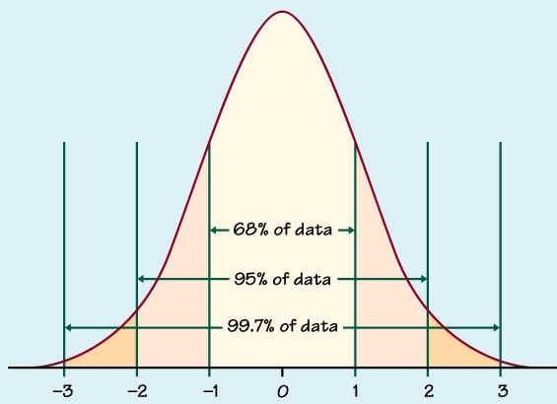

(Graph - see Reference 9)

**Appendix H. Assumptions and Limitations**

1. Assumption was made that VistA and the network were functioning at normal levels.
2. In order to obtain the largest sample size possible, all clinicians performed all scenarios even though the actual task may fall outside their prescribed duties.
3. With respect to number 2 above, a clinician’s unfamiliarity with the task would reflect a new or inexperienced user and thus is valid to the current study.
4. The number of medications used in the Sorting and Comparing Medications Scenarios was arbitrary based upon averaging several CPRS test patient profiles. Sample results do not reflect all actual timings due to variations in the number of medications a patient may be receiving.
5. The number of orders used in the Finding and Sorting Orders Task Scenarios was arbitrary based upon averaging several CPRS test patient profiles. Sample timing results do not reflect all actual timings due to variations in the number of orders a patient may have.
6. The Cover Sheet Postings scenario represents a best case situation in trying to determine posting information. It assumes that the information needed is actually located in the posting itself. What the BI Team observed and what this scenario does not reflect, is that if the information exists in a scanned image, a clinician must go into VistA imaging to retrieve the image. The purpose of this scenario is to highlight efficiencies in the use of well-placed first-glance data.

EHT Investigation Support Project

**Appendix I. References**

This report is framed by the following documents listed in Table I-1 and I-2.

**Table I-1. List of References**

|  |  |  |
| --- | --- | --- |
| **Document Name** | **Version/Date** | **Produced By** |
| Request For Proposal (RFQ) No. 776-07-986 | 3 July 2007 | Veterans Health Administration  Office of Information  Chief Health Informatics Office  Emerging Health Technologies |
| Emerging Health Technologies Solicitation No. 766-07-986 Technical Response | 30 July 2007 | Business Intelligence, Inc. |
| Purchase Order 776-C70397 for Supplies or Services | 12 September  2007 | Dept of Veterans Affairs Service Center |
| Combined Industrial Engineering and Workflow Engineering Methodology Proposal for Tasks 6 and 7 – Deliverable 6.1/7.1 | 17 December 2007  As revised 21  April 2008 | Business Intelligence, Inc |
| Bay Pines Visit Trip Report—Task 6 (Final) | 14 March 2008 | Business Intelligence, Inc |
| West Roxbury VAMC Site Visit Trip Report—  Task 6 (Final) | 14 March 2008 | Business Intelligence, Inc |
| Baltimore VAMC Site Visit Trip Report—Task 6 (Final) | 14 March 2008 | Business Intelligence, Inc |
| Albany VAMC Site Visit Trip Report—Task 6 (Final) | 14 March 2008 | Business Intelligence, Inc |
| Baseline Response Time & Workflow Efficiency Data—Deliverables 6.2 and 7.2—Draft | 24 April 2008 | Business Intelligence, Inc. |
| Baseline Response Time & Workflow Efficiency Data—Deliverables 6.2 and 7.2—Draft | 24 April 2008 | Business Intelligence, Inc. |
| Response Time Simulation Testing Report  (summary & detail)—Deliverables 6.4 and 7.4 | 24 April 2008 | Business Intelligence, Inc. |
| Simulation Model to Modify and Assess  Acceptable Response Times and Workflow  Efficiency—Deliverables 6.3 and 7.3—Draft | 09 May 2008 | Business Intelligence, Inc. |
| Bay Pines Visit Trip Report—Task 6 (Final) | May 21, 2008 | Business Intelligence, Inc |
| West Roxbury VAMC Site Visit Trip Report—  Task 6 (Final) | May 29, 2008 | Business Intelligence, Inc |
| Baltimore VAMC Site Visit Trip Report—Task 6 (Final) | June 5, 2008 | Business Intelligence, Inc |
| Albany VAMC Site Visit Trip Report—Task 6 (Final) | June 11, 2008 | Business Intelligence, Inc |

Page I-1

EHT Investigation Support Project

**Table I-2. List of Statistical References**

|  |  |  |
| --- | --- | --- |
| **Reference Number** | **Document Name** | **Produced By** |
| 1 | http://www.stat.yale.edu/Courses/1997-98/101/confint.htm | Department of Statistics, Yale University |
| 2 | http://www.itl.nist.gov/div898/software/dataplot/refman1/auxillar/diffmean.  htm | Statistical Engineering  Division, National Institute of Standards and  Technology |
| 2 | http://www.itl.nist.gov/div898/handbook/prc/section4/prc435.htm | Engineering Statistics  Handbook, National  Institute of Standards and Technology |
| 3 | http://www.isixsigma.com/library/content/c040607a.asp | Pamela Hunter, Director of the Center for Survey  Research and Analysis at the University of  Connecticut's Stamford campus |
| 4 | http://ltcconline.net/greenl/courses/201/Estimation/confIntMean.htm | Larry Green – Department of Mathematics, Lake  Tahoe Community College |
| 5 | <http://mathworld.wolfram.com/MarginofError.html>  [*Introduction to the Practice of Statistics.* N](http://www.amazon.com/exec/obidos/ASIN/0716796570/ref=nosim/weisstein-20)ew York: W. H. Freeman, p. 443, 1999 | David Moore Ph.D. Professor of  Statistics, Emeritus,  Purdue University and George McCabe Ph.D.  Professor of Statistic,  Purdue University –  Wolfram Research |
| 6 | "Mean." Fro[m *MathWorld*-](http://mathworld.wolfram.com/)-A Wolfram Web Resource.  [http://mathworld.wolfram.com/Mean.htm](http://mathworld.wolfram.com/Mean.html) | Eric W Weisstein Ph.D. – Wolfram Research |
| 7 | "Standard Deviation." Fro[m *MathWorld*-](http://mathworld.wolfram.com/)-A Wolfram Web Resource.  <http://mathworld.wolfram.com/StandardDeviation.html> | Eric W Weisstein Ph.D. – Wolfram Research |
| 8 | *An Introduction to Mathematical Statistics and Its Applications, Third Edition,* p. 282. | Richard J. Larsen  Professor (retired)  Department of Mathematics, Vanderbilt University and Morris L.  Marx Ph.D. Department of  Mathematics, University of West Florida |
| 9 | www.ltcconline.net/greenl/courses/201/probdist/zScore.htm | Larry Green – Department of Mathematics, Lake  Tahoe Community College |

Page I-2

1. Modeler’s Note: It is intended that the color-coding scheme for New, STAT and Flagged orders be maintained throughout the various screens. It is a limitation in the simulation tool that the data displayed can be sorted **or** colored but cannot be both.
2. Modeler’s Note: It is the intent of the modeler that the sorting capability of orders be maintained throughout the various screens. It is a limitation in simulation tool that the data displayed can be sorted **or** colored but cannot be both.